HANOI UNIVERSITY OF SCIENCE AND TECHNOLOGY

School of Information and communications technology

Software Design Document

Version 1.3

AIMS: An Internet Media Store

Subject: ITSS Software Development

Group 2

Đặng Văn Nhân – 20225990

Hà Việt Khánh – 20225979

Hồ Bảo Thư – 20226003

Trần Cao Phong – 20226061

Nguyễn Lan Nhi - 20225991

*Hanoi,* *May 2025*

*<All notations inside the angle bracket are not part of this document, for its purpose is for extra instruction. When using this document, please erase all these notations and/or replace them with corresponding content as instructed>*

*<This document, written by Prof. NGUYEN Thi Thu Trang, is used as a case study for student with related courses. Any modifications and/or utilization without the consent of the author is strictly forbidden>*

Table of Contents

Table of Contents 1

1 Introduction 14

1.1 Objective 14

1.2 Scope 14

1.3 Glossary 15

1.4 References 17

2 Overall Description 18

2.1 General Overview 18

2.2 Assumptions/Constraints/Risks 18

2.2.1 Assumptions 18

2.2.2 Constraints 18

2.2.3 Risks 19

3 System Architecture and Architecture Design 20

3.1 Architectural Patterns 20

3.2 Interaction Diagrams 22

3.2.1 Place order 22

3.2.2 Pay order 23

3.2.3 Place rush order 24

3.2.4 Create products 25

3.2.5 Update products 26

3.2.6 View product details 27

3.2.7 Delete products 28

3.2.8 Add products to cart 28

3.2.9 Update products in cart 29

3.2.10 View products in cart 30

3.2.11 Delete products in cart 31

3.2.12 Login 31

3.2.13 Search products 32

3.2.14 Cancel order 33

3.2.15 Approve order 33

3.2.16 Reject order 34

3.2.17 View pending order 35

3.2.18 Create new users 36

3.3 Analysis Class Diagrams 37

3.3.1 Model package 37

3.3.2 Controller package 38

3.3.3 View package 39

3.4 Unified Analysis Class Diagram 40

3.5 Security Software Architecture 40

4 Detailed Design 42

4.1 User Interface Design 42

4.1.1 Screen Configuration Standardization 42

4.1.2 Screen Transition Diagrams 43

4.1.3 Screen Specifications 43

4.1.3.1 Home screen 43

4.1.3.2 Product details screen 44

4.1.3.3 Cart screen 45

4.1.3.4 Checkout screen 46

4.1.3.5 Order Review Screen 47

4.1.3.6 Choose Rush Order Screen 48

4.1.3.7 Invoice Screen 49

4.1.3.8 VNPAY screen 50

4.1.3.9 Payment Status screen 50

4.1.3.10 Login screen 51

4.1.3.11 Management Panel 52

4.1.3.12 Create User (Admin screen) 53

4.1.3.13 Products list screen 54

4.1.3.14 CRUD Product screen 55

4.1.3.15 Pending order list screen 56

4.1.3.16 Cancel order screen 57

4.2 Data Modeling 58

4.2.1 Conceptual Data Modeling 58

4.2.2 Database Design 58

4.2.2.1 Database Management System 58

4.2.2.2 Database Diagram 59

4.2.2.3 Database Detail Design 60

4.3 Non-Database Management System Files 75

4.4 Class Design 76

4.4.1 General Class Diagram 76

4.4.2 Class Diagrams 76

4.4.2.1 Class Diagram for Package model 76

4.4.2.2 Class Diagram for Package controller 77

4.4.2.3 Class Diagram for Package service 77

4.4.2.4 Class Diagram for Package repository 78

4.4.2.5 Class Diagram for Package dto 79

4.4.2.6 Class Diagram for Package exception 80

4.4.2.7 Class Diagram for Package utils 81

4.4.3 Class Design 81

4.4.3.1 Class “Product” 81

4.4.3.2 Class “CD” 84

4.4.3.3 Class “DVD” 85

4.4.3.4 Class “LP” 87

4.4.3.5 Class “Book” 88

4.4.3.6 Class “Cart” 90

4.4.3.7 Class “CartItem” 91

4.4.3.8 Class “Invoice” 92

4.4.3.9 Class “Order” 95

4.4.3.10 Class “OrderItem” 99

4.4.3.11 Class “PaymentTransaction” 100

4.4.3.12 Class “RefundTransaction” 102

4.4.3.13 Class “DeliveryInfo” 103

4.4.3.14 Class “ProductChecklog” 105

4.4.3.15 Class “User” 106

4.4.3.16 Class “AuthController” 108

4.4.3.17 Class “CartController” 109

4.4.3.18 Class “HomeController” 110

4.4.3.19 Class “OrderPMController” 111

4.4.3.20 Class “PaymentController” 113

4.4.3.21 Class “PlaceOrderController” 115

4.4.3.22 Class “PlaceRushOrderController” 117

4.4.3.23 Class “ProductPMController” 120

4.4.3.24 Class “ProductUserController” 121

4.4.3.25 Class “AuthService” 121

4.4.3.26 Class “HomeService” 123

4.4.3.27 Class “OrderService” 124

4.4.3.28 Class “ProductService” 126

4.4.3.29 Class “ReservationService” 127

4.4.3.30 Class “TotalUpdateRule” 129

4.4.3.31 Class “TotalDeleteRule” 130

4.4.3.32 Class “UpdatePriceRule” 131

4.4.3.33 Class “SessionValidatorService” 132

4.4.3.34 Class “RushShippingFee” 133

4.4.3.35 Class “StandardShippingFee” 134

4.4.3.36 Class “SupabaseStorage” 135

4.4.3.37 Class “ProductFactoryProvider” 136

4.4.3.38 Class “ProductFactoryProvider” 137

4.4.3.39 Class “BookFactory” 139

4.4.3.40 Class “CDFactory” 139

4.4.3.41 Class “DVDFactory” 140

4.4.3.42 Class “LPFactory” 141

4.4.3.43 Class “ProductValidator” 141

4.4.3.44 Class “BookValidator” 143

4.4.3.45 Class “CDValidator” 144

4.4.3.46 Class “DVDValidator” 145

4.4.3.47 Class “LPValidator” 146

4.4.3.48 Class “PaymentSubsystem” 147

4.4.3.49 Class “VNPayPaymentSubsystem” 148

4.4.3.50 Class “CartService” 149

5 Design Considerations 152

5.1 Goals and Guidelines 152

5.2 Architectural Strategies 152

5.3 Design and Program Evaluation 153

5.3.1 Cohesion & SRP 154

5.3.2 Coupling & Other SOLID 160

5.4 Design Patterns 161

5.4.1 Factory Pattern 162

5.4.1.1 Usage 162

5.4.1.2 Why to use 162

5.4.1.3 Implementation Details 162

5.4.2 Strategy Pattern 162

5.4.2.1 Usage 162

5.4.2.2 Why to use 162

5.4.2.3 Implementation Details 163

5.4.3 Template Method Pattern 163

5.4.3.1 Usage 163

5.4.3.2 Why to use 163

5.4.3.3 Implementation Details 163

**List of Figures**

Figure 1: Sequence diagram for UC Place order 22

Figure 2: Sequence diagram for UC Pay order 23

Figure 3: Sequence diagram for UC Place rush order 24

Figure 4: Sequence diagram for UC Create products 25

Figure 5: Sequence diagram for UC Update products 26

Figure 6: Sequence diagram for UC View product details - Customer 27

Figure 7: Sequence diagram for UC View product details - Product Manager 27

Figure 8: Sequence diagram for UC Delete products 28

Figure 9: Sequence diagram for UC Add products to cart 28

Figure 10: Sequence diagram for UC Update products in cart 29

Figure 11: Sequence diagram for UC View products in cart 30

Figure 12: Sequence diagram for UC Delete products in cart 31

Figure 13: Sequence diagram for UC Login 31

Figure 14: Sequence diagram for UC Login (Admin) 32

Figure 15: Sequence diagram for UC Search products 32

Figure 16: Sequence diagram for UC Cancel order 33

Figure 17: Sequence diagram for UC Approve order 33

Figure 18: Sequence diagram for UC Reject order 34

Figure 19: Sequence diagram for UC View pending order 35

Figure 20: Sequence diagram for UC Create new users 36

Figure 21: AIMS General Class Diagram 76

Figure 22: Model package 76

Figure 23: Controller package 77

Figure 24: Service package 77

Figure 25: Repository package 78

Figure 26: DTO package 79

Figure 27: Exception package 80

Figure 28: Utils package 81

**List of Tables**

Table 1: Product Table Design 59

Table 2: DVD Table Design 60

Table 3: CD Table Design 61

Table 4: Book Table Design 61

Table 5: LP Table Design 62

Table 6: ProductChecklog Table Design 62

Table 7: Users Table Design 62

Table 8: User_Role_Map Table Design 63

Table 9: Role Table Design 63

Table 10: Reservation Table Design 63

Table 11: Reservation_Item Table Design 64

Table 12: OrderItem Table Design 64

Table 13: Orders Table Design 64

Table 14: DeliveryInfo Table Design 65

Table 15: PaymentTransaction Table Design 65

Table 16: Invoice Table Design 66

Table 17: RefundTransaction Table Design 66

Table 20. Attribute Design 80

Table 21. Operation Design 81

Table 22. Attribute Design 83

Table 23. Operation Design 83

Table 24. Attribute Design 84

Table 25. Operation Design 85

Table 26. Attribute Design 86

Table 27. Operation Design 86

Table 28. Attribute Design 87

Table 29. Operation Design 88

Table 30. Attribute Design 89

Table 31. Operation Design 89

Table 32. Attribute Design 90

Table 33. Operation Design 91

Table 34. Attribute Design 91

Table 35. Operation Design 92

Table 36. Attribute Design 94

Table 37. Operation Design 95

Table 38. Attribute Design 98

Table 39. Operation Design 98

Table 40. Attribute Design 99

Table 41. Operation Design 100

Table 42. Attribute Design 101

Table 43. Operation Design 102

Table 44. Attribute Design 102

Table 45. Operation Design 103

Table 46. Attribute Design 104

Table 47. Operation Design 104

Table 48. Attribute Design 105

Table 49. Operation Design 106

Table 50. Attribute Design 107

Table 51. Operation Design 107

Table 52. Attribute Design 108

Table 53. Operation Design 108

Table 54. Attribute Design 109

Table 55. Operation Design 109

Table 56. Attribute Design 110

Table 57. Operation Design 111

Table 58. Attribute Design 112

Table 59. Operation Design 112

Table 60. Attribute Design 114

Table 61. Operation Design 115

Table 62. Attribute Design 116

Table 63. Operation Design 117

Table 64. Attribute Design 119

Table 65. Operation Design 119

Table 66. Attribute Design 120

Table 67. Operation Design 120

Table 68. Attribute Design 120

Table 69. Operation Design 121

Table 70. Attribute Design 122

Table 71. Operation Design 122

Table 72. Attribute Design 123

Table 73. Operation Design 124

Table 74. Attribute Design 125

Table 75. Operation Design 125

Table 76. Attribute Design 126

Table 77. Operation Design 127

Table 78. Attribute Design 128

Table 79. Operation Design 128

Table 80. Attribute Design 129

Table 81. Operation Design 129

Table 82. Attribute Design 130

Table 83. Operation Design 130

Table 84. Attribute Design 131

Table 85. Operation Design 132

Table 86. Attribute Design 132

Table 87. Operation Design 133

Table 88. Attribute Design 133

Table 89. Operation Design 133

Table 90. Attribute Design 134

Table 91. Operation Design 134

Table 90. Attribute Design 135

Table 91. Operation Design 135

Table 90. Attribute Design 136

Table 91. Operation Design 136

Table 90. Attribute Design 138

Table 91. Operation Design 138

Table 90. Attribute Design 138

Table 91. Operation Design 139

Table 90. Attribute Design 139

Table 91. Operation Design 139

Table 90. Attribute Design 140

Table 91. Operation Design 140

Table 92. Attribute Design 140

Table 93. Operation Design 141

Table 94. Attribute Design 142

Table 95. Operation Design 142

Table 96. Attribute Design 143

Table 97. Operation Design 143

Table 98. Attribute Design 144

Table 99. Operation Design 144

Table 100. Attribute Design 145

Table 101. Operation Design 145

Table 100. Attribute Design 146

Table 101. Operation Design 146

Table 102. Attribute Design 147

Table 103. Operation Design 147

Table 102. Attribute Design 148

Table 103. Operation Design 149

Table 104. Cohesion & SRP of AIMS 153

Table 105. Coupling & other SOLID of AIMS 159

# Introduction

The Software Design Document (SDD) serves as a detailed blueprint for the software development process. It provides in-depth descriptions of the system’s architecture, components, data structures, and interfaces. This document captures the key design decisions and strategies used to meet project requirements, ensuring that all stakeholders share a clear understanding of the system’s structure and behavior. The SDD typically includes sections on overall system architecture, module design, data design, and interface specifications. Its purpose is to enhance team communication, improve system maintainability, and support ongoing development and future enhancements.

## Objective

The Software Design Document (SDD) aims to deliver a comprehensive plan outlining the system architecture, key design choices, and implementation strategies for the development team. It acts as an essential reference point to maintain clarity, consistency, and alignment throughout the software development lifecycle. This document is intended for software engineers, system architects, project managers, QA testers, and other relevant stakeholders. By thoroughly documenting the design specifications, the SDD promotes clear communication, supports a more efficient development workflow, and helps ensure the final product fulfills all defined requirements and quality standards.

## Scope

An Internet Media Store (AIMS) is an e-commerce desktop application designed to facilitate the buying and selling of physical media products such as books, CDs, LP records, and DVDs. This system provides a seamless shopping experience for customers while enabling product managers to efficiently manage inventory. The software is designed to handle up to 1,000 concurrent users without performance degradation and can operate continuously for 300 hours without failure.

AIMS allows users to browse, search, purchase, and manage physical media products in a structured and user-friendly manner. The system supports both normal and rush orders, integrates with VNPay for payment processing, and provides robust inventory management capabilities. Key functionalities include:

* For Customers:
  + Searching and filtering products by attributes.
  + Viewing product details and adding items to the cart.
  + Normal or rush order options.
  + Making payment through VNPay.
  + Viewing and managing past orders, including order cancellations.
* For Product Managers:
  + Adding, editing, and removing products from the inventory.
  + Monitoring and updating product prices.
  + Reviewing and approving customer orders.
  + Managing stock availability.
* For Administrators:
  + Creating and managing user accounts.
  + Assigning roles and permissions to users.

## Glossary

|  |  |  |  |  |
| --- | --- | --- | --- | --- |
| ***No*** | ***Term*** | ***Explanation*** | ***Example*** | ***Note*** |
| 1 | session | A session is a temporary period of interaction between a user and a system, during which the user accesses and interacts with software, a website, or an application. The system maintains session-specific data, such as user authentication, preferences, and activity history, for the duration of the session. Once the session ends—either through user logout, session timeout, or browser closure—the stored session data is typically cleared unless explicitly saved. | software session |  |
| 2 | VAT (Value-added tax) | VAT (Value-Added Tax) is a consumption tax applied to the value added at each stage of production or distribution of goods and services. It is typically calculated as a percentage of the final selling price and is collected by businesses on behalf of the government. |  |  |
| 3 | API (Application Programming Protocol) | An API (Application Programming Interface) is a set of rules, protocols, and tools that enables different software applications to communicate and interact with each other. | VNPay API | AIMS connects API of VNPay for transaction. |
| 4 | Payment gateway | A payment gateway is a technology service that facilitates the secure transmission of payment information between a merchant's website or application and the financial institutions involved in processing payment transactions. |  |  |
| 5 | GUI (Graphical user interface) | A Graphical User Interface (GUI) refers to the visual elements and interactive components of a software application that allow users to interact with the system using graphical icons, buttons, menus, windows, and other visual elements. |  |  |
| 6 | Credit card | A credit card is a payment card issued by a financial institution, such as a bank or credit union, that allows cardholders to borrow funds up to a predetermined limit to make purchases or pay for goods and services. |  | AIMS currently supports for credit card payment through VNPay |
| 7 | Authentication | Authentication is the process of verifying the identity of a user, device, or system attempting to access a resource or service. |  |  |
| 8 | Response time | Response time refers to the amount of time it takes for a system to respond to a user's request or input. |  |  |

## References

Centers for Medicare & Medicaid Services. (n.d.). *System Design Document Template.* Retrieved from Centers for Medicare & Medicaid Services: https://www.cms.gov/Research-Statistics-Data-and-Systems/CMS-Information-Technology/XLC/Downloads/SystemDesignDocument.docx

# Overall Description

In this section, we deliver the main points in the SDD document, which include the overview and technical-view assumptions, constraints and risks for AIMS.

## General Overview

The system context and overall design strategy prioritize building a robust, scalable, and maintainable software solution. The architecture adopts a modular structure, enabling seamless updates and integration with external systems. A layered design is used to separate concerns, promote clean interfaces, and enhance component independence. Key design objectives include delivering high performance, ensuring security, and providing intuitive user interfaces. To illustrate system behavior and workflows, high-level diagrams, such as use case and activity diagrams, are used. These diagrams are regularly updated to reflect evolving requirements or insights, keeping the design aligned with the latest project objectives.

## Assumptions/Constraints/Risks

### Assumptions

The system design is built upon several fundamental assumptions. It presumes a stable hardware environment and the use of designated operating systems as defined in the project specifications. End-users are expected to possess a basic level of technical knowledge, and any anticipated changes in system functionality are assumed to be limited and manageable. Furthermore, the system depends on the availability and compatibility of certain external software components, which are assumed to function as specified for successful integration.

### Constraints

The system design is influenced by a range of global constraints. Hardware limitations, such as restricted processing power and memory, require careful performance optimization. The system must offer a user-friendly interface that functions smoothly across multiple device types. Given potential resource variability, the design must accommodate fluctuations in availability. Industry standards compliance and compatibility with existing systems are essential, guiding the design of interfaces and communication protocols. Licensing constraints also play a role, affecting the selection and cost of software components. The data repository must ensure secure, efficient storage and distribution, while security requirements - including data protection and user privacy - remain a top priority. Additionally, the system must meet performance benchmarks for speed and reliability, support robust network communication, and undergo thorough verification and validation to ensure overall quality. These constraints collectively shape the architecture and implementation strategy of the system.

### Risks

The system design must account for several potential risks, such as security threats, resource constraints, and integration difficulties. Security-related risks, including unauthorized access and data breaches, are mitigated through strong encryption and authentication protocols. Limitations in processing power and memory are addressed with efficient code and performance tuning. To handle integration with existing systems and third-party components, the design emphasizes comprehensive testing and compliance with interoperability standards. Furthermore, the system must remain adaptable to possible changes in user needs or operating conditions. This is achieved by employing a modular and flexible architecture that can evolve with requirements. Ongoing risk evaluation and the application of proactive mitigation strategies help ensure that potential problems are identified early and effectively managed.

# System Architecture and Architecture Design

This section presents a high-level overview of the System Architecture Design. It begins by identifying the appropriate architectural patterns to guide the system structure. Based on these patterns, sequence diagrams are created to illustrate component interactions. These interaction diagrams serve as the foundation for developing analysis class diagrams, which in turn form the basis for more detailed implementation-level class diagrams.

## Architectural Patterns

The Model-View-Controller (MVC) architectural pattern is a widely adopted approach that enhances code clarity, maintainability, and scalability. It achieves this by dividing the application into three main components, each with a distinct responsibility.

* The Model encapsulates the core business data and logic. It represents real-world entities and is responsible for managing the system's state.
* The View handles presentation logic. It defines how information is displayed to users and how input is captured.
* The Controller acts as the intermediary between the View and the Model. It processes incoming requests, enforces use case logic, and updates the Model and View accordingly.

By separating concerns in this way, the MVC pattern promotes modular design. This makes the system easier to understand, extend, and test, especially as it grows in complexity.

In Spring Boot, the MVC pattern is implemented using dedicated framework features that map directly to each architectural layer:

* Model components are typically defined as Java classes annotated with @Entity. These classes represent business-domain data such as Product, Order, or Customer, and they often use JPA to persist and retrieve information from the database.
* Controller components are annotated with @RestController or @Controller. They are responsible for handling HTTP requests from clients, parsing input, and returning structured responses. A controller delegates business logic to the service layer rather than handling it directly.
* Service classes act as the application's use case controllers. Annotated with @Service, they coordinate interactions between the Model and other components. This is where business rules are enforced, transactions are handled, and domain logic is executed. For example, a PlaceOrderService would validate data, call relevant entity methods, and persist changes.

In Spring MVC REST applications, the "View" is represented by the JSON response returned by controllers. However, in traditional web applications, it could be HTML rendered through templating engines like Thymeleaf or JSP.

## Interaction Diagrams

### Place order

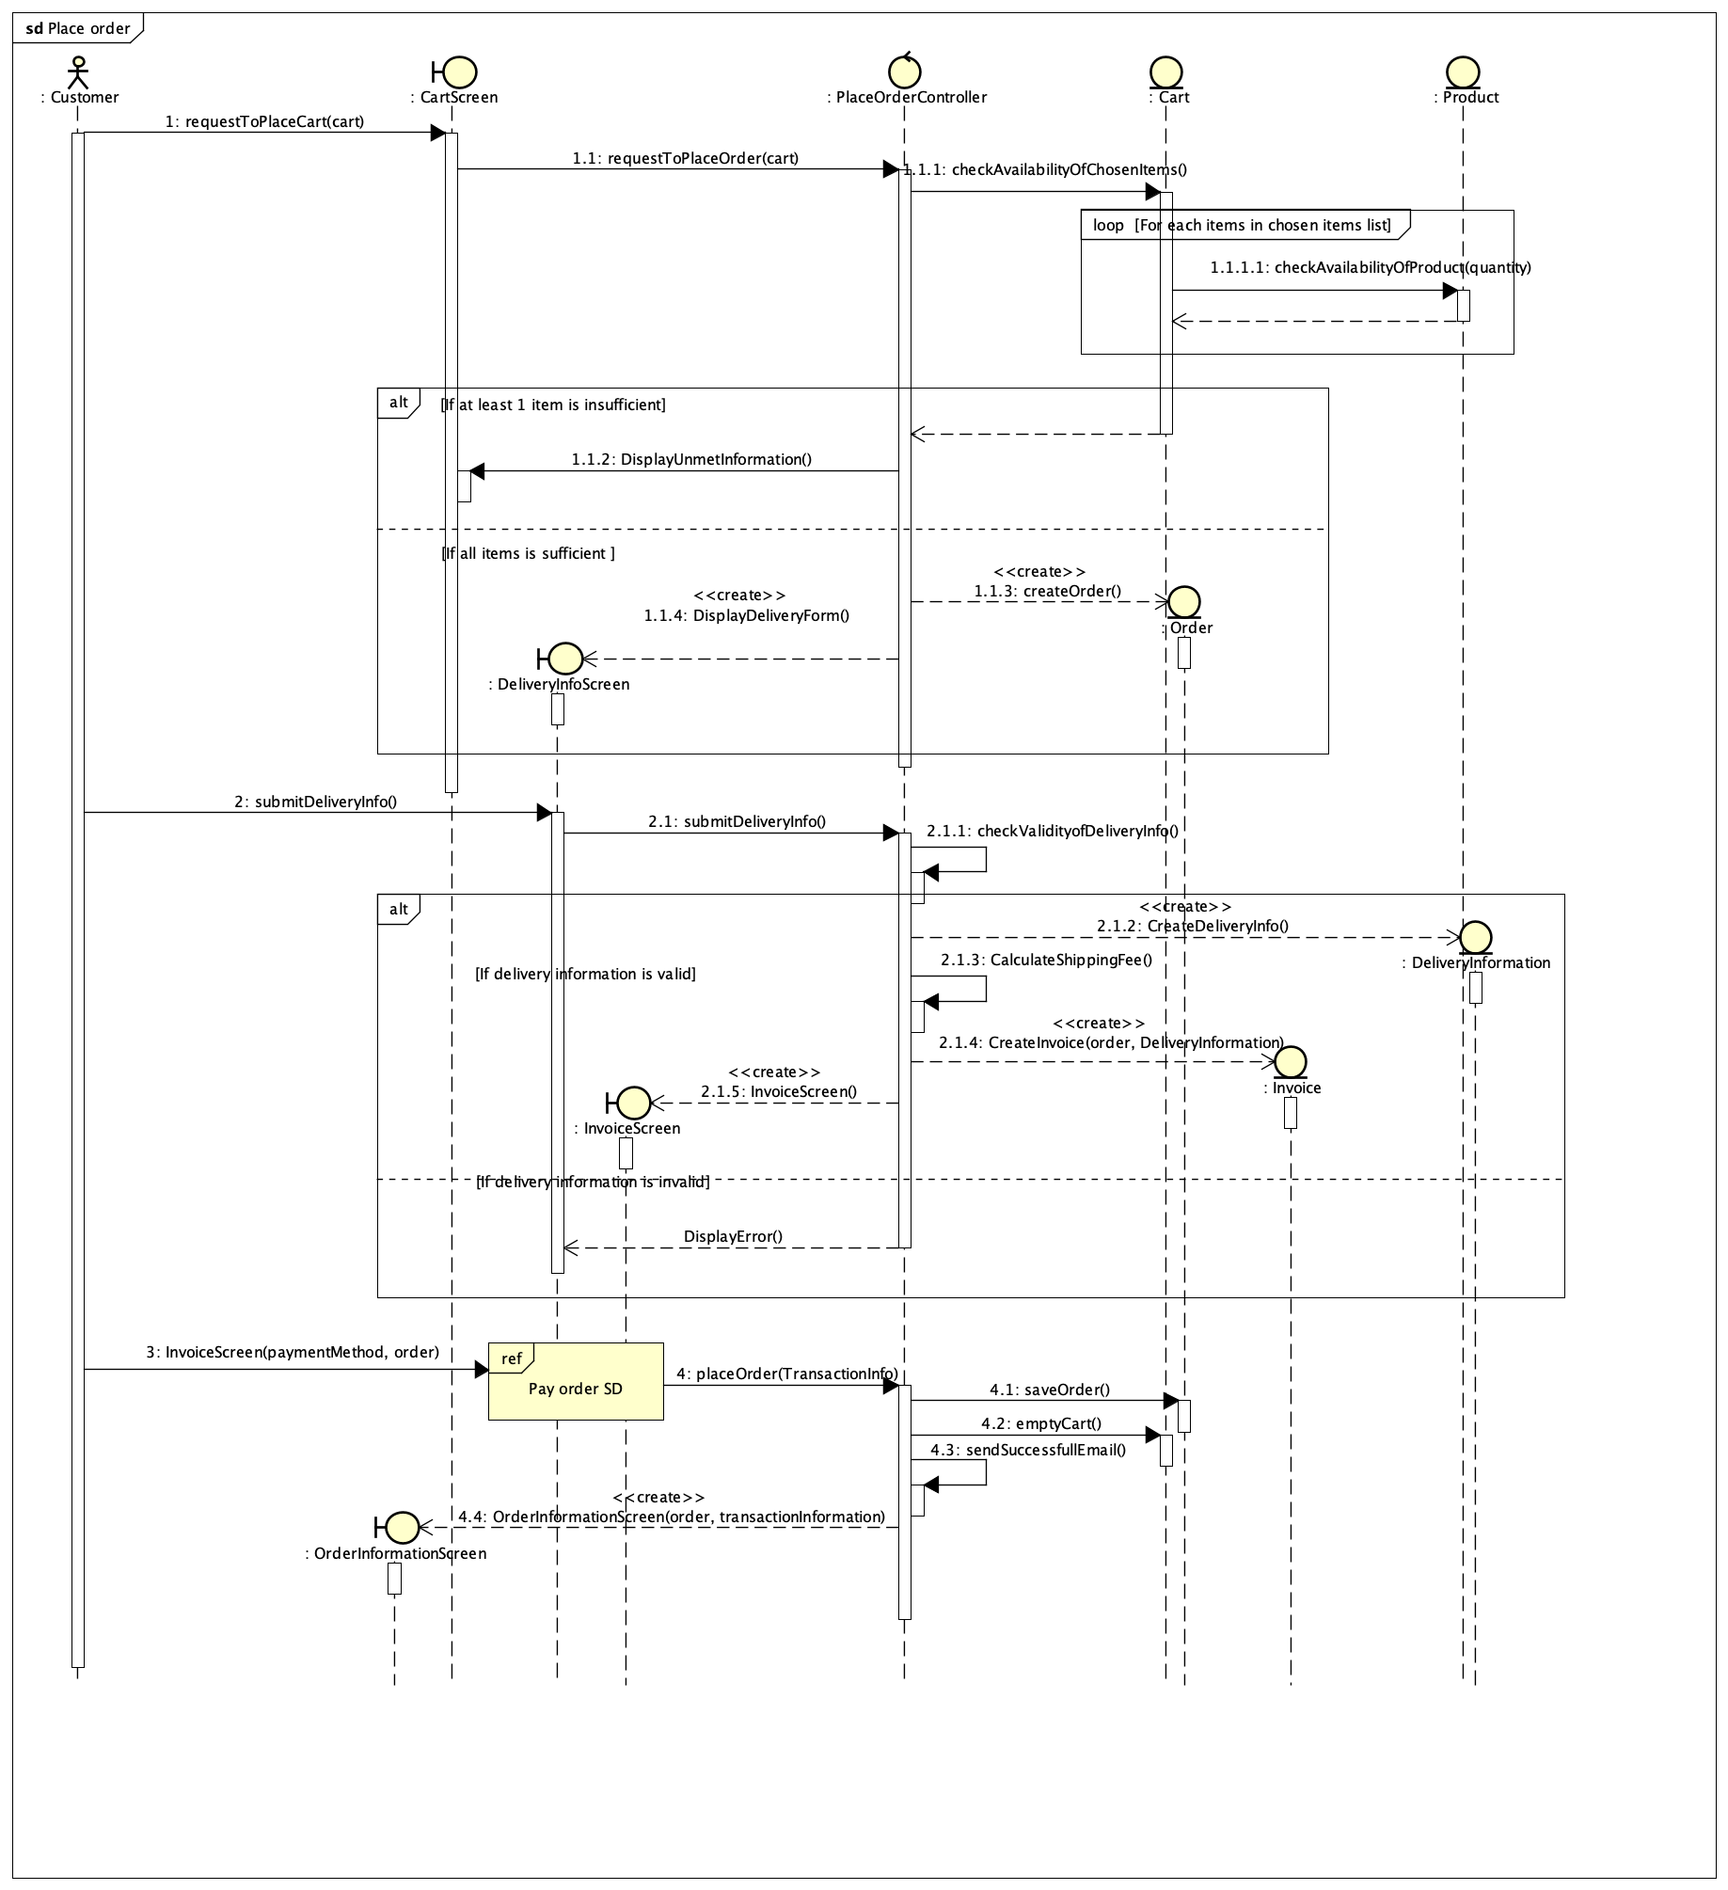

Figure 1: Sequence diagram for UC Place order

### Pay order

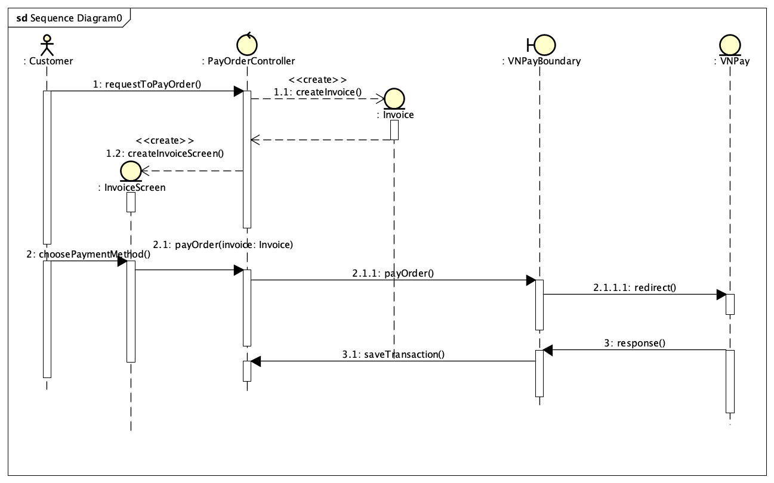

Figure 2: Sequence diagram for UC Pay order

### Place rush order

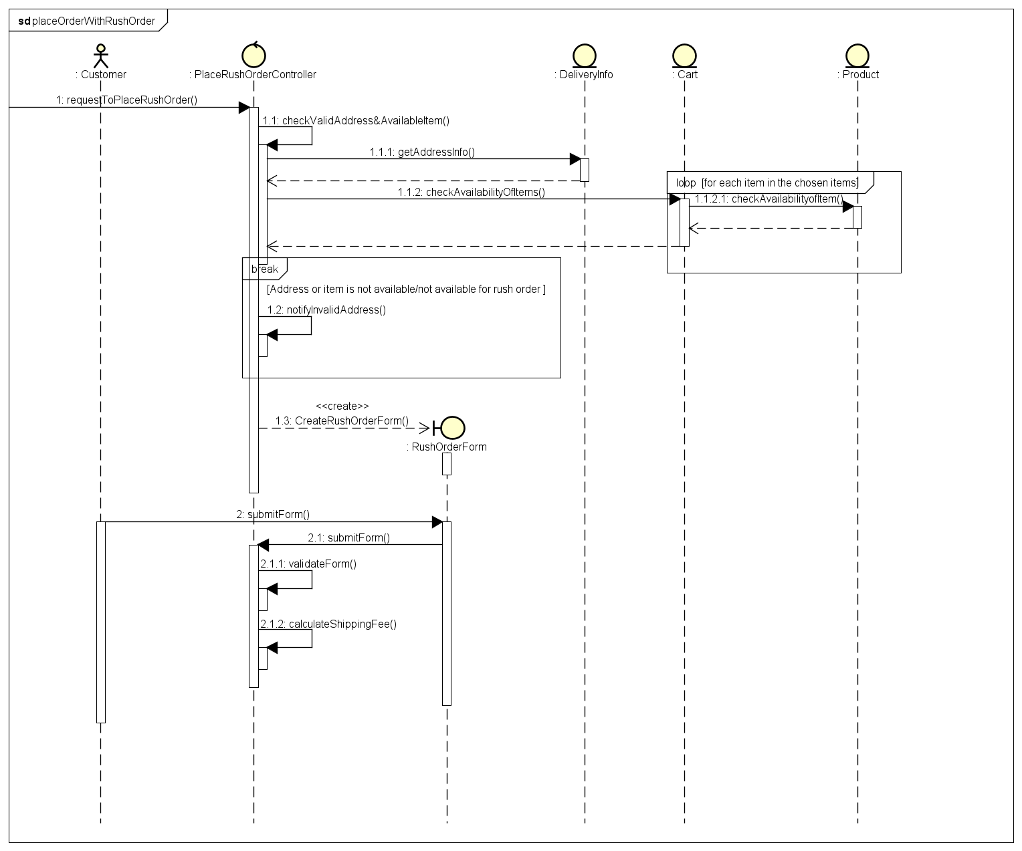

Figure 3: Sequence diagram for UC Place rush order

### Create products

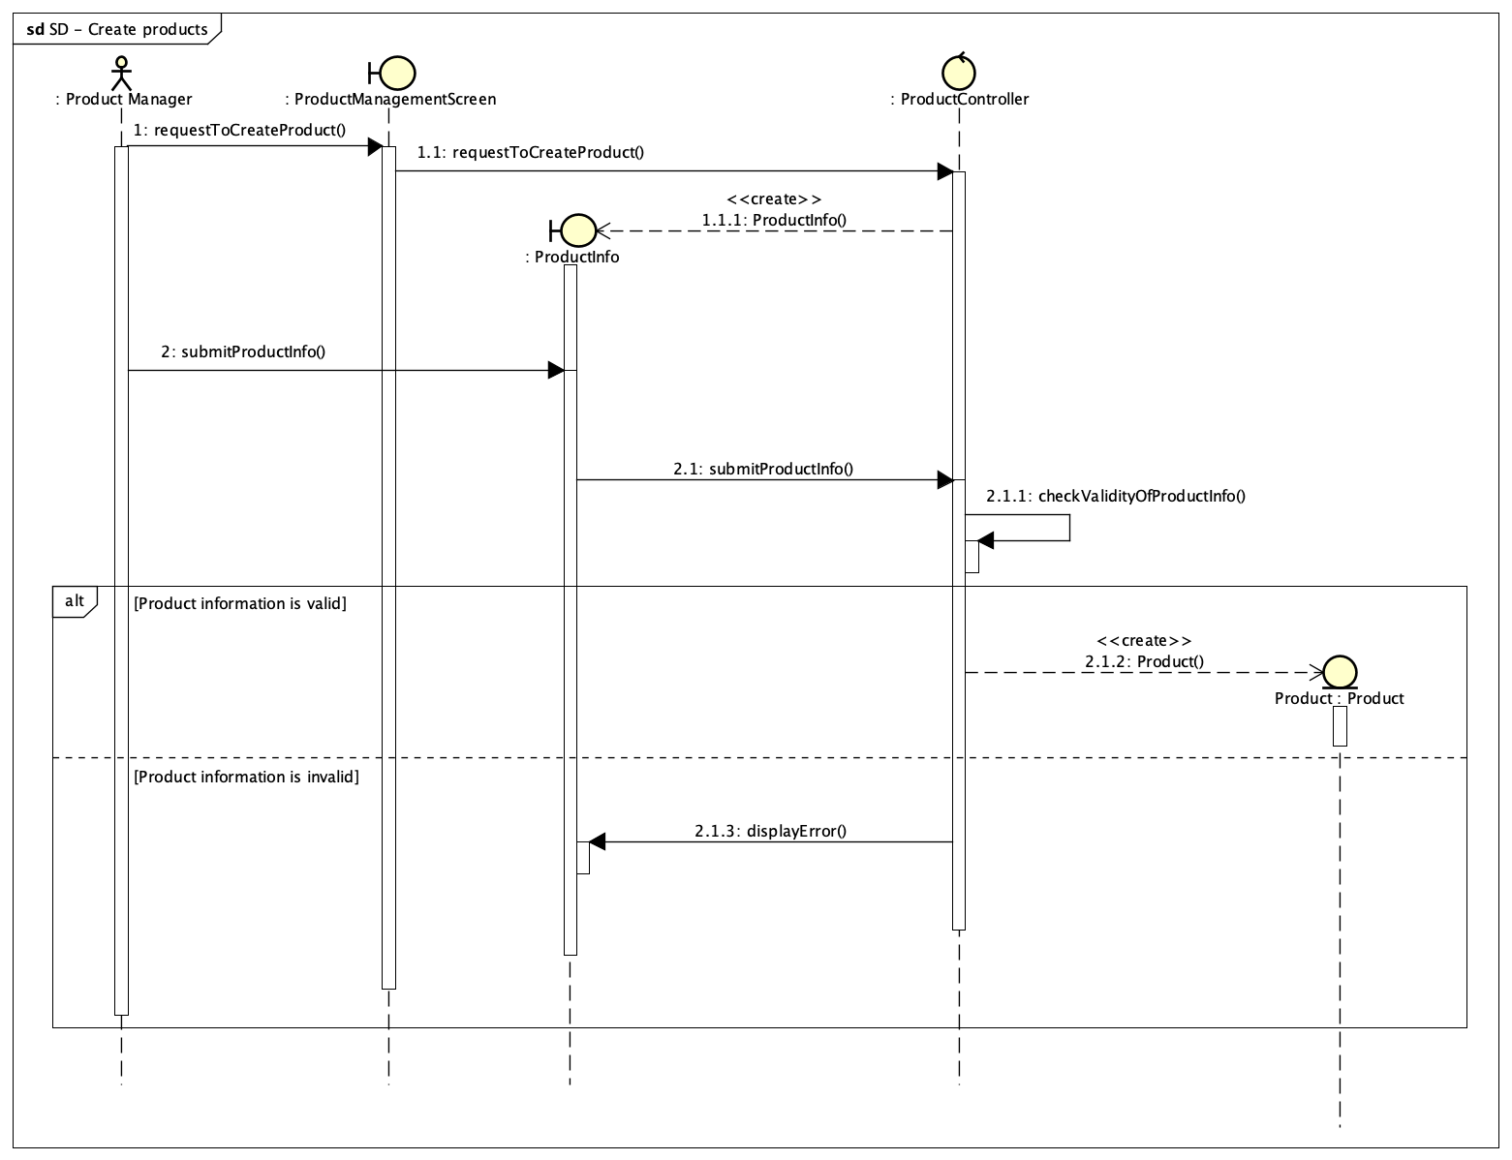

Figure 4: Sequence diagram for UC Create products

### Update products

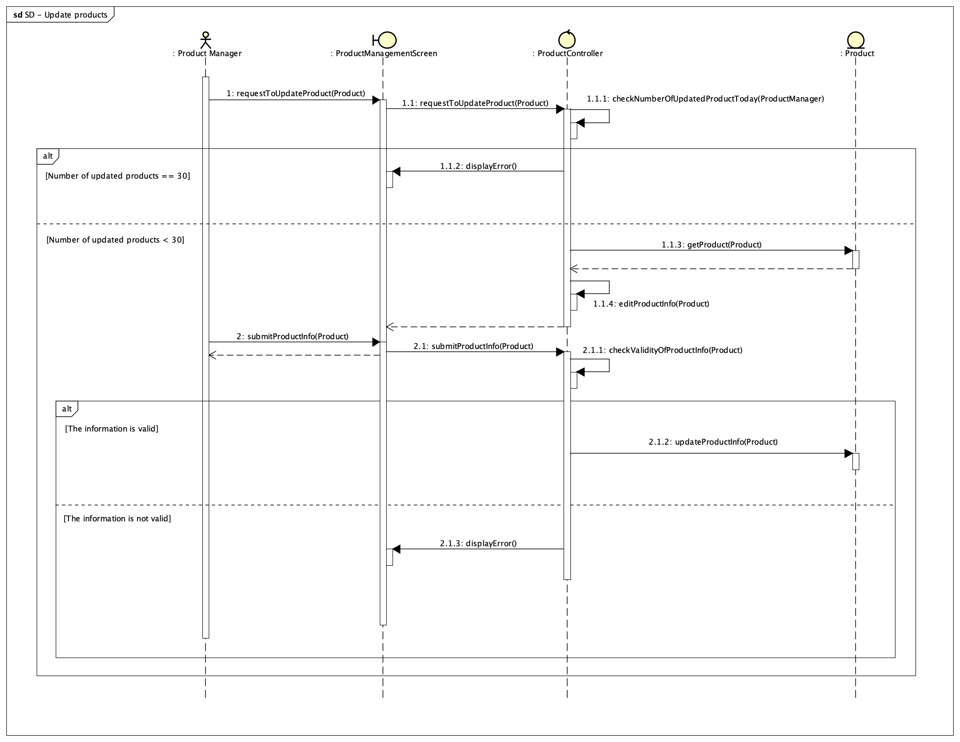

Figure 5: Sequence diagram for UC Update products

### View product details

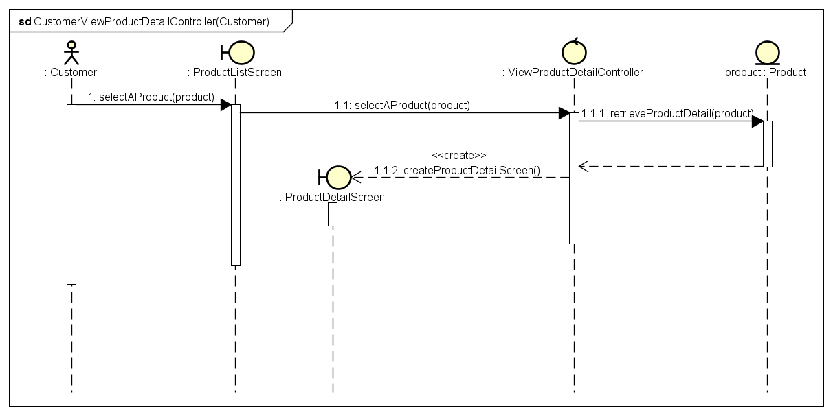

Figure 6: Sequence diagram for UC View product details - Customer

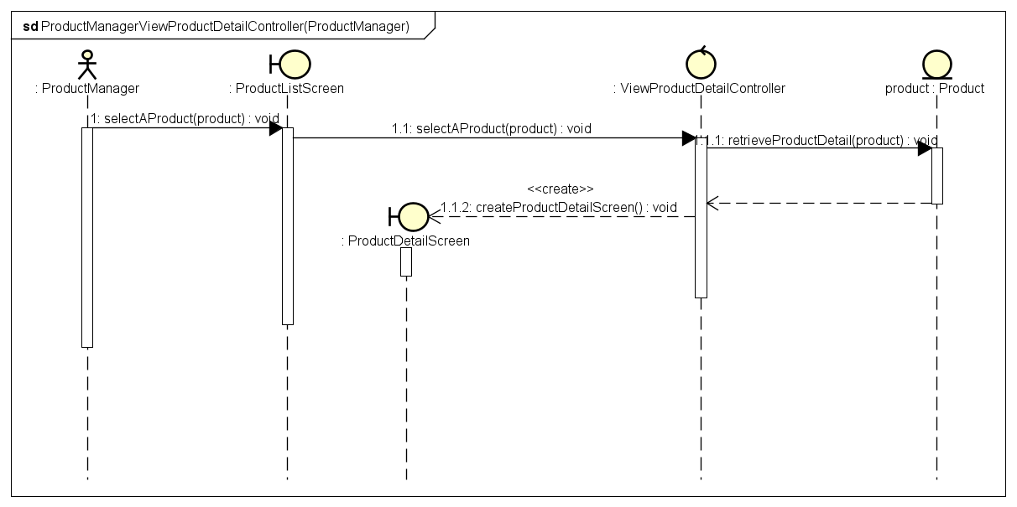

Figure 7: Sequence diagram for UC View product details - Product Manager

### Delete products

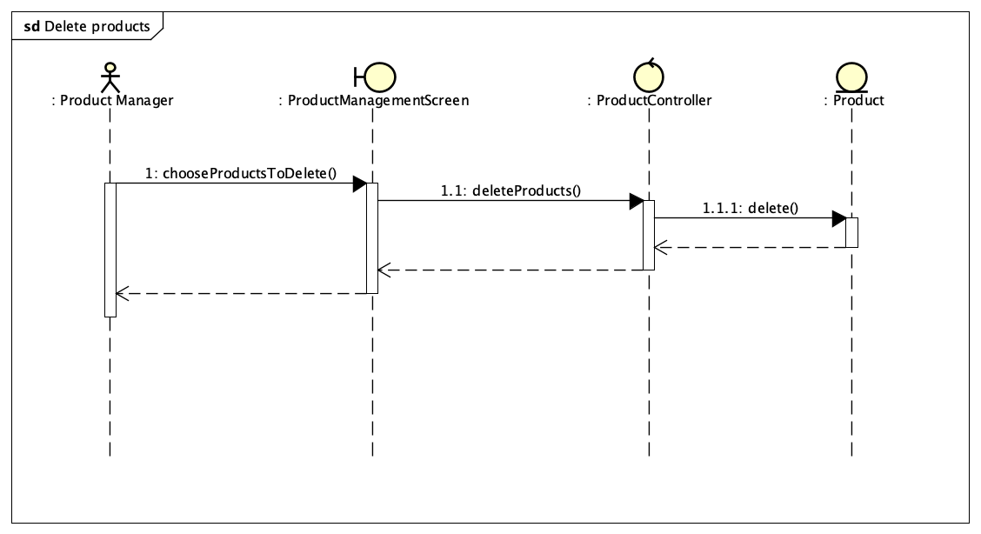

Figure 8: Sequence diagram for UC Delete products

### Add products to cart

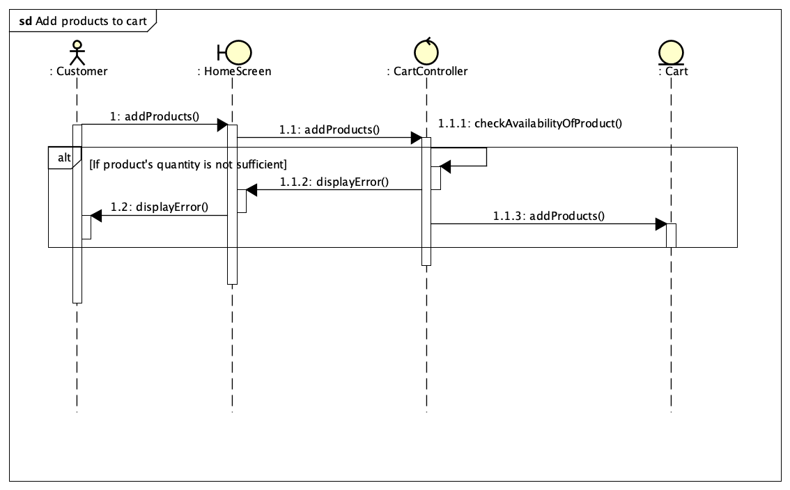

Figure 9: Sequence diagram for UC Add products to cart

### Update products in cart

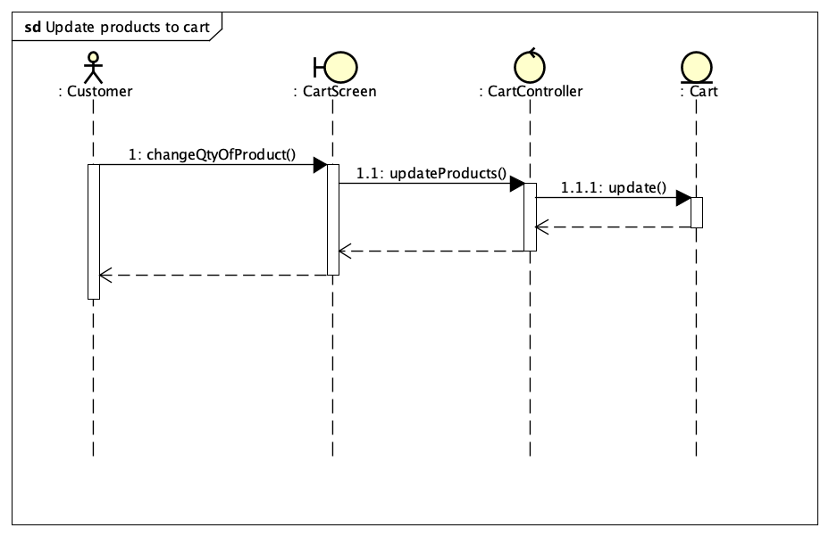

Figure 10: Sequence diagram for UC Update products in cart

### View products in cart

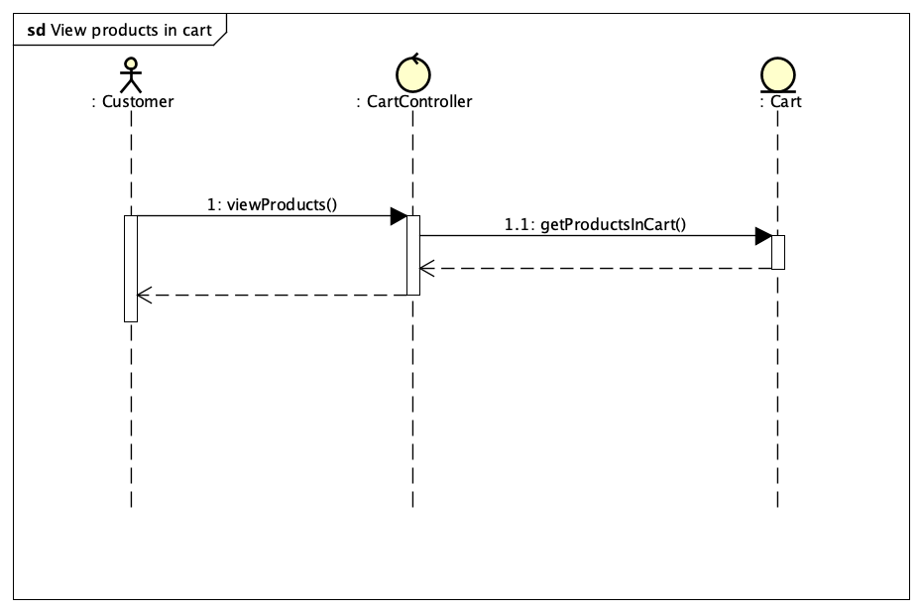

Figure 11: Sequence diagram for UC View products in cart

### Delete products in cart

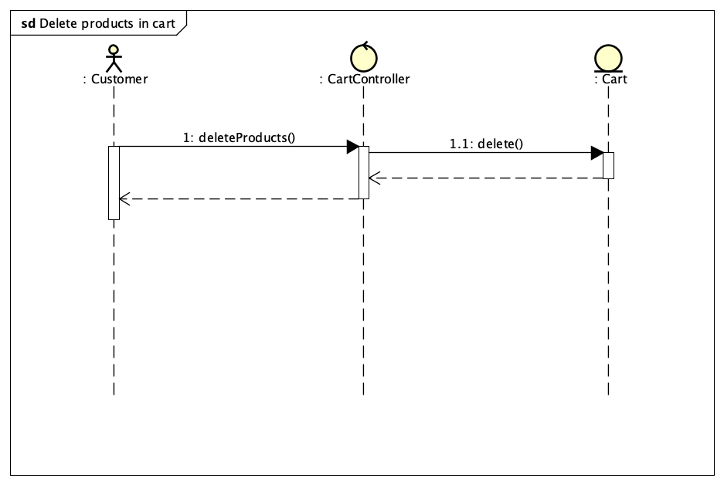

Figure 12: Sequence diagram for UC Delete products in cart

### Login

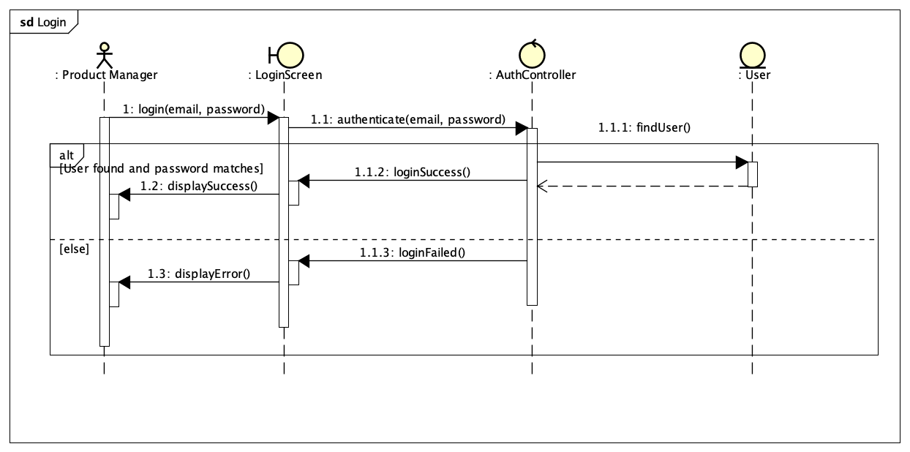

Figure 13: Sequence diagram for UC Login

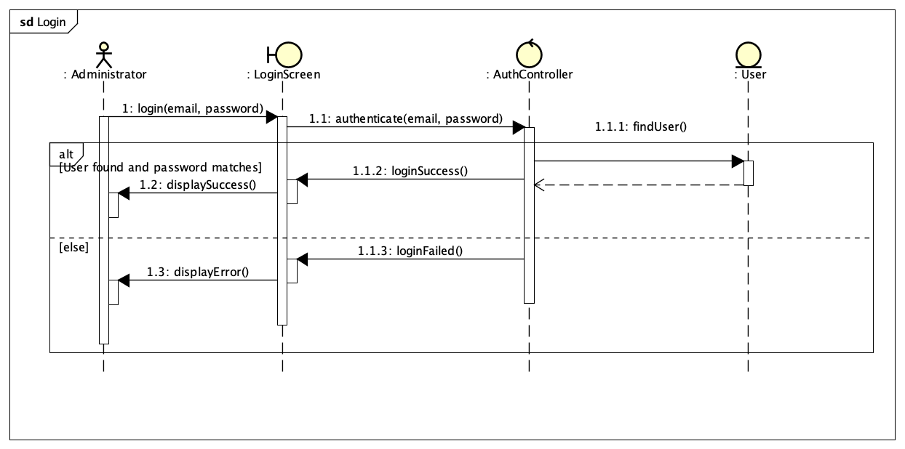

Figure 14: Sequence diagram for UC Login (Admin)

### Search products

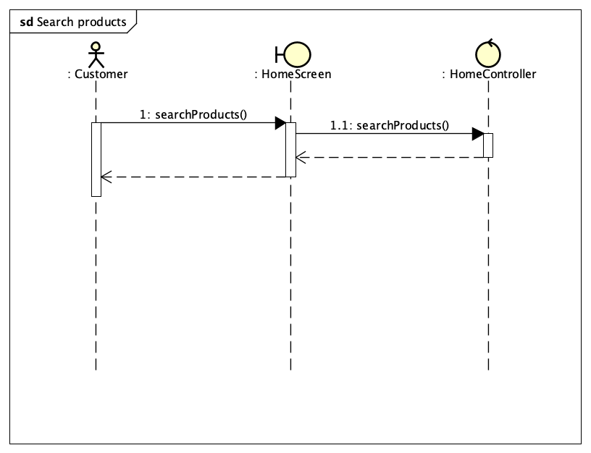

Figure 15: Sequence diagram for UC Search products

### Cancel order

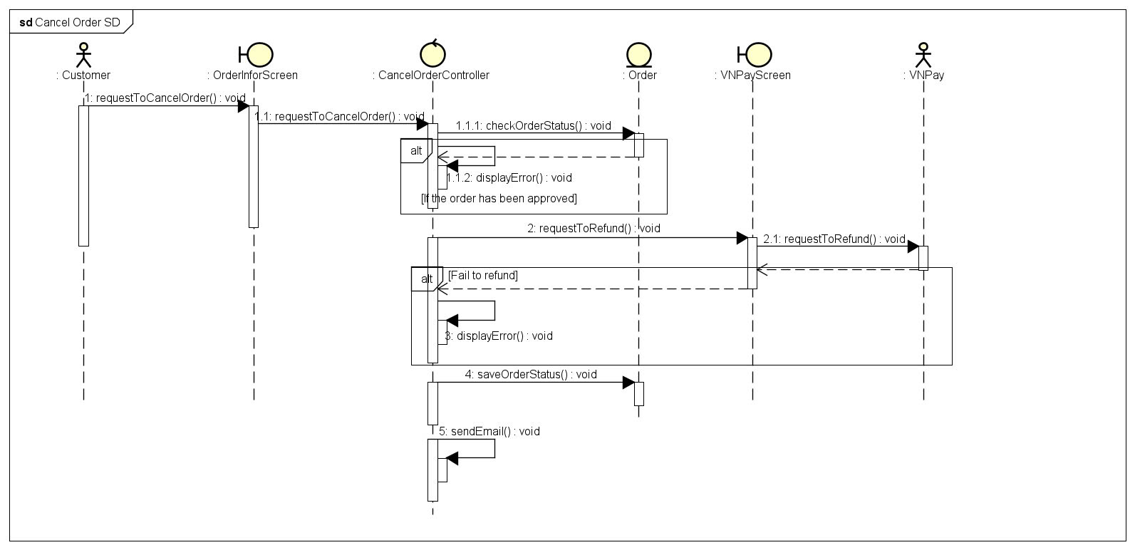

Figure 16: Sequence diagram for UC Cancel order

### Approve order

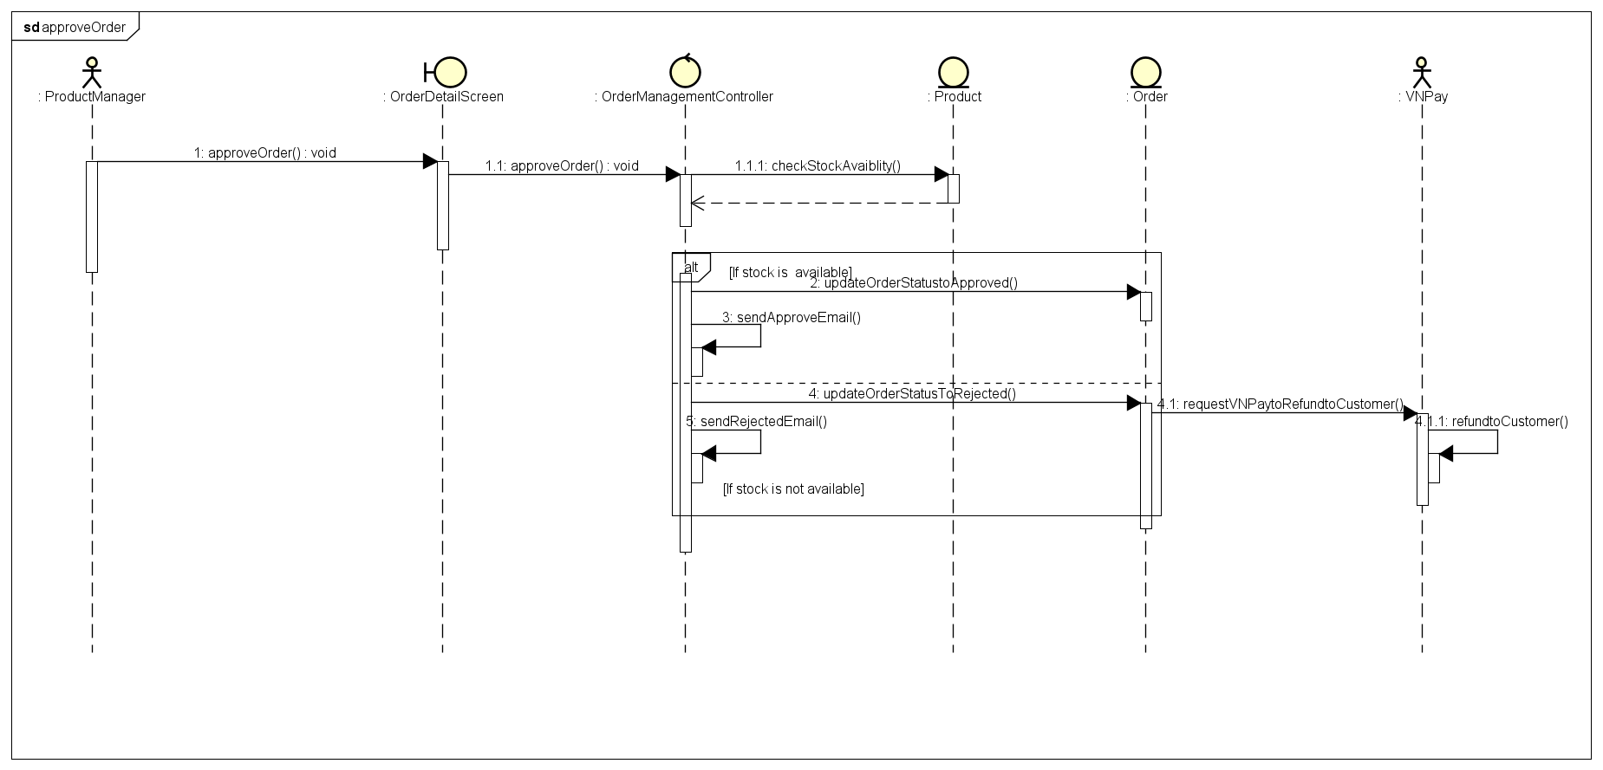

Figure 17: Sequence diagram for UC Approve order

### Reject order

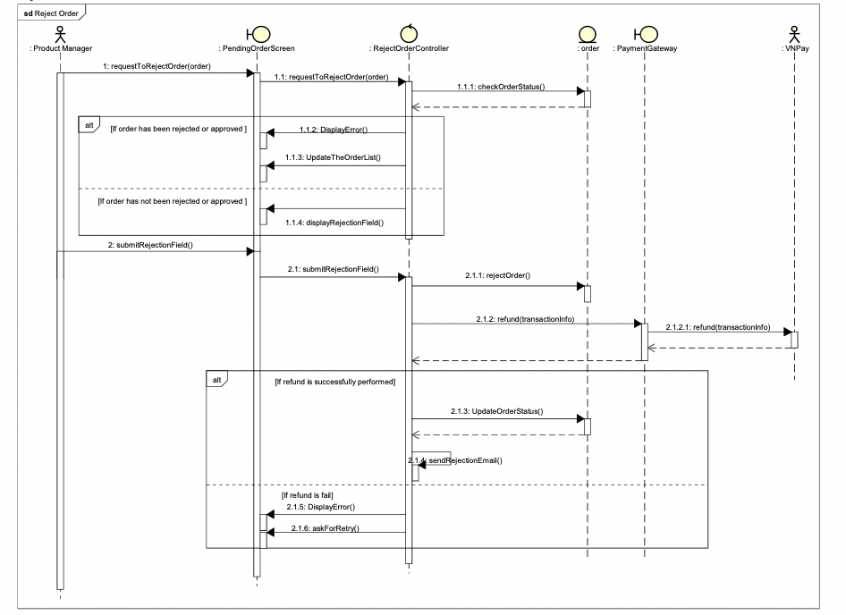

Figure 18: Sequence diagram for UC Reject order

### View pending order

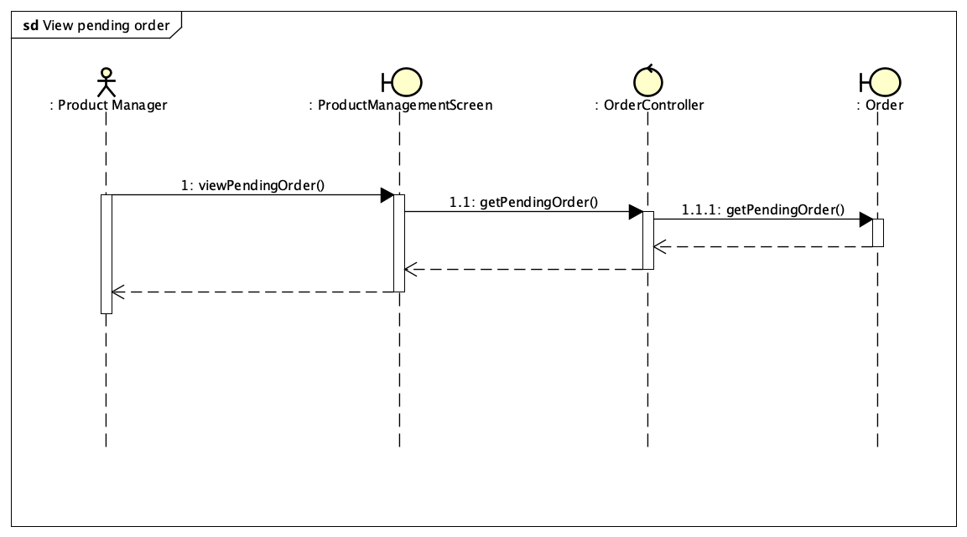

Figure 19: Sequence diagram for UC View pending order

### Create new users

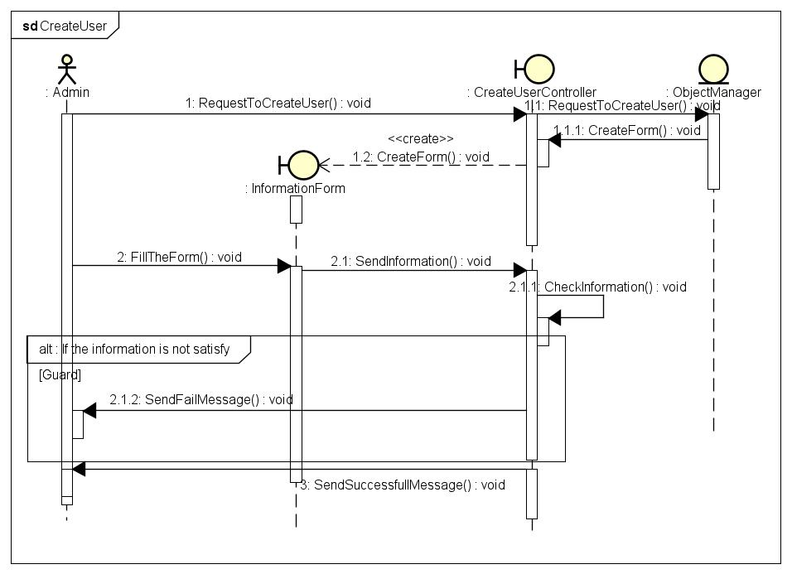

Figure 20: Sequence diagram for UC Create new users

## Analysis Class Diagrams

### Model package

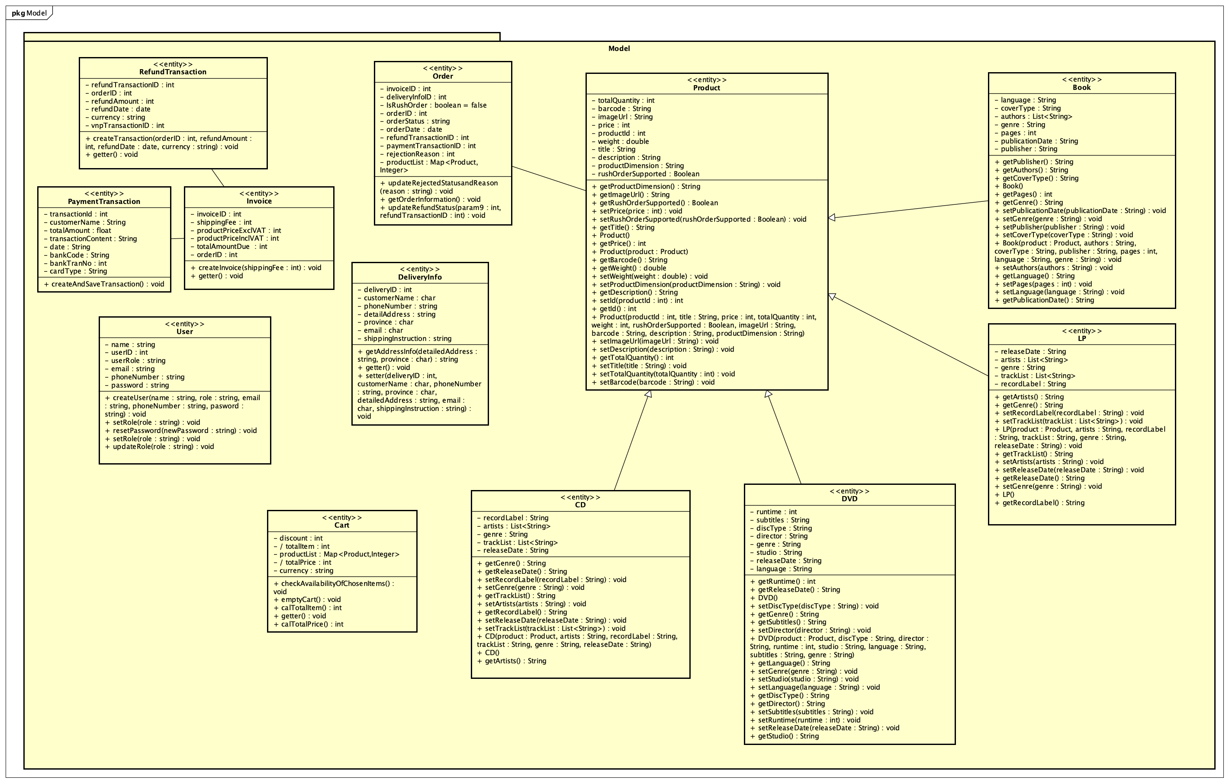

### Controller package

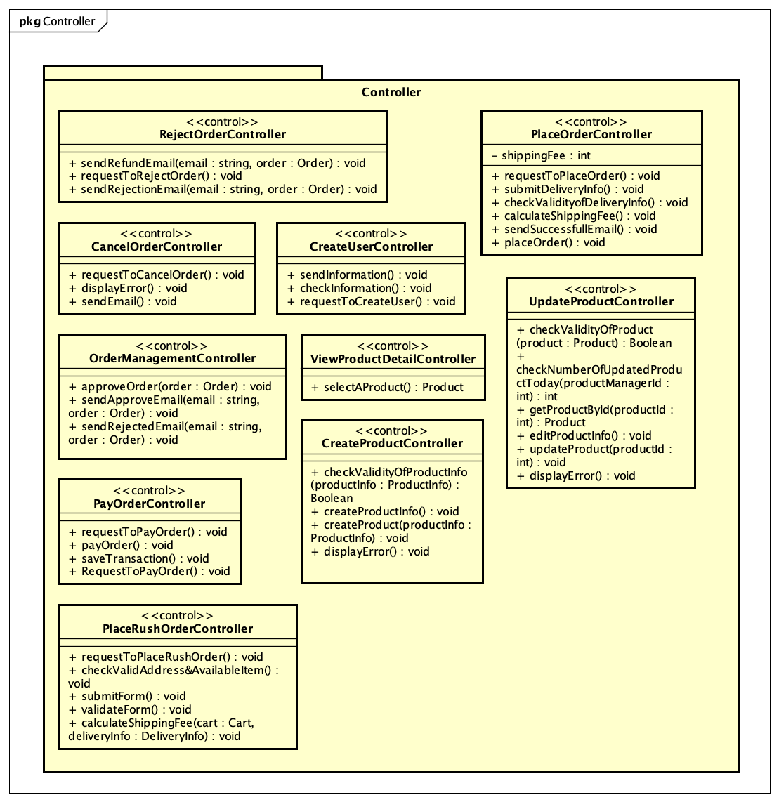

### View package

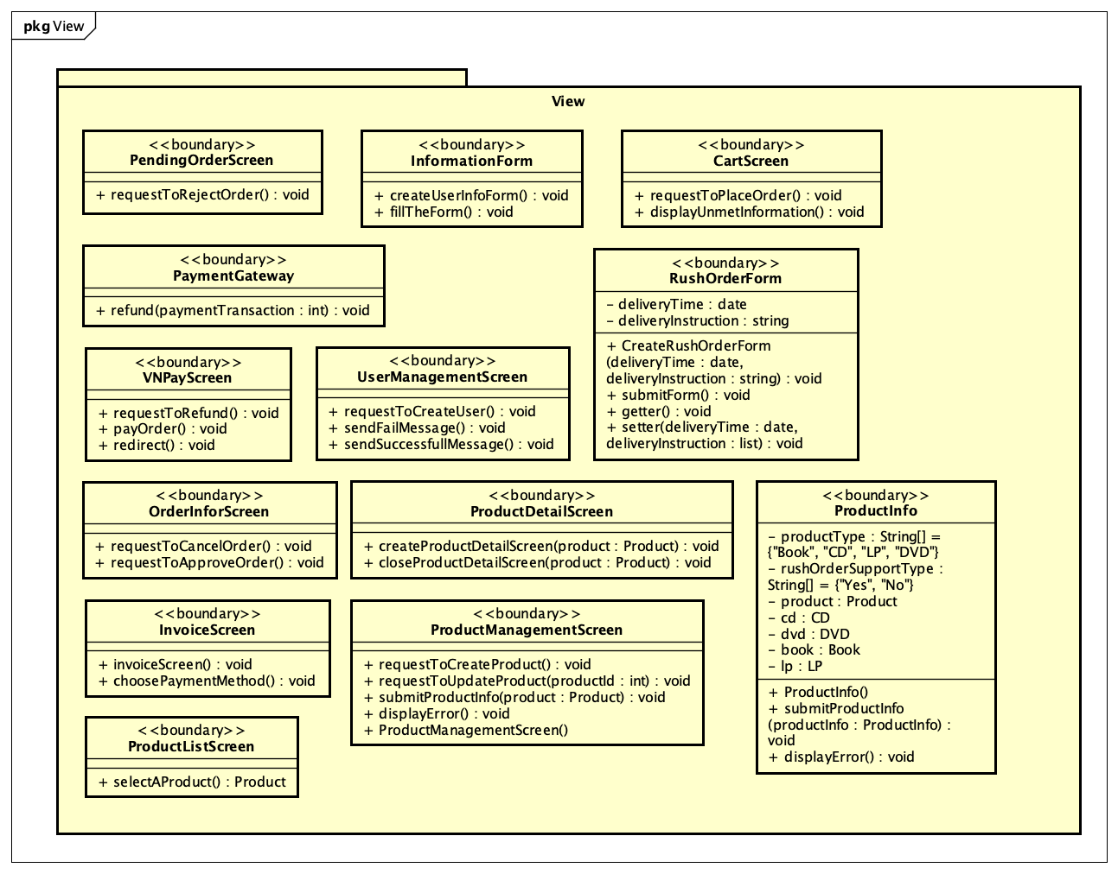

## Unified Analysis Class Diagram

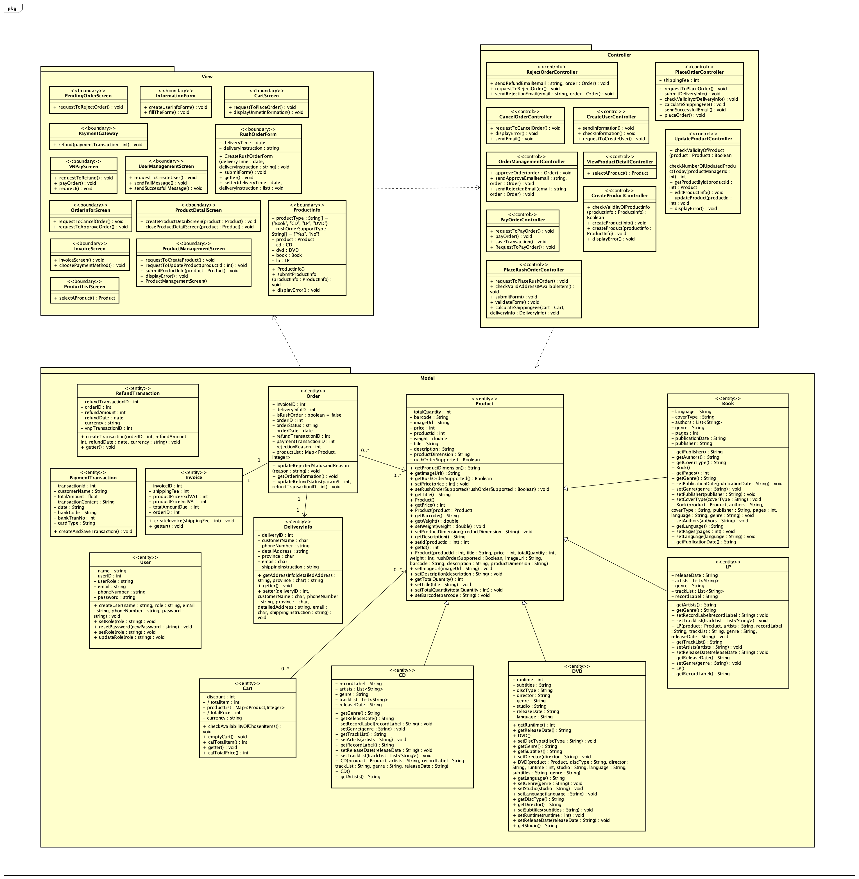

## Security Software Architecture

The AIMS system implements a comprehensive security architecture based on JSON Web Token authentication and role-based access control to protect sensitive business data and ensure secure user access.

The system employs stateless JWT-based authentication to validate user identity. Users submit credentials through secure login endpoints where passwords are verified against BCrypt-hashed values stored in the database. Upon successful authentication, the system generates cryptographically signed tokens using HMAC SHA-256 algorithms with 24-hour expiration periods. The authentication mechanism includes token blacklisting for secure logout functionality, preventing reuse of invalidated tokens even before natural expiration.

A role-based access control system governs user permissions throughout the application. Users are assigned hierarchical roles including basic customer access, product management privileges, and administrative functions. Authorization decisions are made in real-time by extracting user roles from JWT tokens and validating permissions against requested resources. This ensures users can only access functions appropriate to their organizational responsibilities.

Multiple encryption layers protect sensitive information both at rest and in transit. User passwords utilize BCrypt hashing with salt generation to prevent rainbow table attacks. JWT tokens are digitally signed using secure key generation and management practices. The system enforces password complexity requirements and supports secure communication protocols with properly configured cross-origin resource sharing policies.

The security framework includes comprehensive logging for authentication events and security activities. All login attempts, token validations, and access violations are recorded with detailed context information. The audit system captures both successful and failed security events, providing visibility into system access patterns and supporting forensic analysis of potential security incidents. Error conditions and security exceptions are logged with sufficient detail for troubleshooting while protecting sensitive information exposure.

# Detailed Design

## User Interface Design

### Screen Configuration Standardization

The AIMS frontend user interface follows to Material Design principles, providing a responsive and consistent experience across devices. It supports 24-bit color and is optimized for multiple screen sizes, from mobile (320px) to desktop (1920px+), utilizing standardized breakpoints (xs, sm, md, lg, xl). UI elements such as buttons, typography, and cards are consistently styled using the MUI theming system, with a focus on responsive typography, spacing, and touch-friendly controls.

The layout ensures consistency in header/footer positioning, screen titles, and alphanumeric formatting. The header includes a logo, search bar, and user/cart icons, all adapting to screen size. Product cards feature hover animations and responsive images, while the grid system adapts layouts from 1 to 4 columns depending on the breakpoint.

Error messages follow a visual standard with red tones, clear iconography, and pop-up display. Accessibility is well-supported through ARIA labels, focus indicators, and keyboard interactions (Tab, Enter, Escape). Although mobile navigation is not fully implemented, foundational standards for interaction (hover, transitions, focus management) and loading states (skeletons, spinners) are in place.

### Screen Transition Diagrams

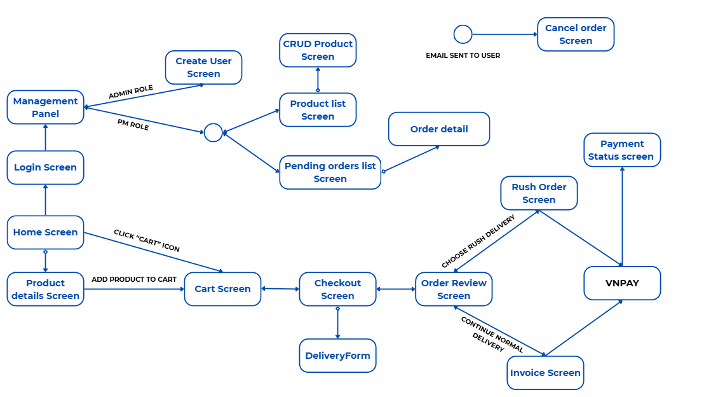

### Screen Specifications

#### Home screen

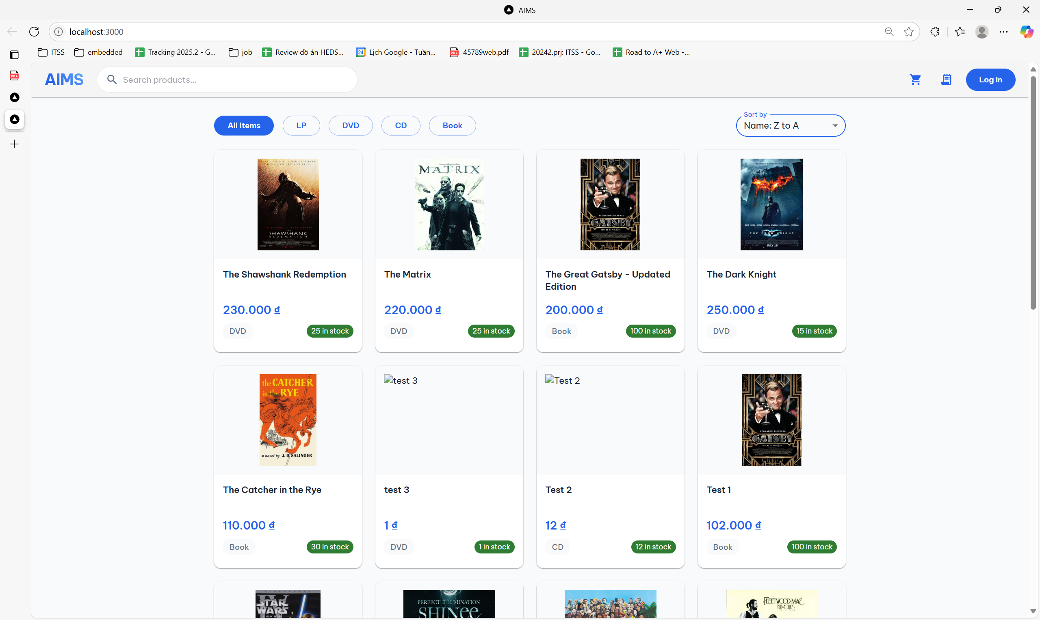

|  |  |  |
| --- | --- | --- |
| **Control** | **Operation** | **Function** |
| Search bar (top left) | Type keywords, press Enter | Search for products by title |
| Category filter buttons (All, DVD…) | Click | Filter products by predefined categories (e.g., DVD, Book) |
| Sort dropdown (top right - “Name ↑, v.v”) | Select from dropdown | Sort products by name or price in ascending/descending order |
| Product card | Click on card | View product details |
| Cart | Click | Navigate to cart screen |
| Login button (top right) | Click | Navigate to login screen |

#### Product details screen

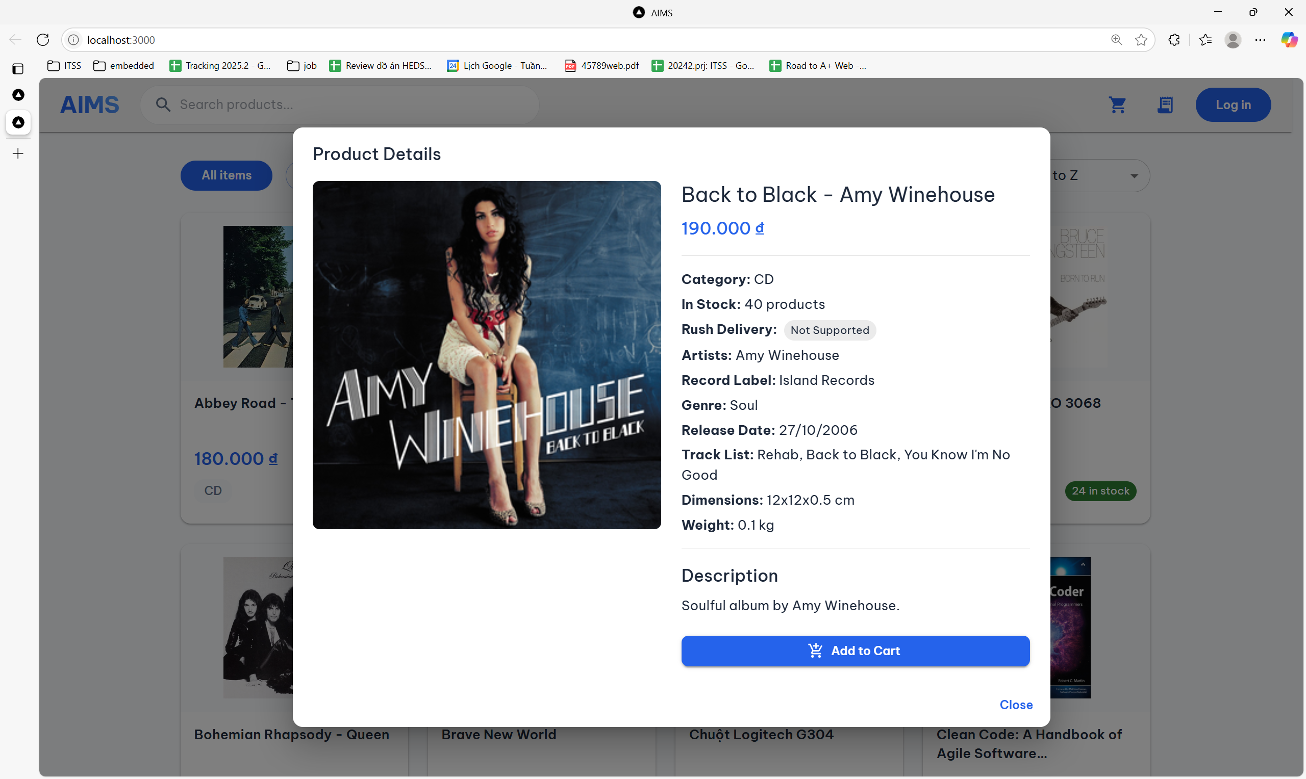

|  |  |  |
| --- | --- | --- |
| **Control** | **Operation** | **Function** |
| "Add to cart" button (green) | Click | Add product to shopping cart |
| Close buttob | Click | Exit from product details screen |

#### Cart screen

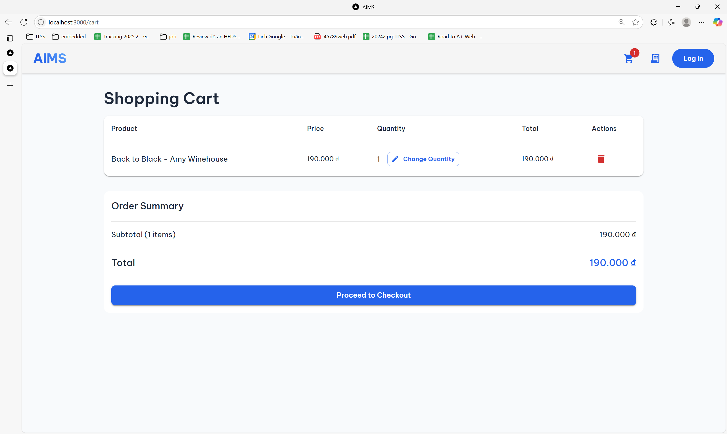

|  |  |  |
| --- | --- | --- |
| **Control** | **Operation** | **Function** |
| Change Quantity button | Click | Confirms quantity update and recalculates the item total |
| Trash icon | Click | Removes the selected item from the shopping cart |
| Proceed to Checkout | Click | Navigates to the checkout screen for payment and order confirmation |

#### Checkout screen

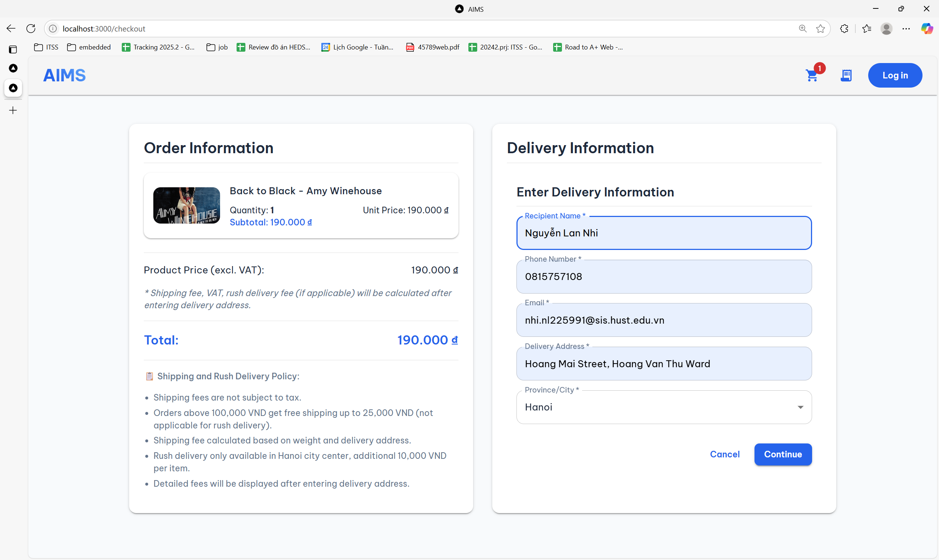

|  |  |  |
| --- | --- | --- |
| **Control** | **Operation** | **Function** |
| Recipient Name field | Type text | Enter the full name of the delivery recipient |
| Phone Number field | Type numbers | Provide a valid contact number for the recipient |
| Email field | Type email | Enter the email address for confirmation and communication |
| Delivery Address field | Type address text | Specify the street, ward, etc., where the product should be delivered |
| Province/City dropdown | Select from list | Choose the delivery city to calculate shipping and check rush availability |
| Cancel button | Click | Discard the form and return to the previous screen |
| Continue button | Click | Submit delivery information and proceed to shipping/payment phase |
| Product summary card | View only | Display product name, unit price, and quantity |
| Payment details section | View only | Show product total, VAT total, shipping fee, and final total |

#### Order Review Screen

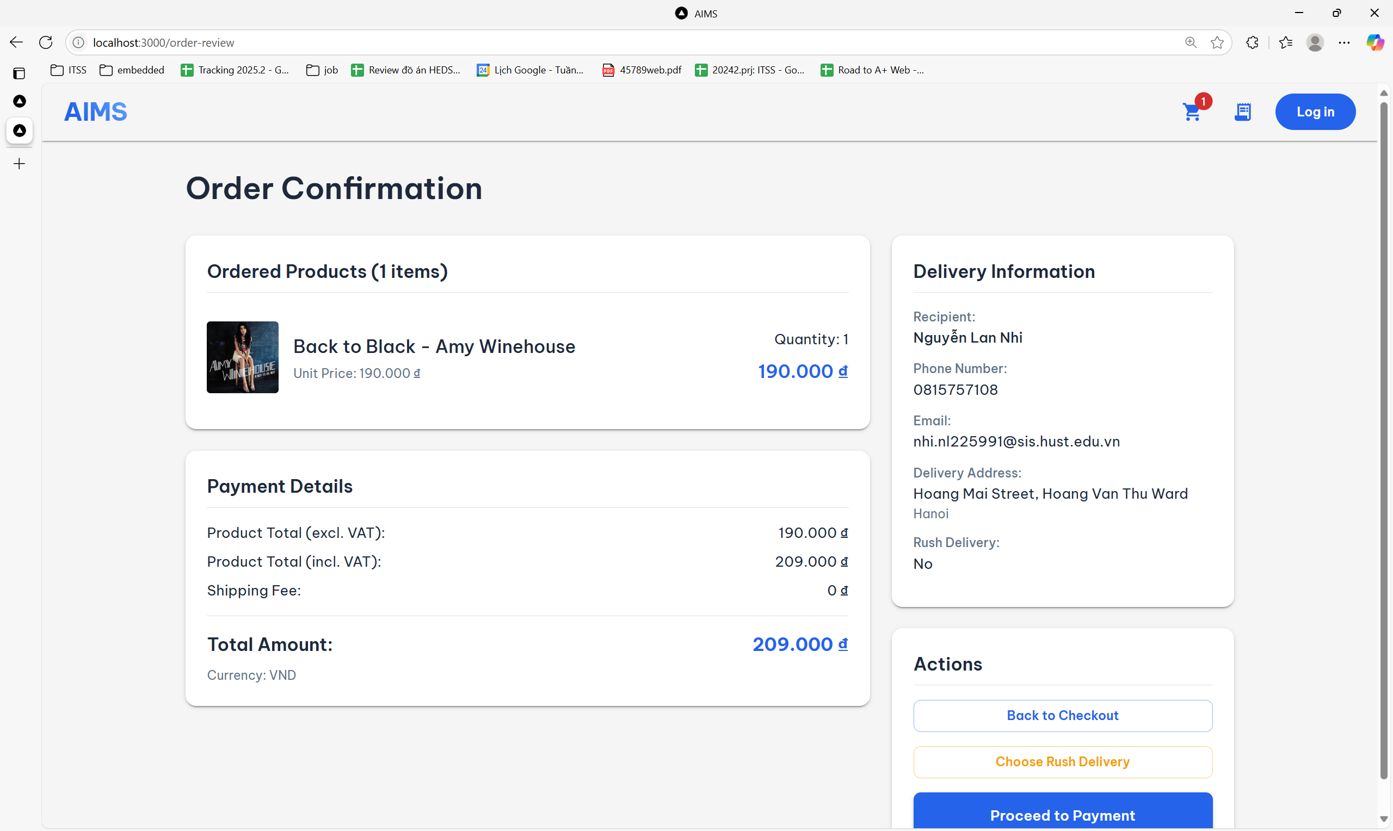

|  |  |  |
| --- | --- | --- |
| **Control** | **Operation** | **Function** |
| Product summary card | View only | Display product name, unit price, and quantity |
| Payment details section | View only | Show product total, VAT total, shipping fee, and final total |
| Delivery information box | View only | Display recipient name, phone, email, address, and rush delivery status |
| Back to Checkout button | Click | Return to the previous screen to modify delivery information |
| Choose Rush Delivery button | Click | Enable rush delivery option and recalculate fees |
| Proceed to Payment button | Click | Confirm order and proceed to invoice screen |

#### Choose Rush Order Screen

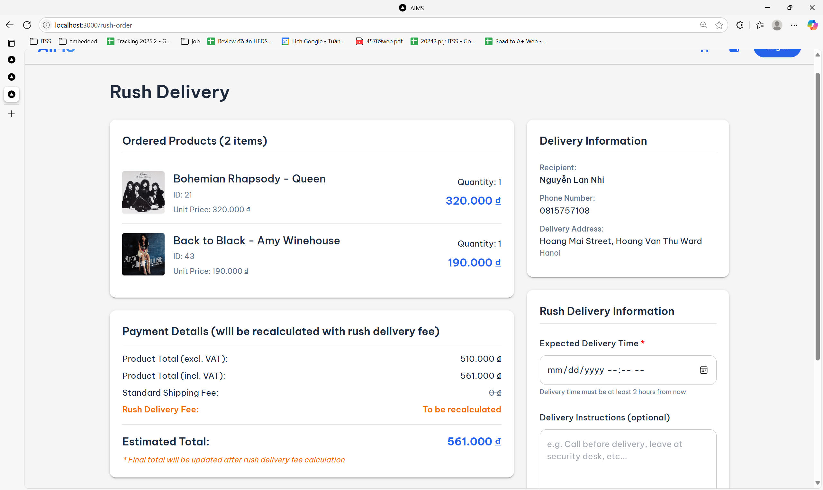

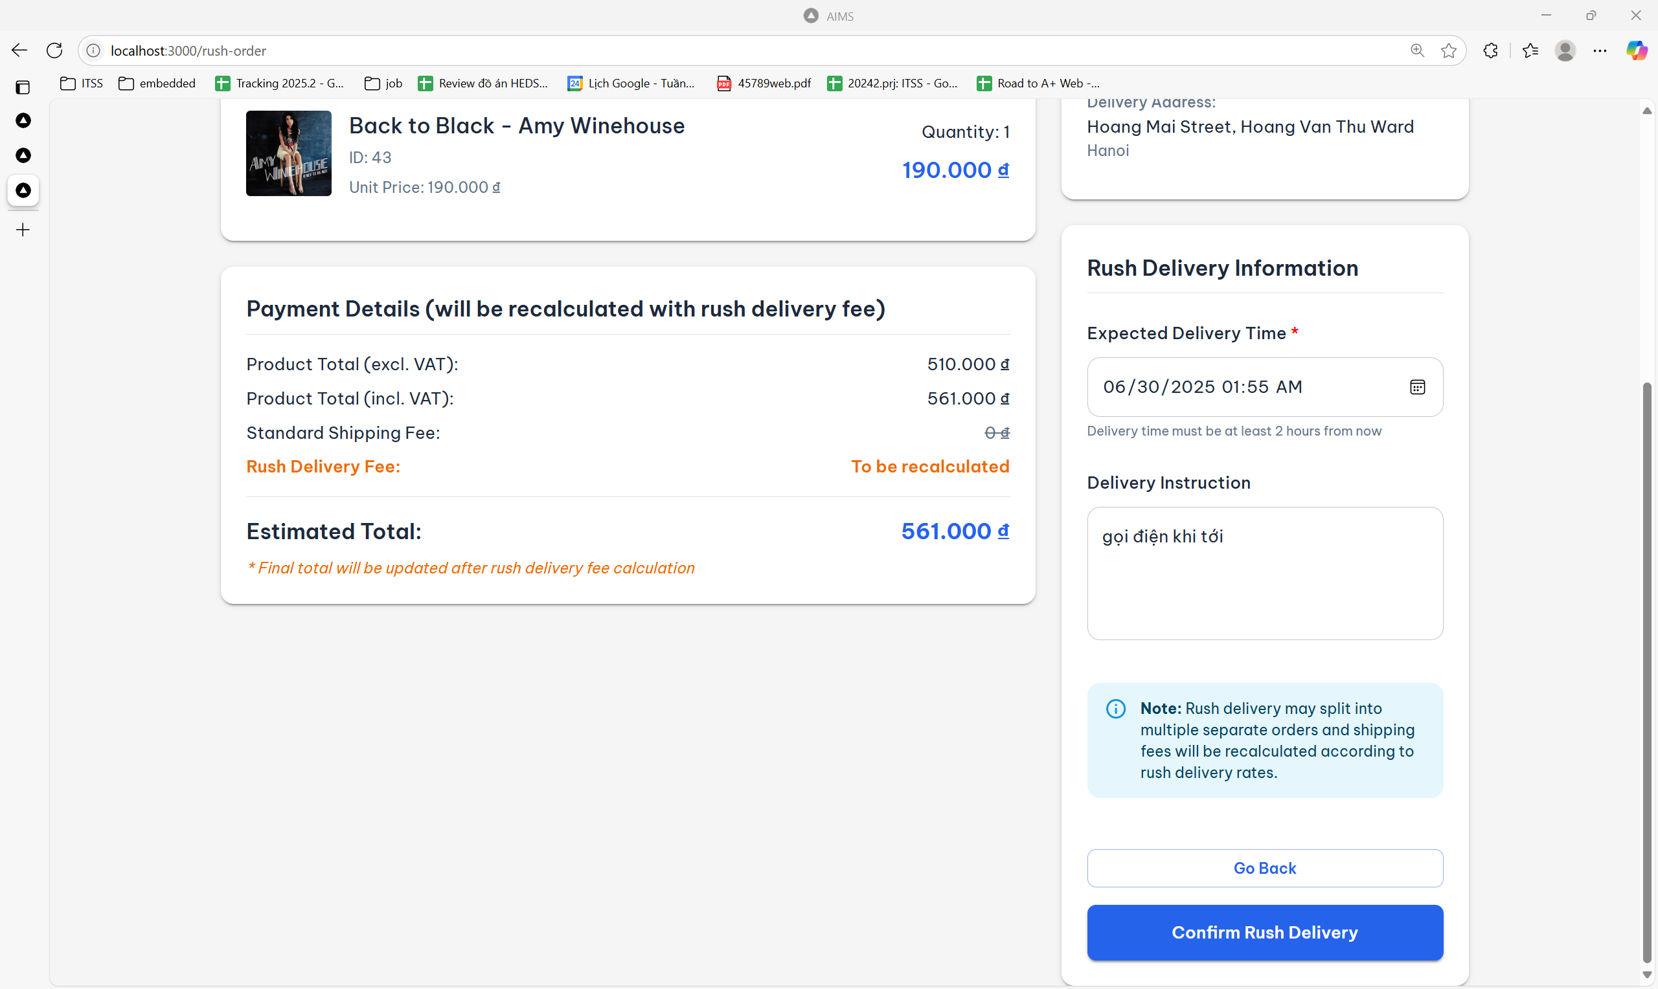

|  |  |  |
| --- | --- | --- |
| **Control** | **Operation** | **Function** |
| Expected Delivery Time (date picker) | Select from calendar | Choose the preferred time for rush delivery (must be at least 2 hours from now) |
| Delivery Instruction (text area) | Type optional message | Provide custom instructions for the delivery (e.g., call before delivery) |
| Ordered Products list | View only | Display product name, ID, unit price, and quantity |
| Payment Details section | View only | Show item subtotal, VAT, standard and rush shipping (dynamic) |
| Go Back button | Click | Return to the previous screen (order review or checkout) |
| Confirm Rush Delivery button | Click | Submit rush delivery info and trigger shipping fee recalculation, and redirect to invoice screen |
| Delivery information box | View only | Display recipient name, phone, email, address |

#### Invoice Screen

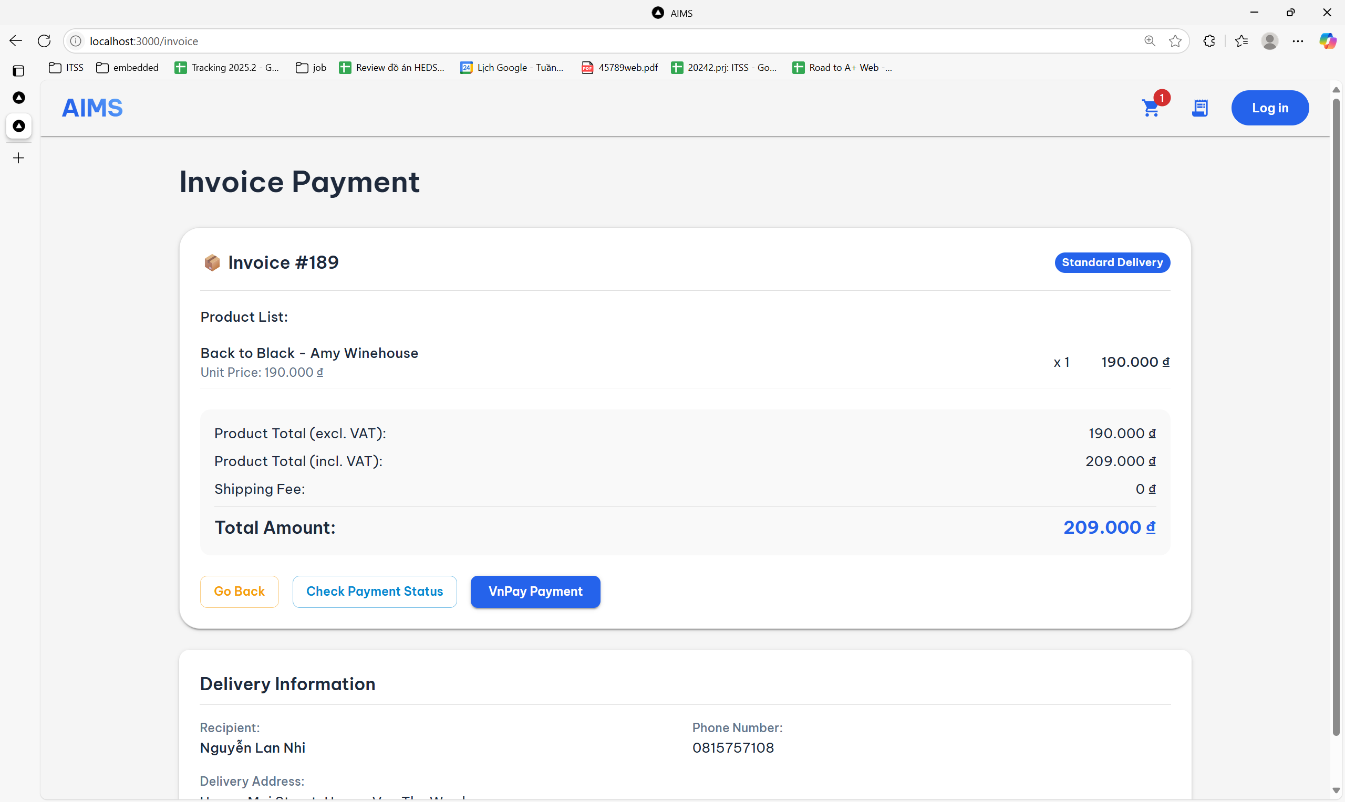

|  |  |  |
| --- | --- | --- |
| **Control** | **Operation** | **Function** |
| Invoice summary panel | View only | Display invoice ID, delivery type, expected delivery time |
| Product List section | View only | Show items included in the invoice (or message if empty) |
| Payment breakdown section | View only | Show subtotal, VAT total, shipping fee, and total amount |
| Go Back button | Click | Navigate back to the previous screen or order list |
| Check Payment Status button | Click | Check whether payment for the invoice has been successfully completed |
| VnPay Payment button | Click | Initiate payment via VNPay gateway for the selected invoice |
| Delivery information box | View only | Display recipient name, phone, email, address |

#### VNPAY screen

#### Payment Status screen

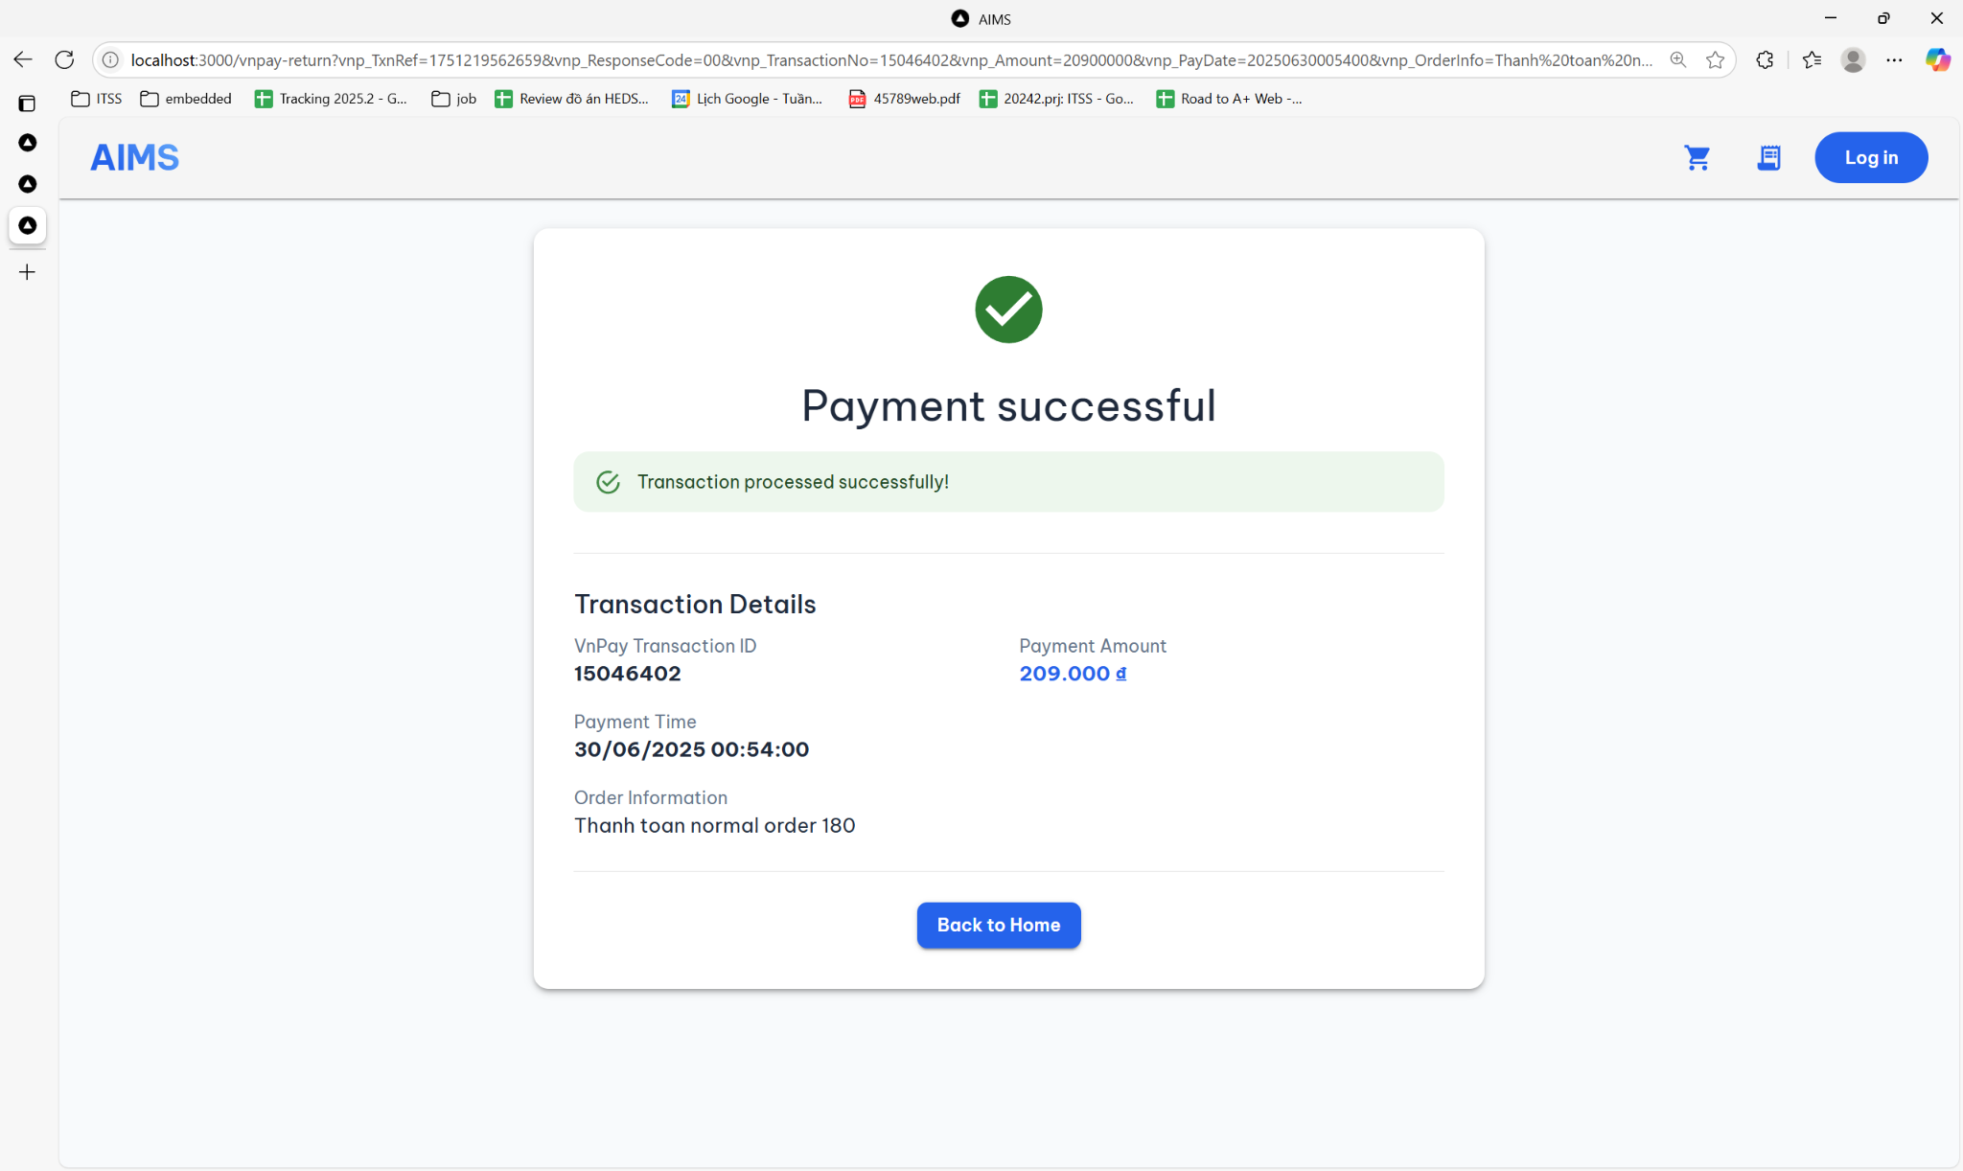

|  |  |  |
| --- | --- | --- |
| **Control** | **Operation** | **Function** |
| Transaction message box | View only | Displays confirmation message that the payment was successful |
| Transaction details section | View only | Shows transaction ID, amount, timestamp, and related order information |
| Back to Home button | Click | Redirects user to the home page after successful payment |

#### Login screen

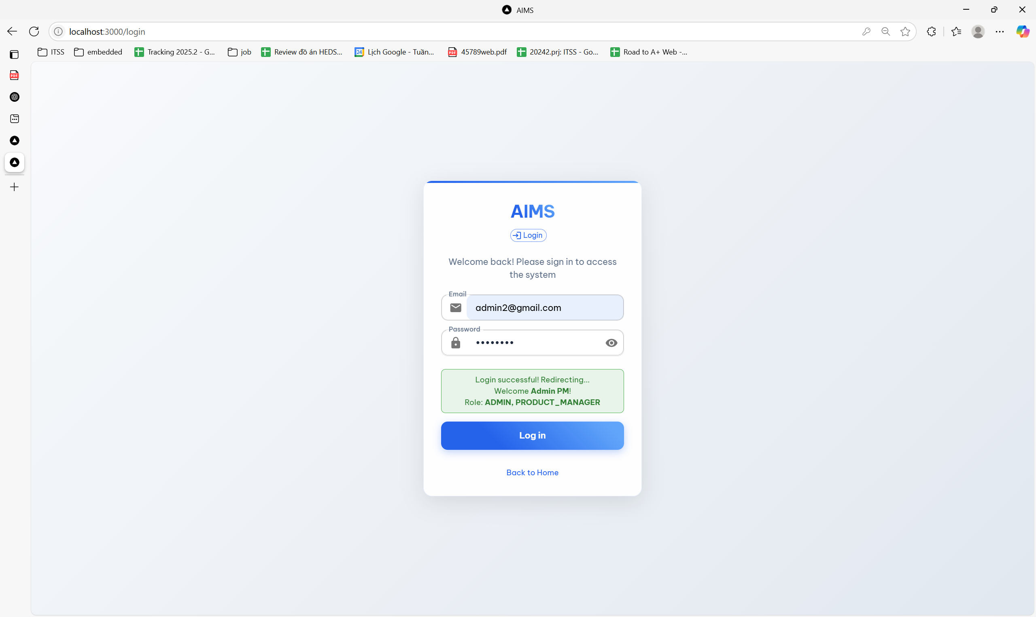

|  |  |  |
| --- | --- | --- |
| **Control** | **Operation** | **Function** |
| Email input field | Type email | Enter user's email address to authenticate |
| Password input field | Type password | Enter the password; obscured by default |
| Show/Hide icon (eye) | Click | Toggle visibility of the password field |
| Log in button | Click | Submit credentials to authenticate user and log in |
| Login message box | View only | Display success or error message after login attempt |
| Back to Home link | Click | Navigate back to the homepage |

#### Management Panel

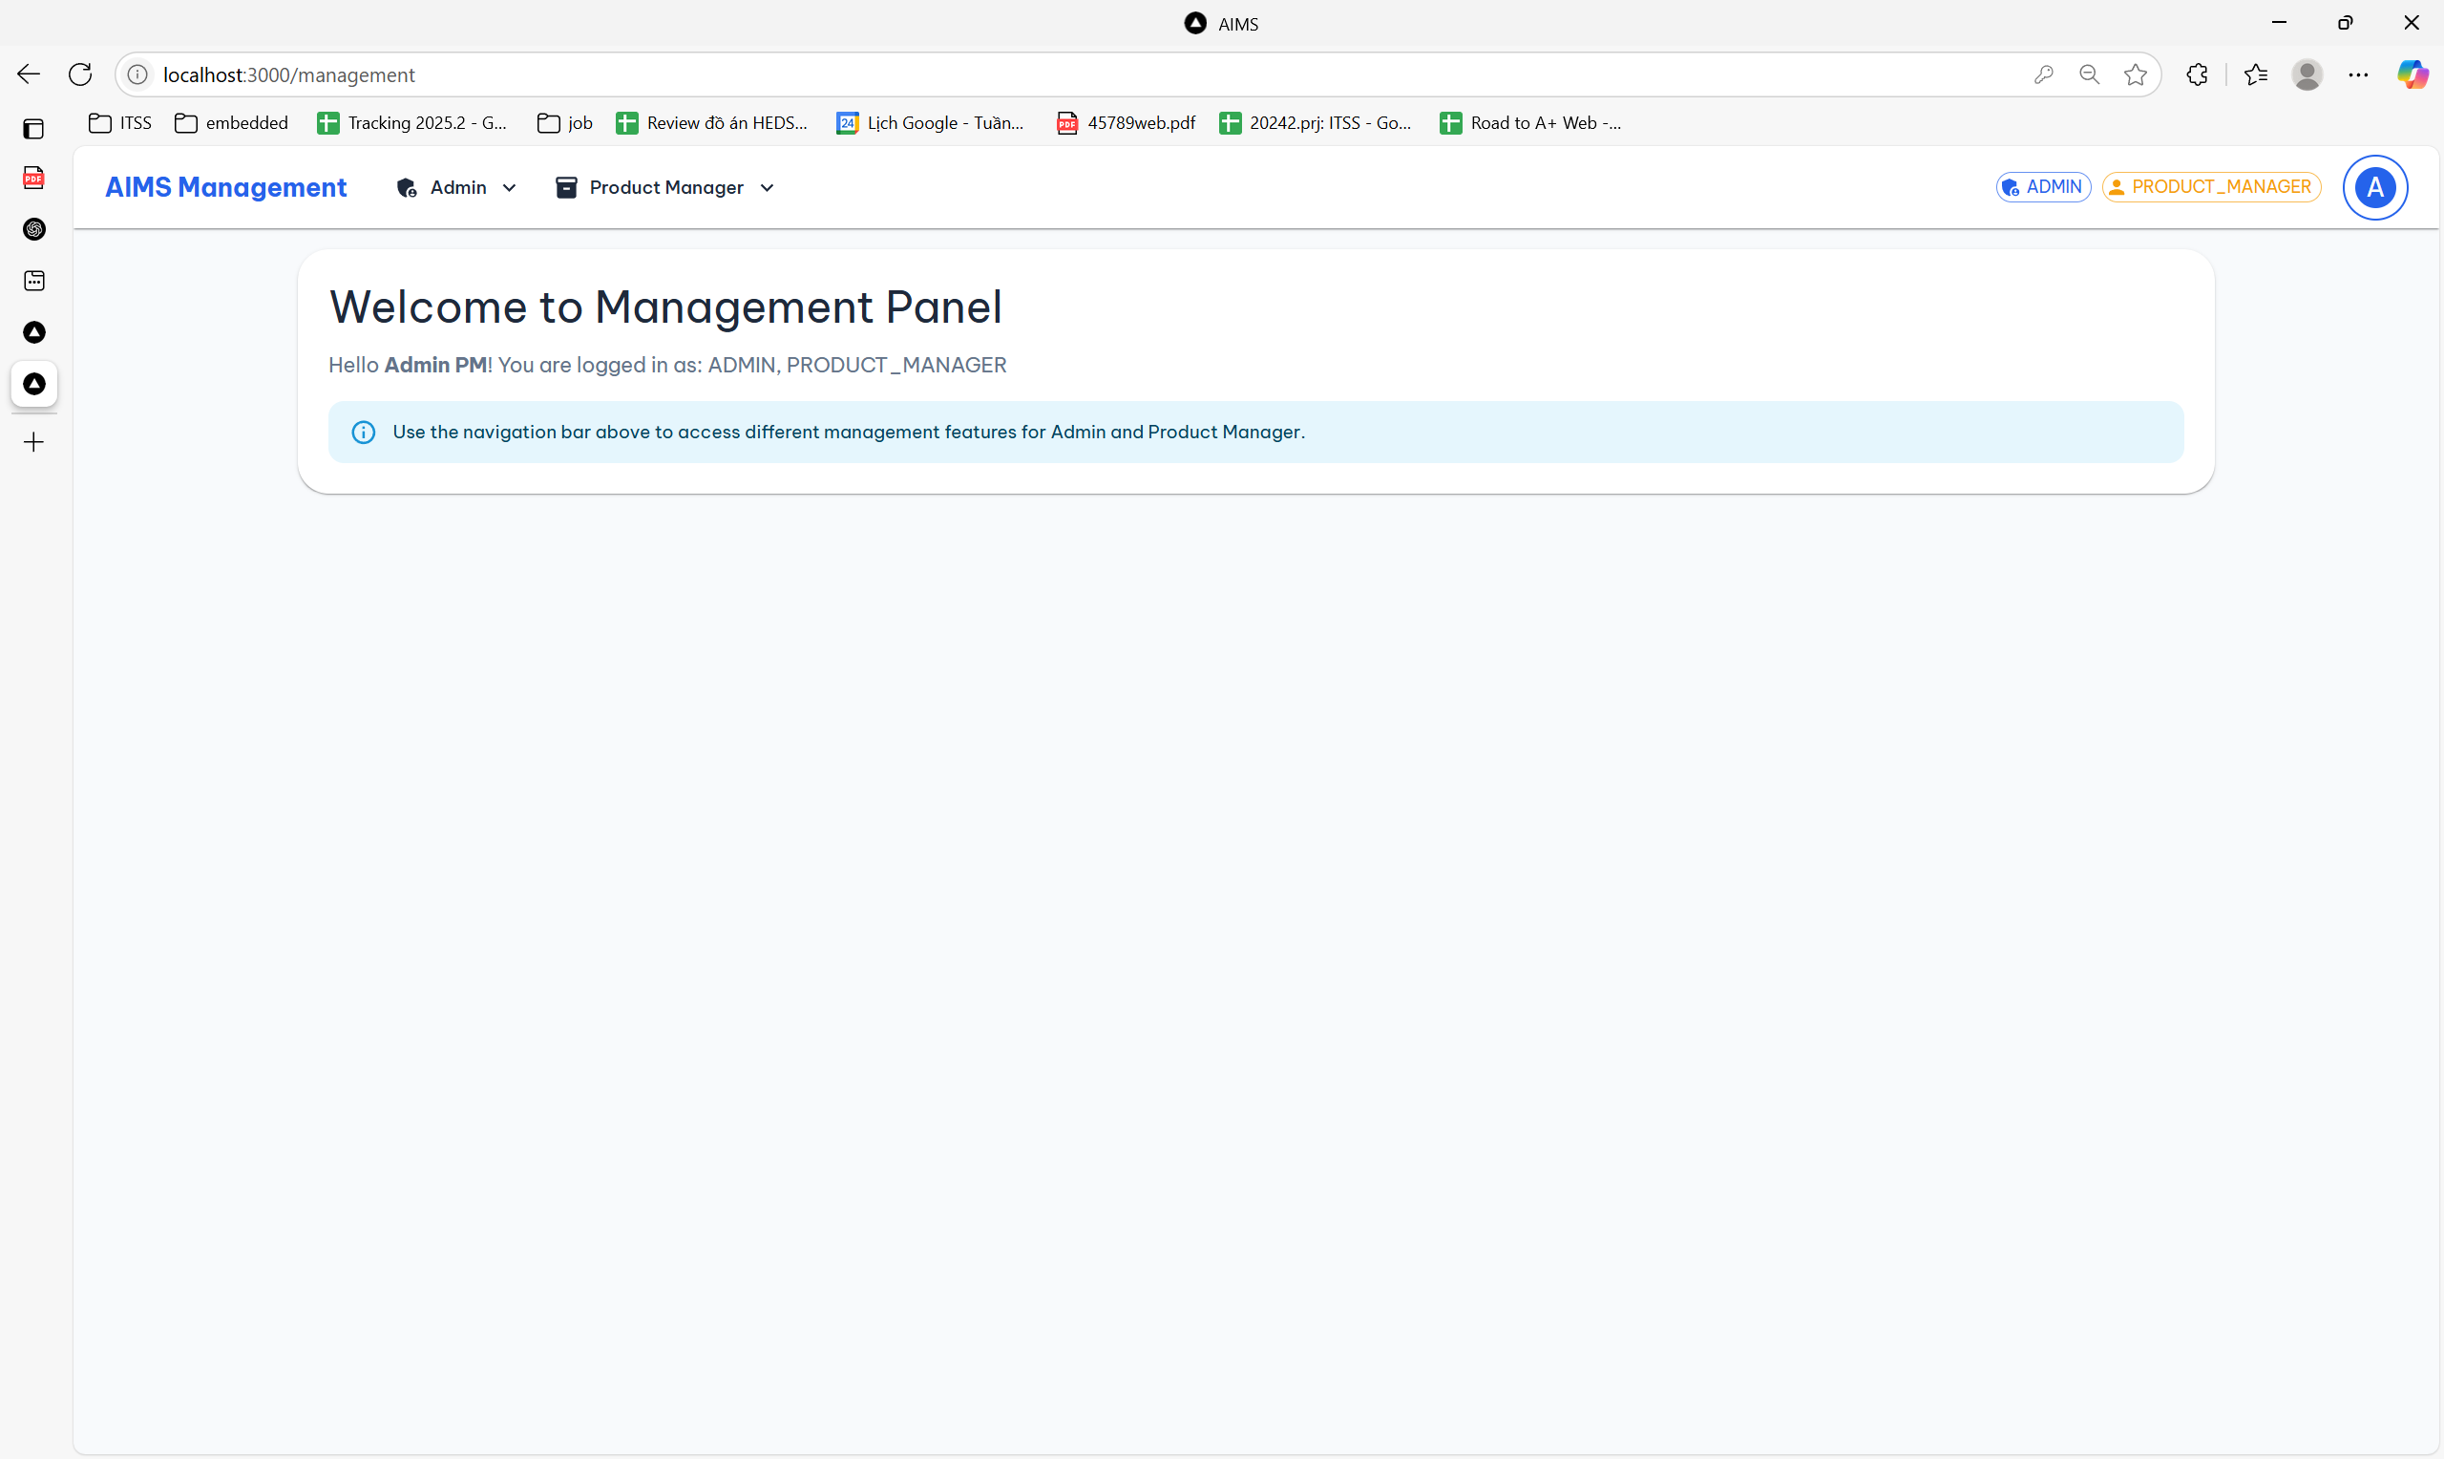

|  |  |  |
| --- | --- | --- |
| **Control** | **Operation** | **Function** |
| Role tags (ADMIN, PRODUCT_MANAGER) | View only | Display the roles currently assigned to the logged-in user |
| Admin dropdown menu | Click | Access management options specific to the Admin role |
| Product Manager dropdown menu | Click | Access management features related to product handling |
| Welcome message panel | View only | Display greeting and current login role |
| Info notice bar | View only | Provide usage instruction for accessing management functions |

#### Create User (Admin screen)

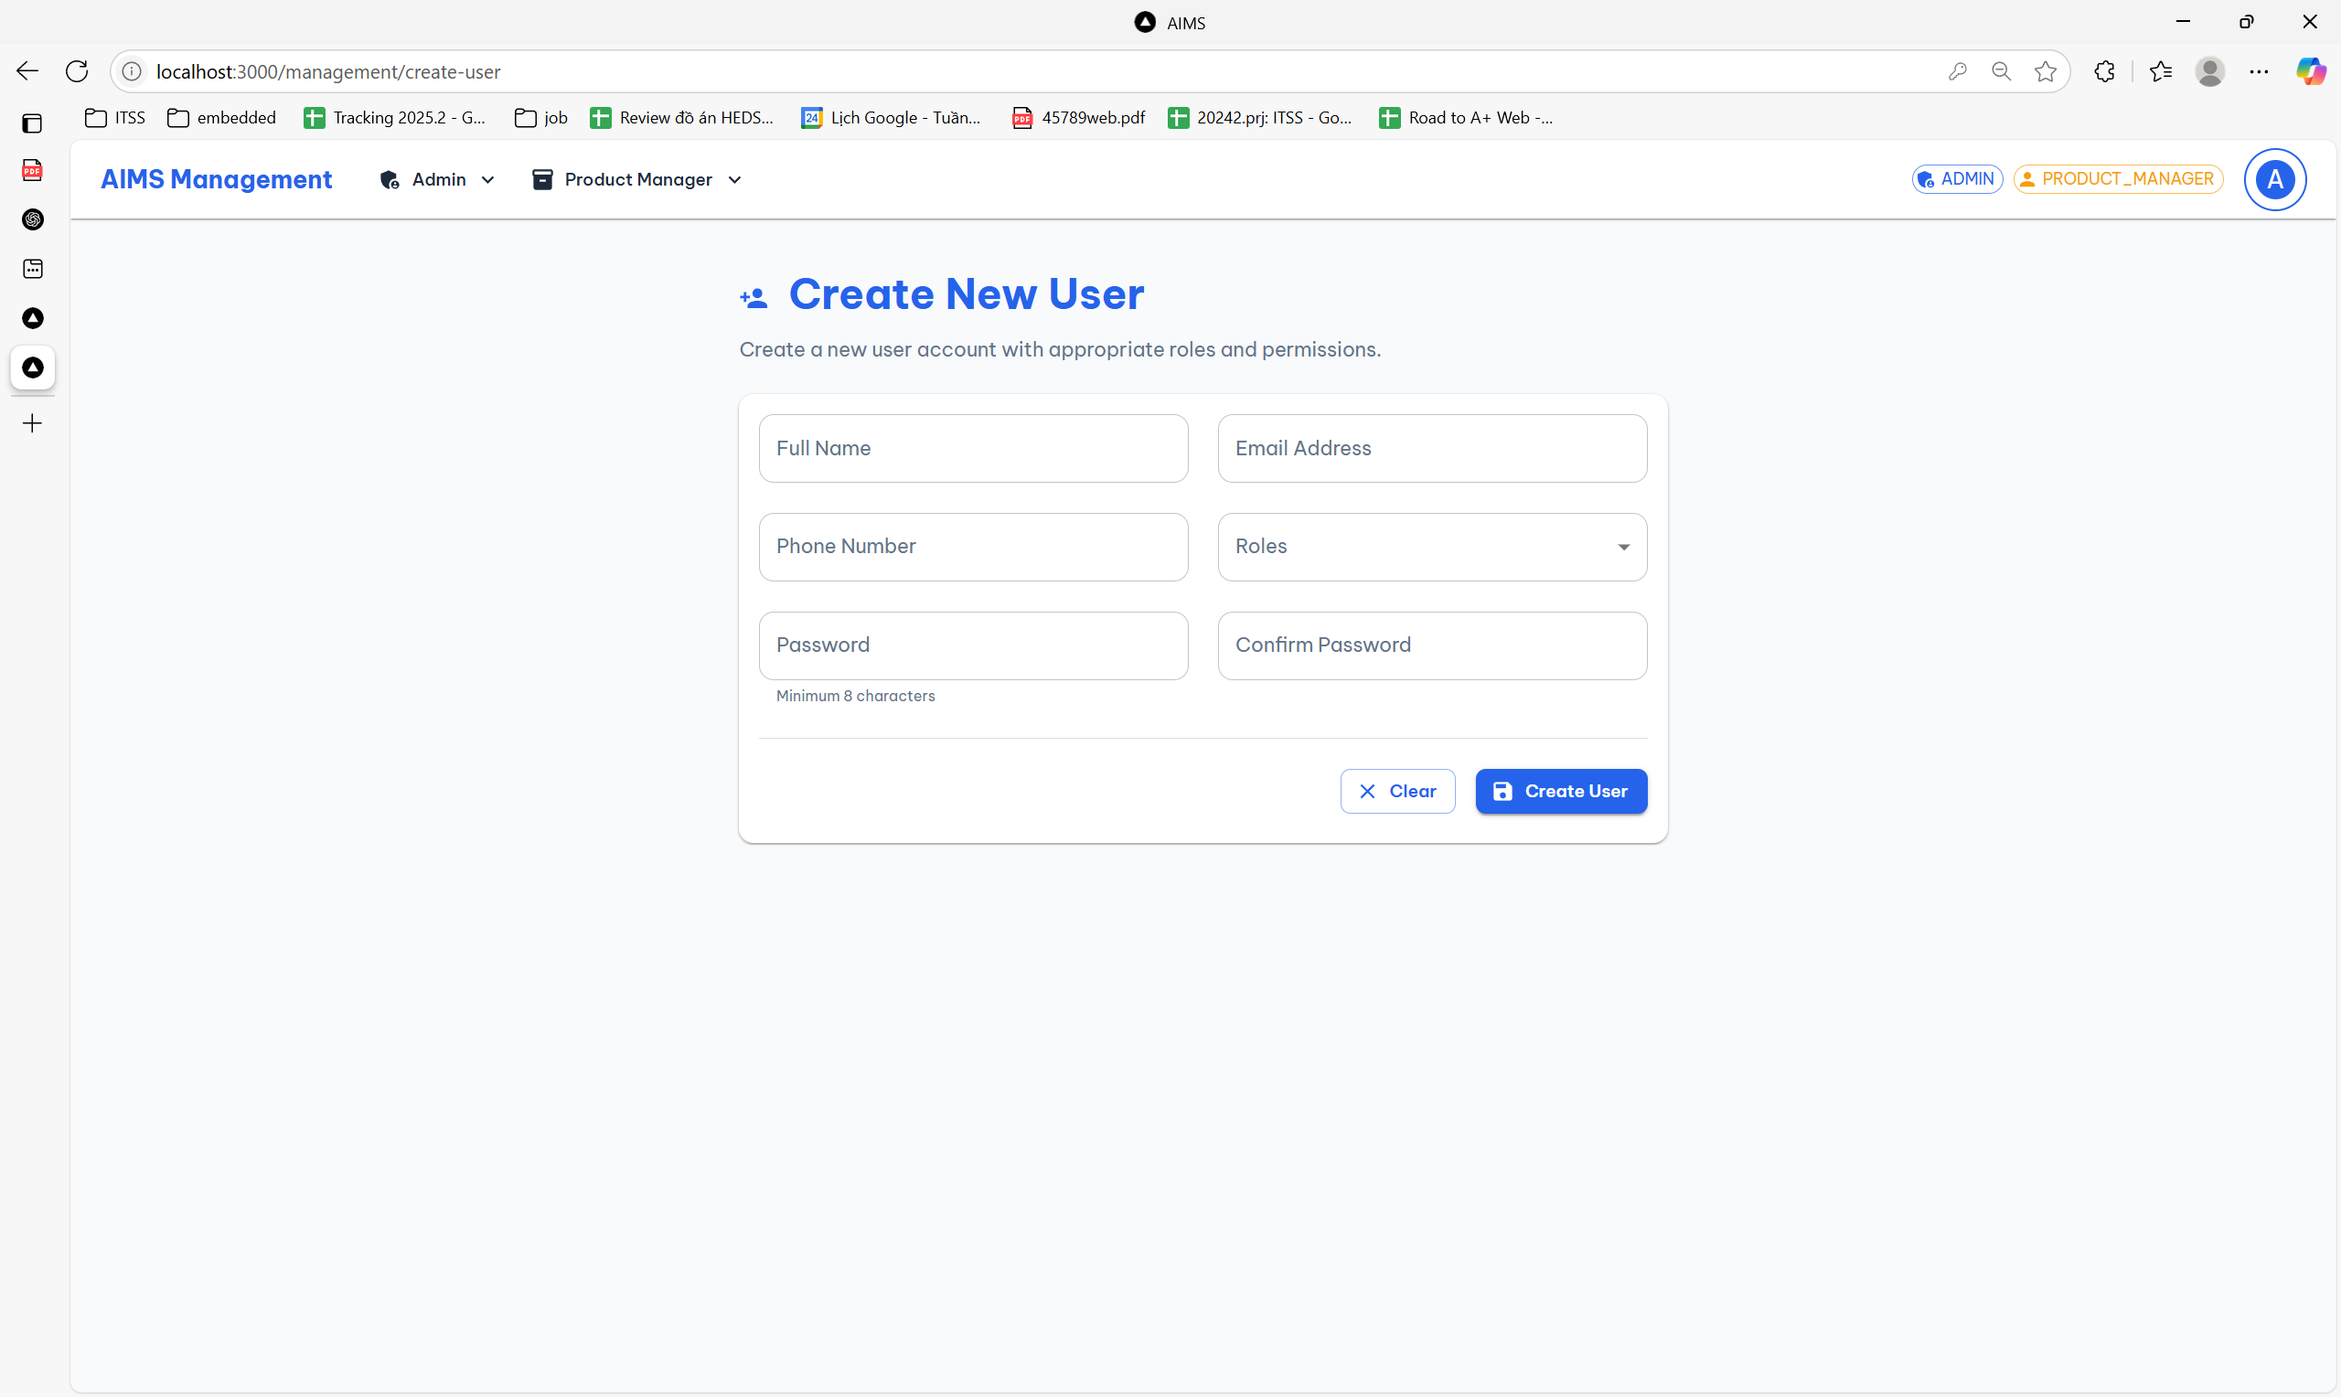

|  |  |  |
| --- | --- | --- |
| **Control** | **Operation** | **Function** |
| Full Name input | Type text | Enter the full name of the new user |
| Email Address input | Type email | Enter the new user’s email address |
| Phone Number input | Type numbers | Enter the new user’s contact phone number |
| Roles dropdown | Select from list | Assign roles to the user (e.g., Admin, Product Manager) |
| Password input | Type password | Set a password for the new account (min. 8 characters) |
| Confirm Password input | Type password | Re-enter password to confirm correctness |
| Clear button | Click | Reset all form fields to blank |
| Create User button | Click | Submit the form to create a new user account with entered credentials |

#### Products list screen

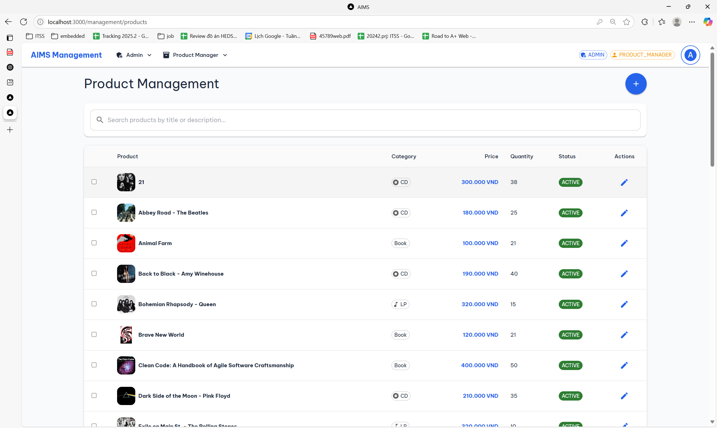

|  |  |  |
| --- | --- | --- |
| **Control** | **Operation** | **Function** |
| Search bar | Type & press Enter | Search products by title or description |
| Product checkbox | Click | Select product(s) for batch actions |
| Price (blue text link) | Click | Navigate to product detail or update view (if implemented) |
| Edit icon | Click | Open the product edit form for that specific item |
| Add Product button | Click | Open form to create a new product |
| Category/Price/Status cells | View only | Display product category, pricing, quantity, and active status |

#### CRUD Product screen

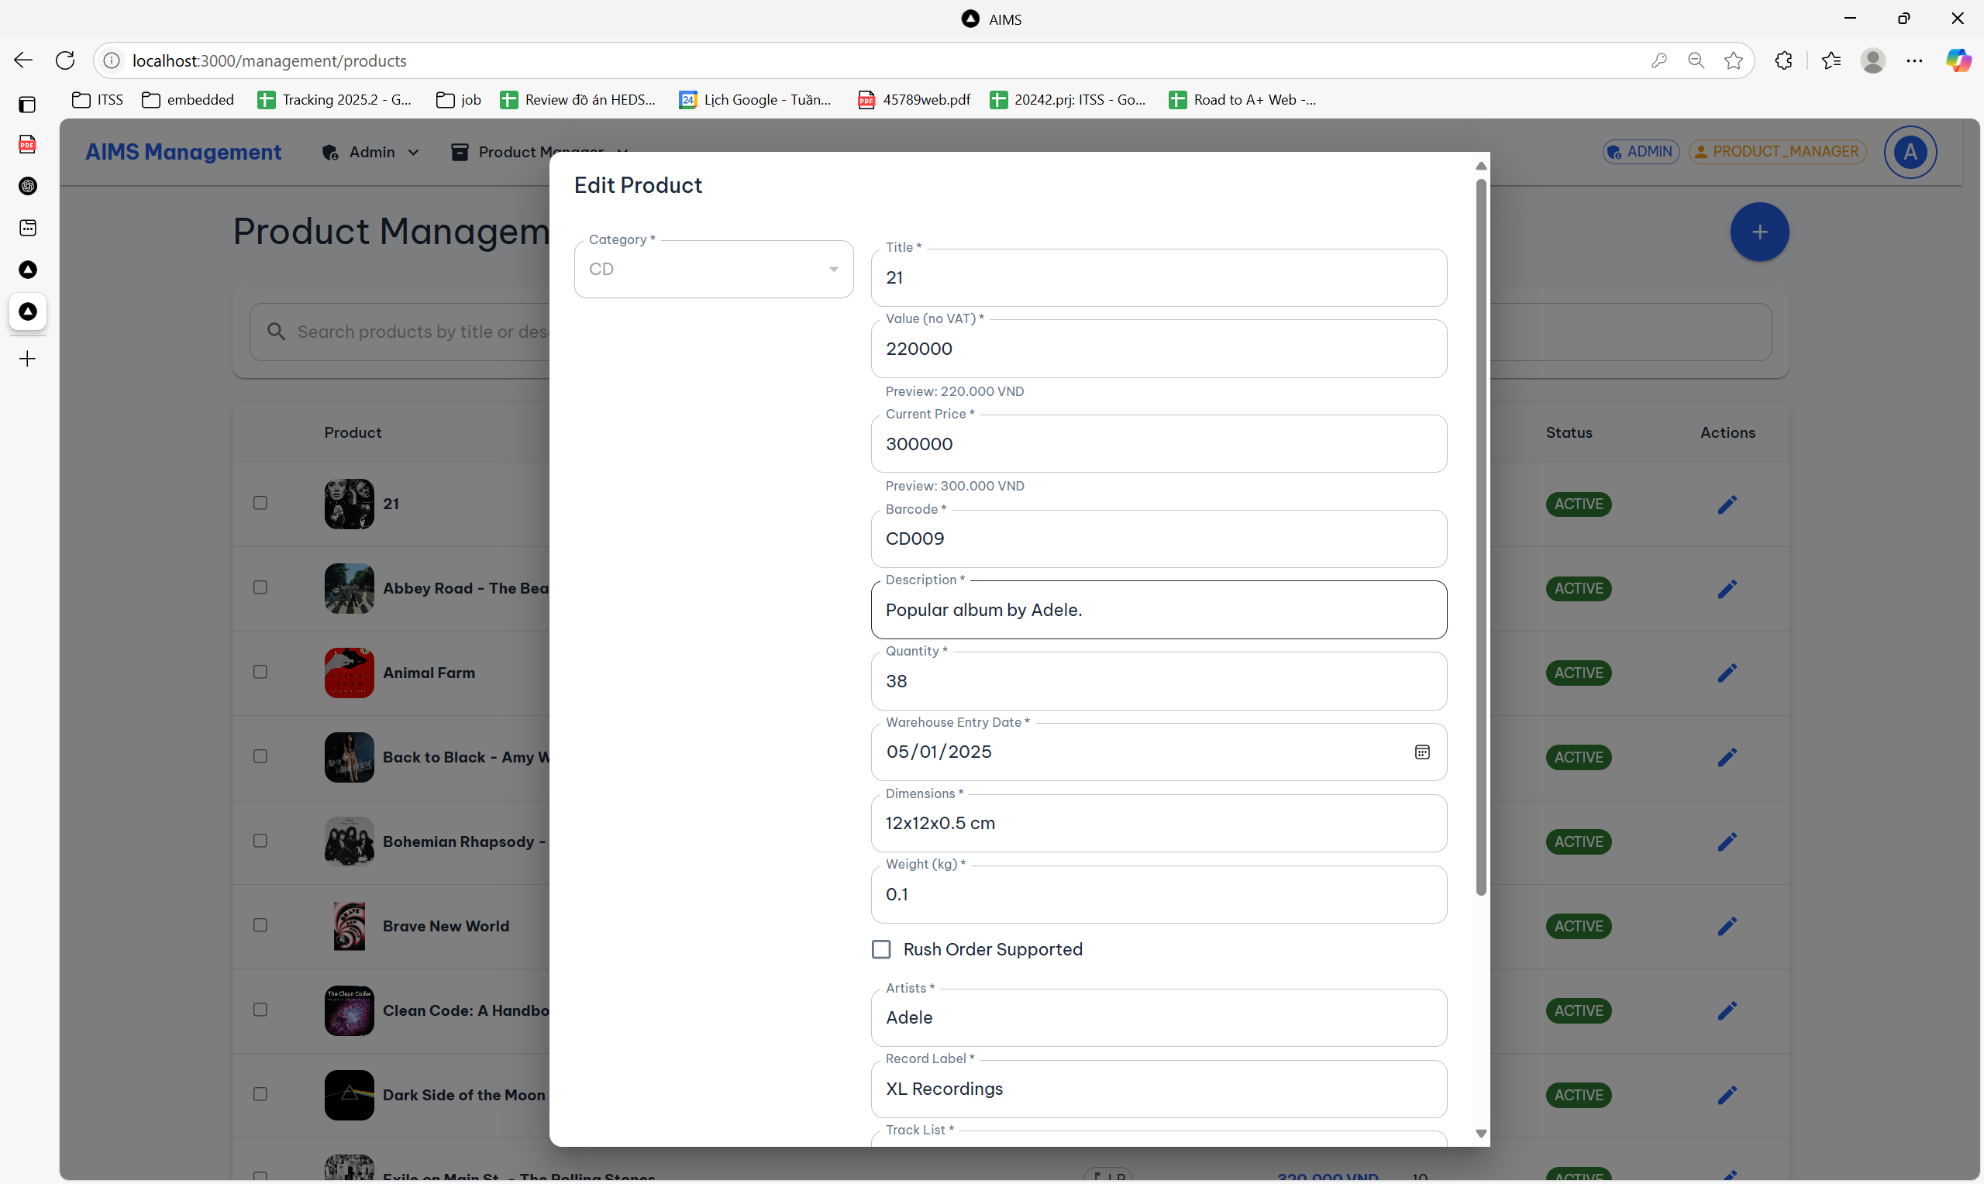

|  |  |  |
| --- | --- | --- |
| **Control** | **Operation** | **Function** |
| Category dropdown | Select from list | Choose the product’s category (e.g., CD, Book, LP) |
| Product’s attributes input | Text/number/upload files/tick | Edit/Add product’s attributes |
| Update button | Click | Save changes |
| Cancel button | Click | Cancel create/edit product |

#### Pending order list screen

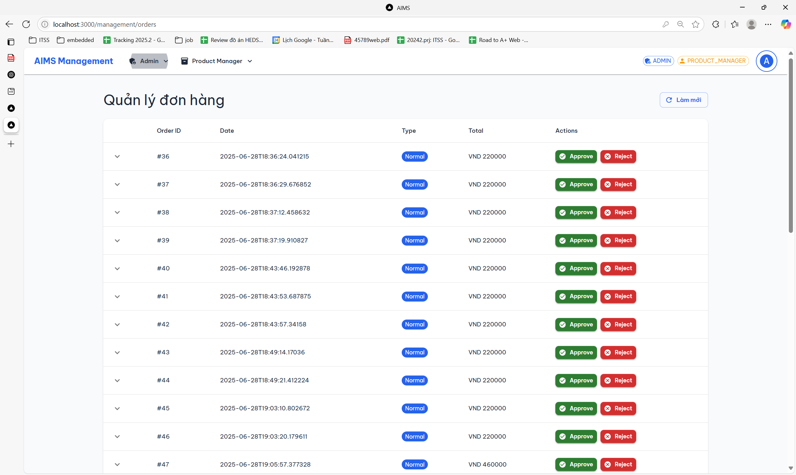

|  |  |  |
| --- | --- | --- |
| **Control** | **Operation** | **Function** |
| Expand/collapse arrow (▾) | Click | Show or hide detailed information of a specific order |
| Order information | View only | Show basic order information |
| Approve button (green) | Click | Approve the order and change its status accordingly |
| Reject button (red) | Click | Reject the order and remove it from approval workflow |
| Refresh button | Click | Reload the order list to reflect latest data |

#### Cancel order screen

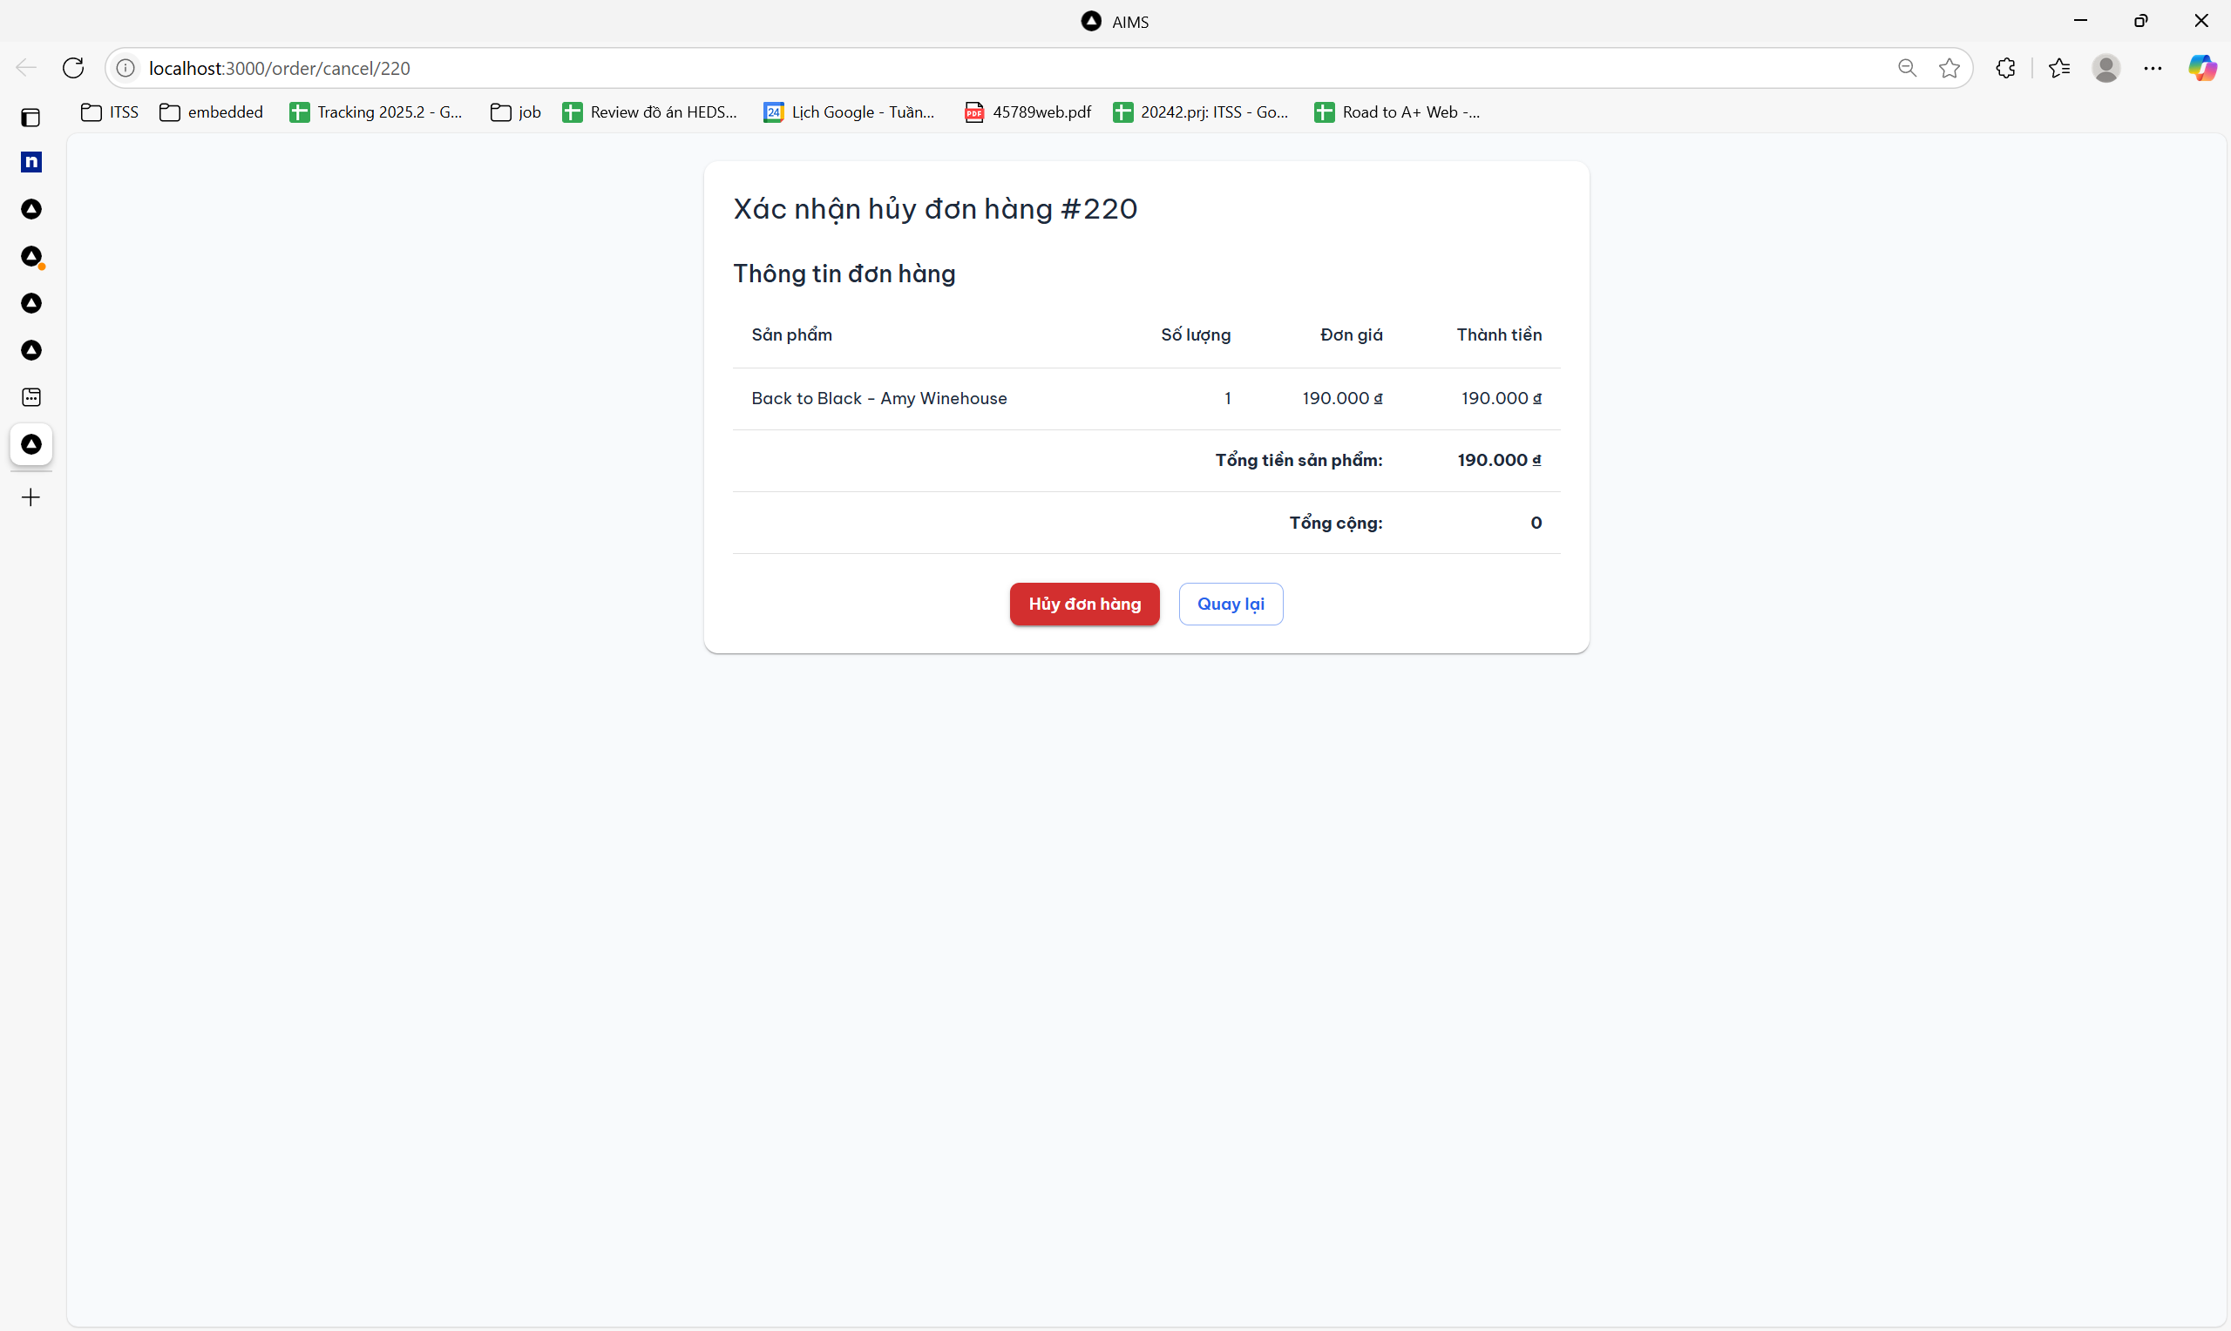

|  |  |  |
| --- | --- | --- |
| **Control** | **Operation** | **Function** |
| Product summary table | View only | Display item(s) in the order including quantity, unit price, and total price |
| Total amount row | View only | Show the total product cost and overall order amount |
| Cancel Order button (red) | Click | Confirm and cancel the order; triggers backend cancellation process |
| Go Back button (blue) | Click | Return to the previous screen without performing cancellation |

## Data Modeling

### Conceptual Data Modeling



Image 1: AIMS's E-R Diagram

The conceptual data model is represented through the above E-R diagram describing a multimedia e-commerce system. At its core, the Product entity is generalized and specialized into four media types: Book, CD, DVD, and LP. Each subtype inherits from Product and contains additional specific attributes, such as director for DVD or author for Book. Relationships among entities are well-defined using ISA (inheritance) and association connections. For instance, a User can place an Order, which includes one or more OrderItems. Each order is linked to DeliveryInformation, an Invoice, and payment/refund records. Additionally, logs (ProductChecklog) track user interactions with product entries, and a Reservation mechanism simulates a shopping cart before final purchase.

### Database Design

#### Database Management System

PostgreSQL was selected as the database management system due to its popularity and powerful feature set. It offers full ACID compliance, essential for ensuring consistency in financial and transactional operations. PostgreSQL's support for inheritance and complex JOIN operations aligns well with the system’s subclass modeling requirements. Additionally, the DBMS includes advanced indexing, strong typing, and extensive support for procedural SQL (PL/pgSQL), enabling robust backend logic and performance tuning. Its native JSON support can be useful for storing flexible metadata or logs. Overall, PostgreSQL provides the necessary flexibility, scalability, and reliability for this application.

#### Database Diagram

The database design followed a systematic approach. First, requirements were gathered to identify the main entities and their attributes, ensuring that the business needs (such as product type variations and order processing) were clearly understood. Second, a conceptual E-R model was constructed, visualizing all entities and their relationships. In the third phase, this model was translated into a logical schema, carefully applying normalization principles to ensure data integrity and reduce redundancy. Then, physical design steps were taken, including the definition of data types, constraints, indexes, and foreign keys. Finally, the model was implemented and validated against sample scenarios to confirm completeness.

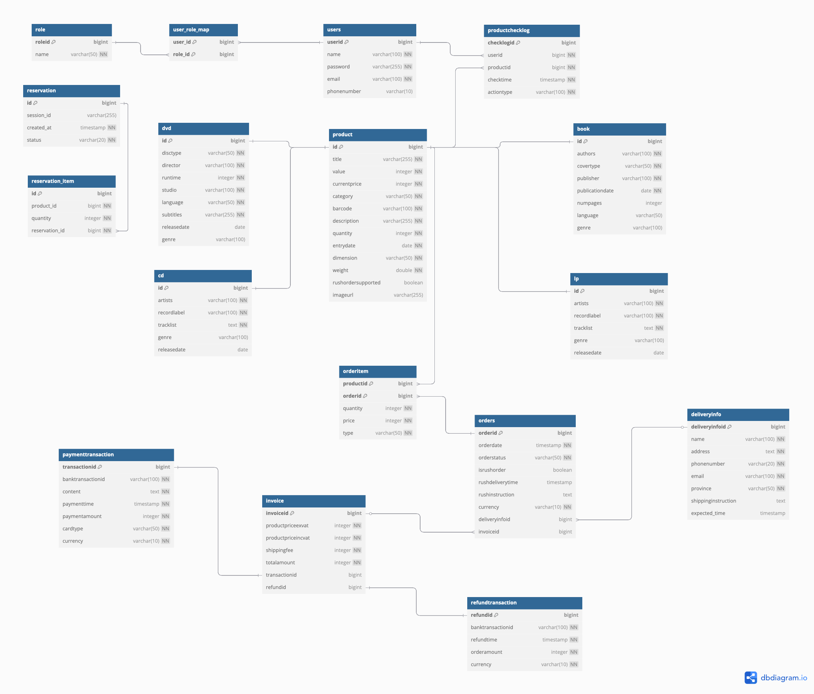

Image 2: AIMS's Relational Schema

#### Database Detail Design

Table 1: Product Table Design

|  |  |  |  |  |  |  |  |
| --- | --- | --- | --- | --- | --- | --- | --- |
| *#* | *PK* | *FK* | *Column name* | *Data type* | *Default value* | *Mandatory* | *Description* |
| 1 | x |  | id | bigint | – | x | Unique product identifier |
| 2 |  |  | title | varchar(255) | – | x | Product title |
| 3 |  |  | value | integer | – | x | Original product value (VND) |
| 4 |  |  | currentprice | integer | – | x | Current selling price (VND) |
| 5 |  |  | category | varchar(50) | – | x | Product category |
| 6 |  |  | barcode | varchar(100) | – | x | Product barcode |
| 7 |  |  | description | varchar(255) | – | x | Product description |
| 8 |  |  | quantity | integer | – | x | Quantity in stock |
| 9 |  |  | entrydate | date | – | x | Date of entry into the system |
| 10 |  |  | dimension | varchar(50) | – | x | Product dimensions |
| 11 |  |  | weight | double | – | x | Product weight (kg) |
| 12 |  |  | rushordersupported | boolean | false |  | Supports rush order or not |
| 13 |  |  | imageurl | varchar(255) | – |  | Image URL of the product |

Table 2: DVD Table Design

|  |  |  |  |  |  |  |  |
| --- | --- | --- | --- | --- | --- | --- | --- |
| # | *PK* | *FK* | *Column name* | *Data type* | *Default value* | *Mandatory* | *Description* |
| 1 | x |  | id | bigint | – | x | DVD identifier |
| 2 |  |  | disctype | varchar(50) | – | x | Type of disc (e.g., DVD, Blu-ray) |
| 3 |  |  | director | varchar(100) | – | x | Film director |
| 4 |  |  | runtime | integer | – | x | Runtime in minutes |
| 5 |  |  | studio | varchar(100) | – | x | Studio or production company |
| 6 |  |  | language | varchar(50) | – | x | Language of the DVD |
| 7 |  |  | subtitles | varchar(255) | – | x | Subtitle languages |
| 8 |  |  | releasedate | date | – | x | Date of release |
| 9 |  |  | genre | varchar(100) | – | x | Genre (e.g., Action, Drama) |

Table 3: CD Table Design

|  |  |  |  |  |  |  |  |
| --- | --- | --- | --- | --- | --- | --- | --- |
| *#* | *PK* | *FK* | *Column name* | *Data type* | *Default value* | *Mandatory* | *Description* |
| 1 | x |  | id | bigint | – | x | CD identifier |
| 2 |  |  | artists | varchar(100) | – | x | Name of artists |
| 3 |  |  | recordlabel | varchar(100) | – | x | Record label or music publisher |
| 4 |  |  | tracklist | text | – | x | List of tracks |
| 5 |  |  | genre | varchar(100) | – | x | Music genre (e.g., Rock, Jazz) |
| 6 |  |  | releasedate | date | – | x | Date of release |

Table 4: Book Table Design

|  |  |  |  |  |  |  |  |
| --- | --- | --- | --- | --- | --- | --- | --- |
| *#* | *PK* | *FK* | *Column name* | *Data type* | *Default value* | *Mandatory* | *Description* |
| 1 | x |  | id | bigint | – | x | Book identifier |
| 2 |  |  | authors | varchar(100) | – | x | Book authors |
| 3 |  |  | covertype | varchar(50) | – | x | Type of cover (hard/soft) |
| 4 |  |  | publisher | varchar(100) | – | x | Publishing company |
| 5 |  |  | publicationdate | date | – | x | Publication date |
| 6 |  |  | numpages | integer | – | x | Number of pages |
| 7 |  |  | language | varchar(50) | – | x | Book language |
| 8 |  |  | genre | varchar(100) | – | x | Book genre |

Table 5: LP Table Design

|  |  |  |  |  |  |  |  |
| --- | --- | --- | --- | --- | --- | --- | --- |
| *#* | *PK* | *FK* | *Column name* | *Data type* | *Default value* | *Mandatory* | *Description* |
| 1 | x |  | id | bigint | – | x | LP identifier |
| 2 |  |  | artists | varchar(100) | – | x | Artist(s) |
| 3 |  |  | recordlabel | varchar(100) | – | x | Record label |
| 4 |  |  | tracklist | text | – | x | Track listing |
| 5 |  |  | genre | varchar(100) | – | x | Music genre |
| 6 |  |  | releasedate | date | – | x | Release date |

Table 6: ProductChecklog Table Design

|  |  |  |  |  |  |  |  |
| --- | --- | --- | --- | --- | --- | --- | --- |
| *#* | *PK* | *FK* | *Column name* | *Data type* | *Default value* | *Mandatory* | *Description* |
| 1 | x |  | checklogid | bigint | – | x | Unique ID of the check log |
| 2 |  | x | userid | bigint | – | x | ID of the user who performed action |
| 3 |  | x | productid | bigint | – | x | ID of the product being checked |
| 4 |  |  | checktime | timestamp | – | x | Time of the action |
| 5 |  |  | actiontype | varchar(100) | – | x | Type of action performed |

Table 7: Users Table Design

|  |  |  |  |  |  |  |  |
| --- | --- | --- | --- | --- | --- | --- | --- |
| *#* | *PK* | *FK* | *Column name* | *Data type* | *Default value* | *Mandatory* | *Description* |
| 1 | x |  | userid | bigint | – | x | User identifier |
| 2 |  |  | name | varchar(100) | – | x | Full name of the user |
| 3 |  |  | password | varchar(255) | – | x | Encrypted user password |
| 4 |  |  | email | varchar(100) | – | x | Email address |
| 5 |  |  | phonenumber | varchar(10) | – |  | User’s phone number |

Table 8: User_Role_Map Table Design

|  |  |  |  |  |  |  |  |
| --- | --- | --- | --- | --- | --- | --- | --- |
| *#* | *PK* | *FK* | *Column name* | *Data type* | *Default value* | *Mandatory* | *Description* |
| 1 | x | x | user_id | bigint | – | x | Reference to user |
| 2 | x | x | role_id | bigint | – | x | Reference to role |

Table 9: Role Table Design

|  |  |  |  |  |  |  |  |
| --- | --- | --- | --- | --- | --- | --- | --- |
| *#* | *PK* | *FK* | *Column name* | *Data type* | *Default value* | *Mandatory* | *Description* |
| 1 | x |  | roleid | bigint | – | x | Role identifier |
| 2 |  |  | name | varchar(50) | – | x | Name of the role |

Table 10: Reservation Table Design

|  |  |  |  |  |  |  |  |
| --- | --- | --- | --- | --- | --- | --- | --- |
| *#* | *PK* | *FK* | *Column name* | *Data type* | *Default value* | *Mandatory* | *Description* |
| 1 | x |  | id | bigint | – | x | Reservation identifier |
| 2 |  |  | session_id | varchar(255) | – |  | Session or transaction ID |
| 3 |  |  | created_at | timestamp | – | x | Time of reservation creation |
| 4 |  |  | status | varchar(20) | – | x | Reservation status |

Table 11: Reservation_Item Table Design

|  |  |  |  |  |  |  |  |
| --- | --- | --- | --- | --- | --- | --- | --- |
| *#* | *PK* | *FK* | *Column name* | *Data type* | *Default value* | *Mandatory* | *Description* |
| 1 | x |  | id | bigint | – | x | Reservation item ID |
| 2 |  | x | product_id | bigint | – | x | Reserved product ID |
| 3 |  |  | quantity | integer | – | x | Quantity reserved |
| 4 |  | x | reservation_id | bigint | – | x | Reference to reservation |

Table 12: OrderItem Table Design

|  |  |  |  |  |  |  |  |
| --- | --- | --- | --- | --- | --- | --- | --- |
| *#* | *PK* | *FK* | *Column name* | *Data type* | *Default value* | *Mandatory* | *Description* |
| 1 | x | x | productid | bigint | – | x | Product identifier |
| 2 | x | x | orderid | bigint | – | x | Order identifier |
| 3 |  |  | quantity | integer | – | x | Quantity ordered |
| 4 |  |  | price | integer | – | x | Unit price |
| 5 |  |  | type | varchar(50) | – | x | Type of product |

Table 13: Orders Table Design

|  |  |  |  |  |  |  |  |
| --- | --- | --- | --- | --- | --- | --- | --- |
| *#* | *PK* | *FK* | *Column name* | *Data type* | *Default value* | *Mandatory* | *Description* |
| 1 | x |  | orderid | bigint | – | x | Order identifier |
| 2 |  |  | orderdate | timestamp | – | x | Date of order placement |
| 3 |  |  | orderstatus | varchar(50) | – | x | Status of the order |
| 4 |  |  | isrushorder | boolean | false |  | Indicates if order is a rush order |
| 5 |  |  | rushdeliverytime | timestamp | – |  | Requested rush delivery time |
| 6 |  |  | rushinstruction | text | – |  | Instructions for rush delivery |
| 7 |  |  | currency | varchar(10) | – | x | Currency code |
| 8 |  | x | deliveryinfoid | bigint | – |  | Delivery info reference |
| 9 |  | x | invoiceid | bigint | – |  | Invoice reference |

Table 14: DeliveryInfo Table Design

|  |  |  |  |  |  |  |  |
| --- | --- | --- | --- | --- | --- | --- | --- |
| *#* | *PK* | *FK* | *Column name* | *Data type* | *Default value* | *Mandatory* | *Description* |
| 1 | x |  | deliveryinfoid | bigint | – | x | Delivery information ID |
| 2 |  |  | name | varchar(100) | – | x | Recipient's name |
| 3 |  |  | address | text | – | x | Delivery address |
| 4 |  |  | phonenumber | varchar(20) | – | x | Recipient phone number |
| 5 |  |  | email | varchar(100) | – | x | Email address |
| 6 |  |  | province | varchar(50) | – | x | Province or region |
| 7 |  |  | shippinginstruction | text | – |  | Delivery notes |
| 8 |  |  | expected_time | timestamp | – |  | Expected delivery time |

Table 15: PaymentTransaction Table Design

|  |  |  |  |  |  |  |  |
| --- | --- | --- | --- | --- | --- | --- | --- |
| *#* | *PK* | *FK* | *Column name* | *Data type* | *Default value* | *Mandatory* | *Description* |
| 1 | x |  | transactionid | bigint | – | x | Payment transaction ID |
| 2 |  |  | banktransactionid | varchar(100) | – | x | Bank transaction reference |
| 3 |  |  | content | text | – | x | Payment content/description |
| 4 |  |  | paymenttime | timestamp | – | x | Time of payment |
| 5 |  |  | paymentamount | integer | – | x | Amount paid |
| 6 |  |  | cardtype | varchar(50) | – |  | Card type used |
| 7 |  |  | currency | varchar(10) | – |  | Currency code |

Table 16: Invoice Table Design

|  |  |  |  |  |  |  |  |
| --- | --- | --- | --- | --- | --- | --- | --- |
| *#* | *PK* | *FK* | *Column name* | *Data type* | *Default value* | *Mandatory* | *Description* |
| 1 | x |  | invoiceid | bigint | – | x | Invoice identifier |
| 2 |  |  | productpriceexvat | integer | – | x | Product price excluding VAT |
| 3 |  |  | productpriceincvat | integer | – | x | Product price including VAT |
| 4 |  |  | shippingfee | integer | – | x | Shipping fee |
| 5 |  |  | totalamount | integer | – | x | Total invoice amount |
| 6 |  | x | transactionid | bigint | – |  | Reference to payment transaction |
| 7 |  | x | refundid | bigint | – |  | Reference to refund transaction |

Table 17: RefundTransaction Table Design

|  |  |  |  |  |  |  |  |
| --- | --- | --- | --- | --- | --- | --- | --- |
| *#* | *PK* | *FK* | *Column name* | *Data type* | *Default value* | *Mandatory* | *Description* |
| 1 | x |  | refundid | bigint | – | x | Refund transaction ID |
| 2 |  |  | banktransactionid | varchar(100) | – | x | Bank reference for refund |
| 3 |  |  | refundtime | timestamp | – | x | Timestamp of refund |
| 4 |  |  | orderamount | integer | – | x | Refunded amount |
| 5 |  |  | currency | varchar(10) | – | x | Currency used |

**Database Script:**

|  |
| --- |
| -- USERS  CREATE TABLE users (  userid BIGSERIAL PRIMARY KEY,  name VARCHAR(100) NOT NULL,  password VARCHAR(255) NOT NULL,  email VARCHAR(100) UNIQUE NOT NULL,  phonenumber VARCHAR(10)  );  -- ROLE  CREATE TABLE role (  roleid BIGSERIAL PRIMARY KEY,  name VARCHAR(50) NOT NULL UNIQUE  );  -- USER_ROLE_MAP (join table)  CREATE TABLE user_role_map (  user_id BIGINT,  role_id BIGINT,  PRIMARY KEY (user_id, role_id),  FOREIGN KEY (user_id) REFERENCES users(userid) ON DELETE CASCADE,  FOREIGN KEY (role_id) REFERENCES role(roleid) ON DELETE CASCADE  );  -- PRODUCT  CREATE TABLE product (  id BIGSERIAL PRIMARY KEY,  title VARCHAR(255) NOT NULL,  value INTEGER NOT NULL,  currentprice INTEGER NOT NULL,  category VARCHAR(50) NOT NULL,  barcode VARCHAR(100) NOT NULL,  description VARCHAR(255) NOT NULL,  quantity INTEGER NOT NULL,  entrydate DATE NOT NULL,  dimension VARCHAR(50) NOT NULL,  weight DOUBLE PRECISION NOT NULL,  rushordersupported BOOLEAN,  imageurl VARCHAR(255)  );  -- PRODUCT CHILD TABLES  CREATE TABLE dvd (  id BIGINT PRIMARY KEY,  disctype VARCHAR(50) NOT NULL,  director VARCHAR(100) NOT NULL,  runtime INTEGER NOT NULL,  studio VARCHAR(100) NOT NULL,  language VARCHAR(50) NOT NULL,  subtitles VARCHAR(255) NOT NULL,  releasedate DATE,  genre VARCHAR(100),  FOREIGN KEY (id) REFERENCES product(id) ON DELETE CASCADE  );  CREATE TABLE cd (  id BIGINT PRIMARY KEY,  artists VARCHAR(100) NOT NULL,  recordlabel VARCHAR(100) NOT NULL,  tracklist TEXT NOT NULL,  genre VARCHAR(100),  releasedate DATE,  FOREIGN KEY (id) REFERENCES product(id) ON DELETE CASCADE  );  CREATE TABLE lp (  id BIGINT PRIMARY KEY,  artists VARCHAR(100) NOT NULL,  recordlabel VARCHAR(100) NOT NULL,  tracklist TEXT NOT NULL,  genre VARCHAR(100),  releasedate DATE,  FOREIGN KEY (id) REFERENCES product(id) ON DELETE CASCADE  );  CREATE TABLE book (  id BIGINT PRIMARY KEY,  authors VARCHAR(100) NOT NULL,  covertype VARCHAR(50) NOT NULL,  publisher VARCHAR(100) NOT NULL,  publicationdate DATE NOT NULL,  numpages INTEGER,  language VARCHAR(50),  genre VARCHAR(100),  FOREIGN KEY (id) REFERENCES product(id) ON DELETE CASCADE  );  -- PRODUCT CHECK LOG  CREATE TABLE productchecklog (  checklogid BIGSERIAL PRIMARY KEY,  productid BIGINT NOT NULL,  userid BIGINT NOT NULL,  checktime TIMESTAMP NOT NULL,  actiontype VARCHAR(100) NOT NULL,  FOREIGN KEY (productid) REFERENCES product(id) ON DELETE CASCADE,  FOREIGN KEY (userid) REFERENCES users(userid) ON DELETE CASCADE  );  -- DELIVERY INFO  CREATE TABLE deliveryinfo (  deliveryinfoid BIGSERIAL PRIMARY KEY,  name VARCHAR(100) NOT NULL,  address TEXT NOT NULL,  phonenumber VARCHAR(20) NOT NULL,  email VARCHAR(100) NOT NULL,  province VARCHAR(50) NOT NULL,  shippinginstruction TEXT,  expected_time TIMESTAMP  );  -- PAYMENT  CREATE TABLE paymenttransaction (  transactionid BIGSERIAL PRIMARY KEY,  banktransactionid VARCHAR(100) NOT NULL,  content TEXT NOT NULL,  paymenttime TIMESTAMP NOT NULL,  paymentamount INTEGER NOT NULL,  cardtype VARCHAR(50) NOT NULL,  currency VARCHAR(10) NOT NULL  );  -- REFUND  CREATE TABLE refundtransaction (  refundid BIGSERIAL PRIMARY KEY,  banktransactionid VARCHAR(100) NOT NULL,  refundtime TIMESTAMP NOT NULL,  orderamount INTEGER NOT NULL,  currency VARCHAR(10) NOT NULL  );  -- INVOICE  CREATE TABLE invoice (  invoiceid BIGSERIAL PRIMARY KEY,  productpriceexvat INTEGER NOT NULL,  productpriceincvat INTEGER NOT NULL,  shippingfee INTEGER NOT NULL,  totalamount INTEGER NOT NULL,  transactionid BIGINT UNIQUE,  refundid BIGINT UNIQUE,  FOREIGN KEY (transactionid) REFERENCES paymenttransaction(transactionid) ON DELETE SET NULL,  FOREIGN KEY (refundid) REFERENCES refundtransaction(refundid) ON DELETE SET NULL  );  -- ORDERS  CREATE TABLE orders (  orderid BIGSERIAL PRIMARY KEY,  orderdate TIMESTAMP NOT NULL,  orderstatus VARCHAR(50) NOT NULL DEFAULT 'PENDING',  isrushorder BOOLEAN,  rushdeliverytime TIMESTAMP,  rushinstruction TEXT,  currency VARCHAR(10) NOT NULL DEFAULT 'VND',  deliveryinfoid BIGINT,  invoiceid BIGINT,  FOREIGN KEY (invoiceid) REFERENCES invoice(invoiceid) ON DELETE SET NULL,  FOREIGN KEY (deliveryinfoid) REFERENCES deliveryinfo(deliveryinfoid) ON DELETE SET NULL  );  -- ORDER ITEM  CREATE TABLE orderitem (  orderid BIGINT,  productid BIGINT,  quantity INTEGER NOT NULL,  price INTEGER NOT NULL,  type VARCHAR(50) NOT NULL,  PRIMARY KEY (orderid, productid),  FOREIGN KEY (orderid) REFERENCES orders(orderid) ON DELETE CASCADE,  FOREIGN KEY (productid) REFERENCES product(id) ON DELETE CASCADE  );  CREATE TABLE reservation (  id BIGSERIAL PRIMARY KEY,  session_id VARCHAR(255),  created_at TIMESTAMP NOT NULL DEFAULT CURRENT_TIMESTAMP,  status VARCHAR(20) NOT NULL  );  CREATE TABLE reservation_item (  id BIGSERIAL PRIMARY KEY,  product_id BIGINT NOT NULL,  quantity INTEGER NOT NULL,  reservation_id BIGINT NOT NULL,  CONSTRAINT fk_reservation  FOREIGN KEY (reservation_id)  REFERENCES reservation(id)  ON DELETE CASCADE  );  -- INDEXES  CREATE INDEX idx_user_email ON users(email);  CREATE INDEX idx_product_title ON product(title);  CREATE INDEX idx_product_price ON product(currentprice);  CREATE INDEX idx_product_quantity ON product(quantity);  CREATE INDEX idx_product_category ON product(category);  CREATE INDEX idx_product_price_quantity ON product(currentprice, quantity);  CREATE INDEX idx_productchecklog_productid ON productchecklog(productid);  CREATE INDEX idx_productchecklog_checktime ON productchecklog(checktime);  CREATE INDEX idx_productchecklog_product_time ON productchecklog(productid, checktime);  CREATE INDEX idx_orders_date ON orders(orderdate);  CREATE INDEX idx_orders_status ON orders(orderstatus);  CREATE INDEX idx_orders_status_date ON orders(orderstatus, orderdate);  CREATE INDEX idx_deliveryinfo_province ON deliveryinfo(province);  CREATE INDEX idx_payment_bank_transaction ON paymenttransaction(banktransactionid);  CREATE INDEX idx_payment_time ON paymenttransaction(paymenttime); |

## Non-Database Management System Files

Our group don’t use any non-database management system files.

## Class Design

### General Class Diagram



Figure 21: AIMS General Class Diagram

### Class Diagrams

#### Class Diagram for Package model

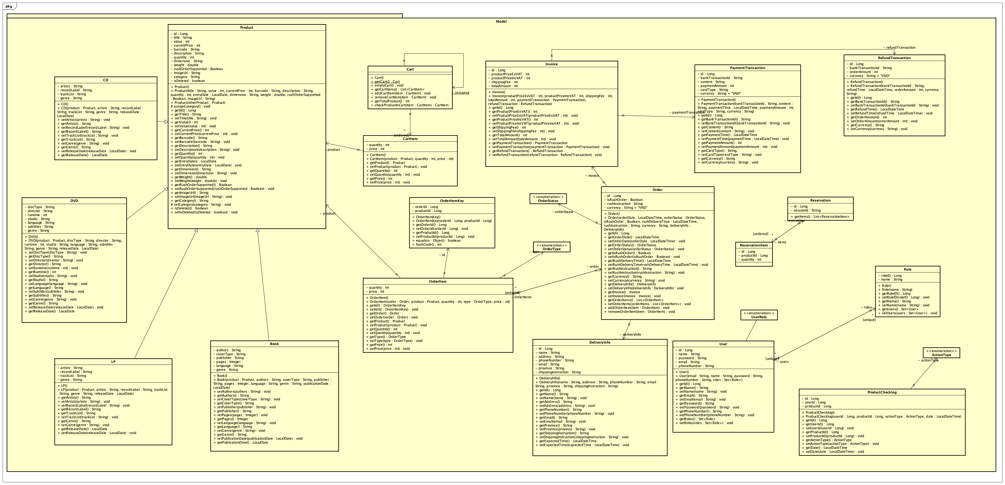

Figure 22: Model package

#### Class Diagram for Package controller

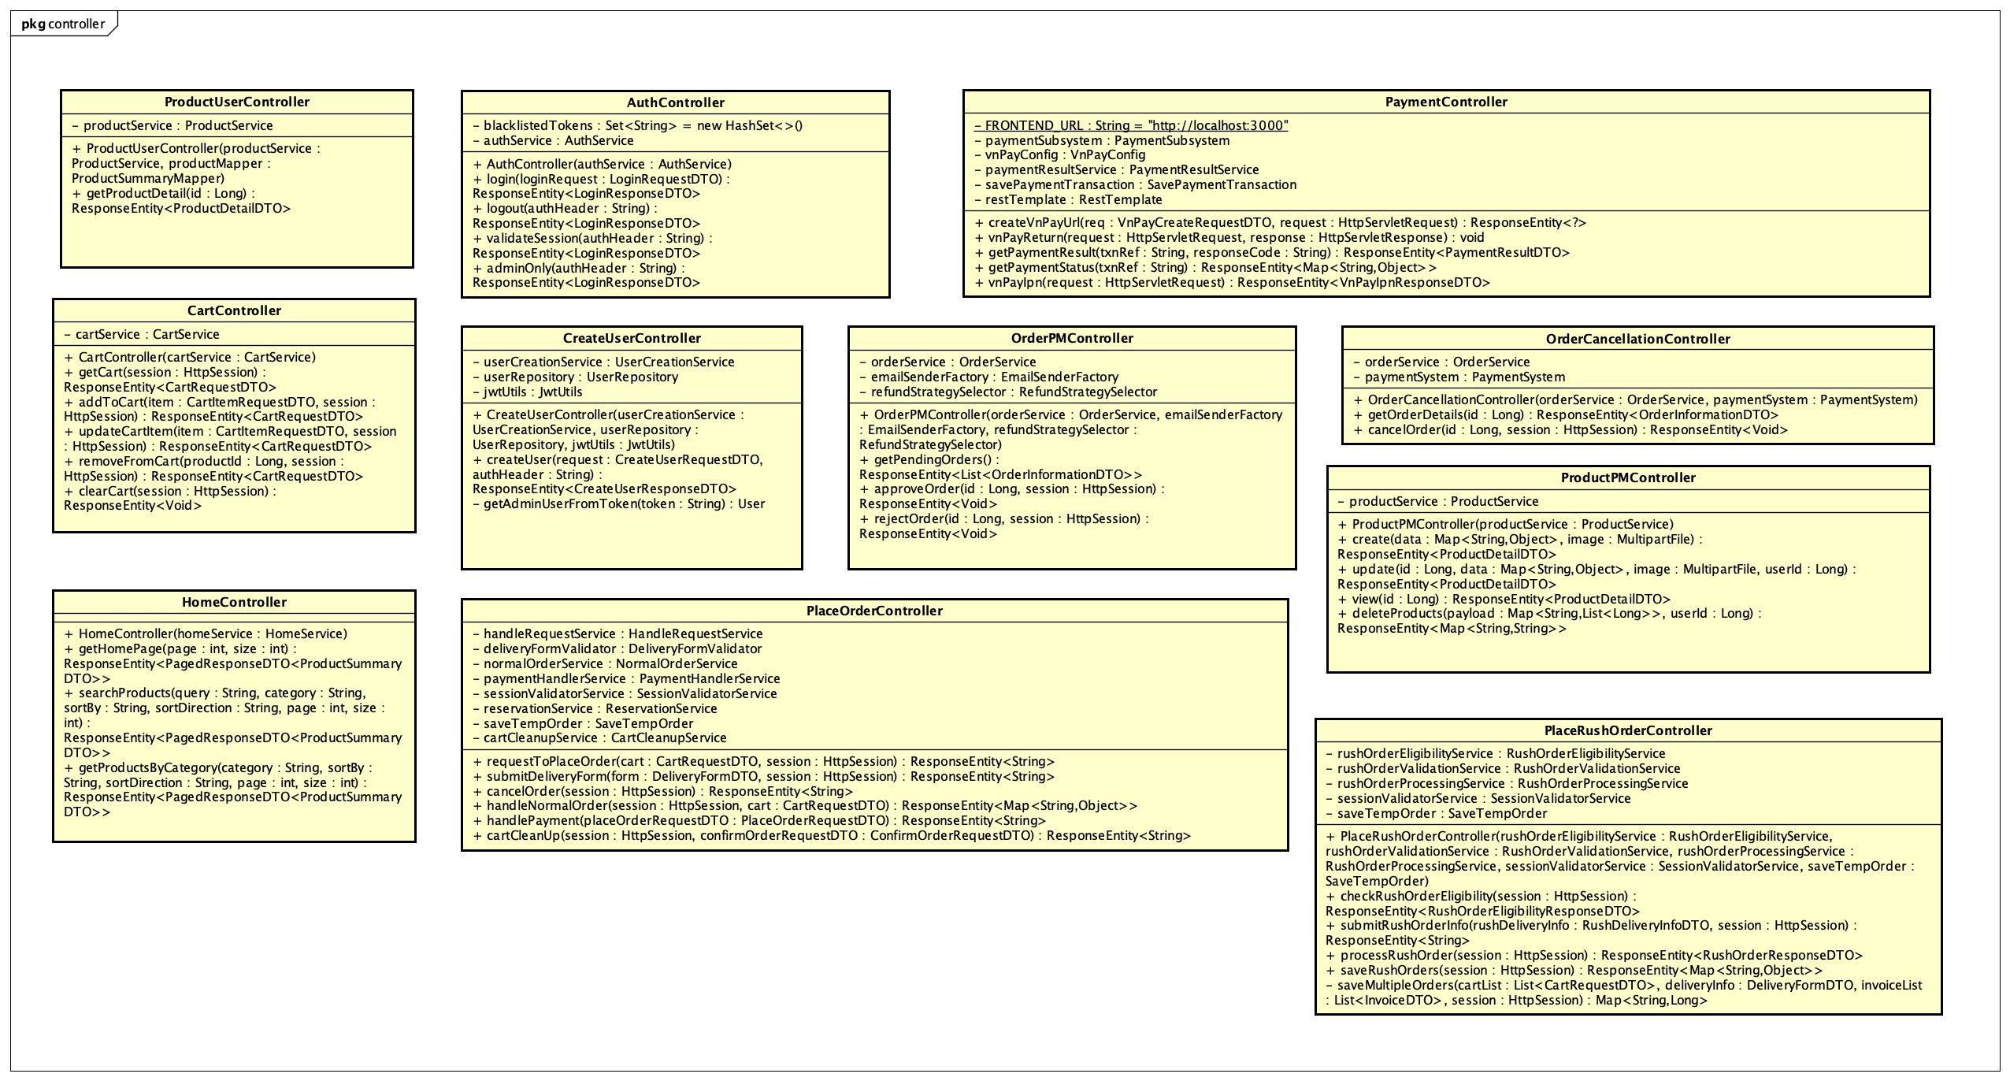

Figure 23: Controller package

#### Class Diagram for Package service



Figure 24: Service package

#### Class Diagram for Package repository

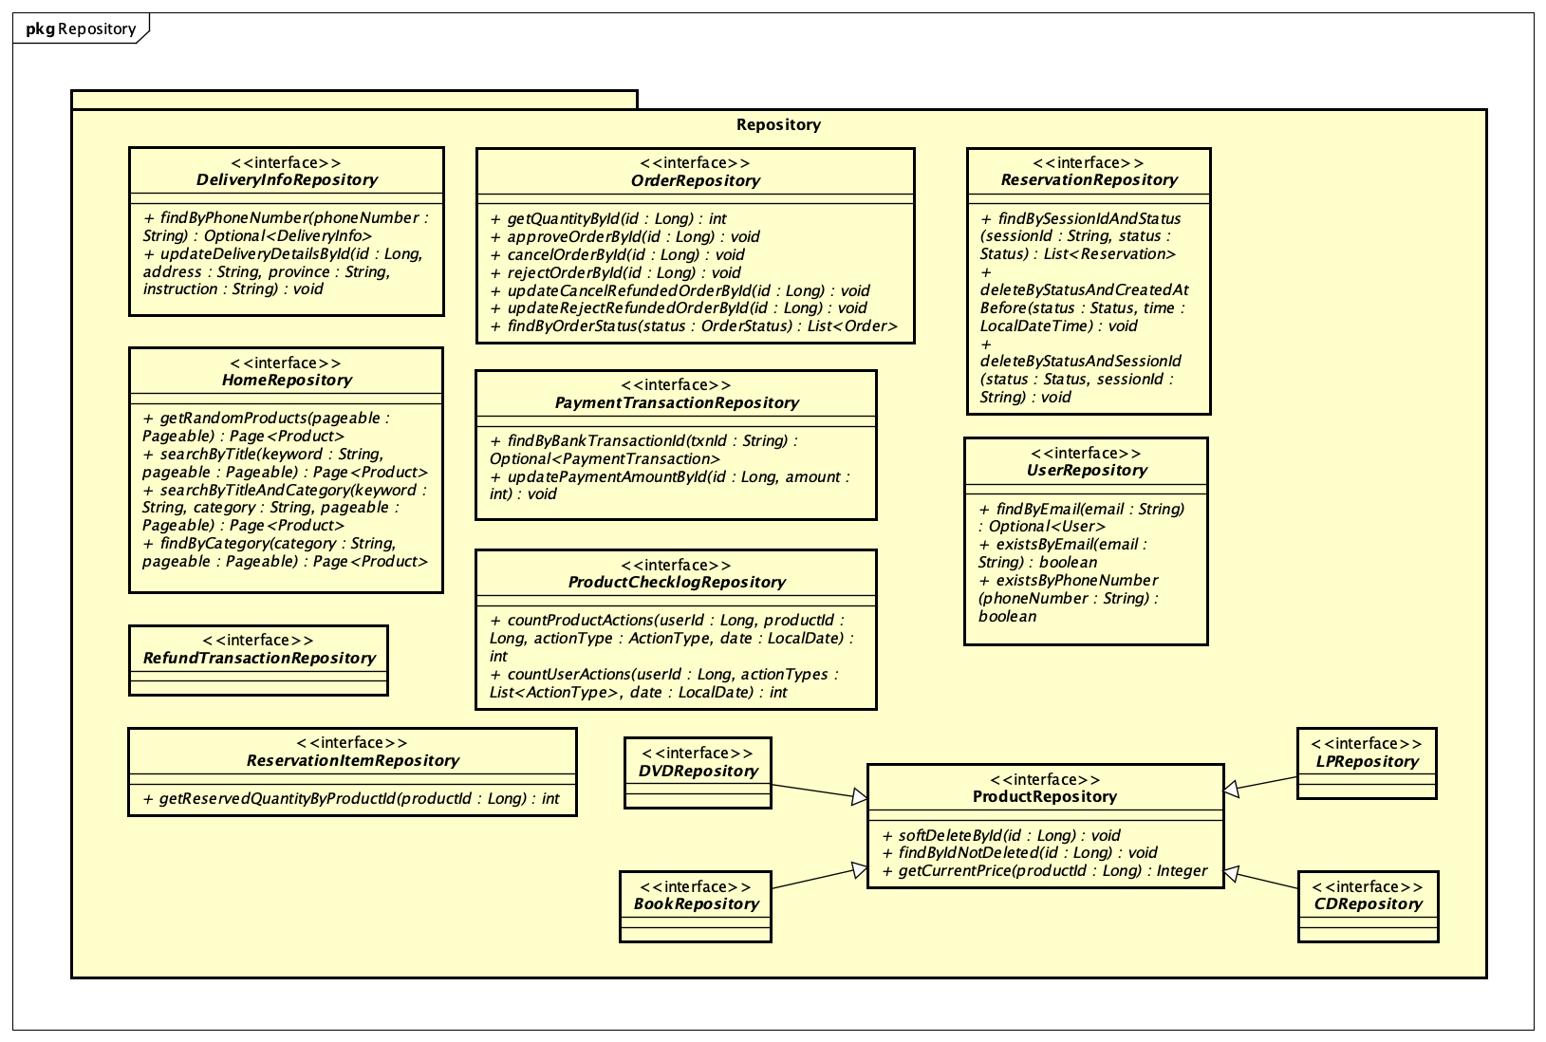

Figure 25: Repository package

#### Class Diagram for Package dto

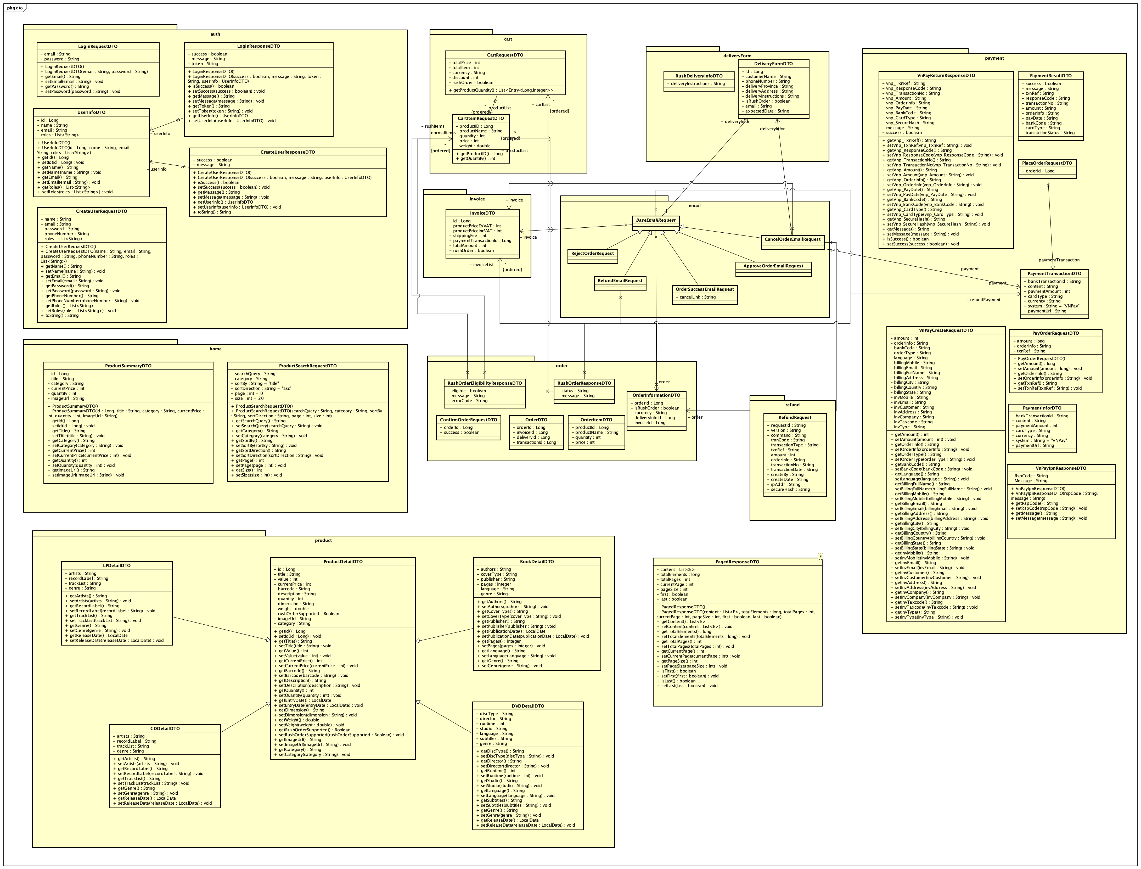

Figure 26: DTO package

#### Class Diagram for Package exception

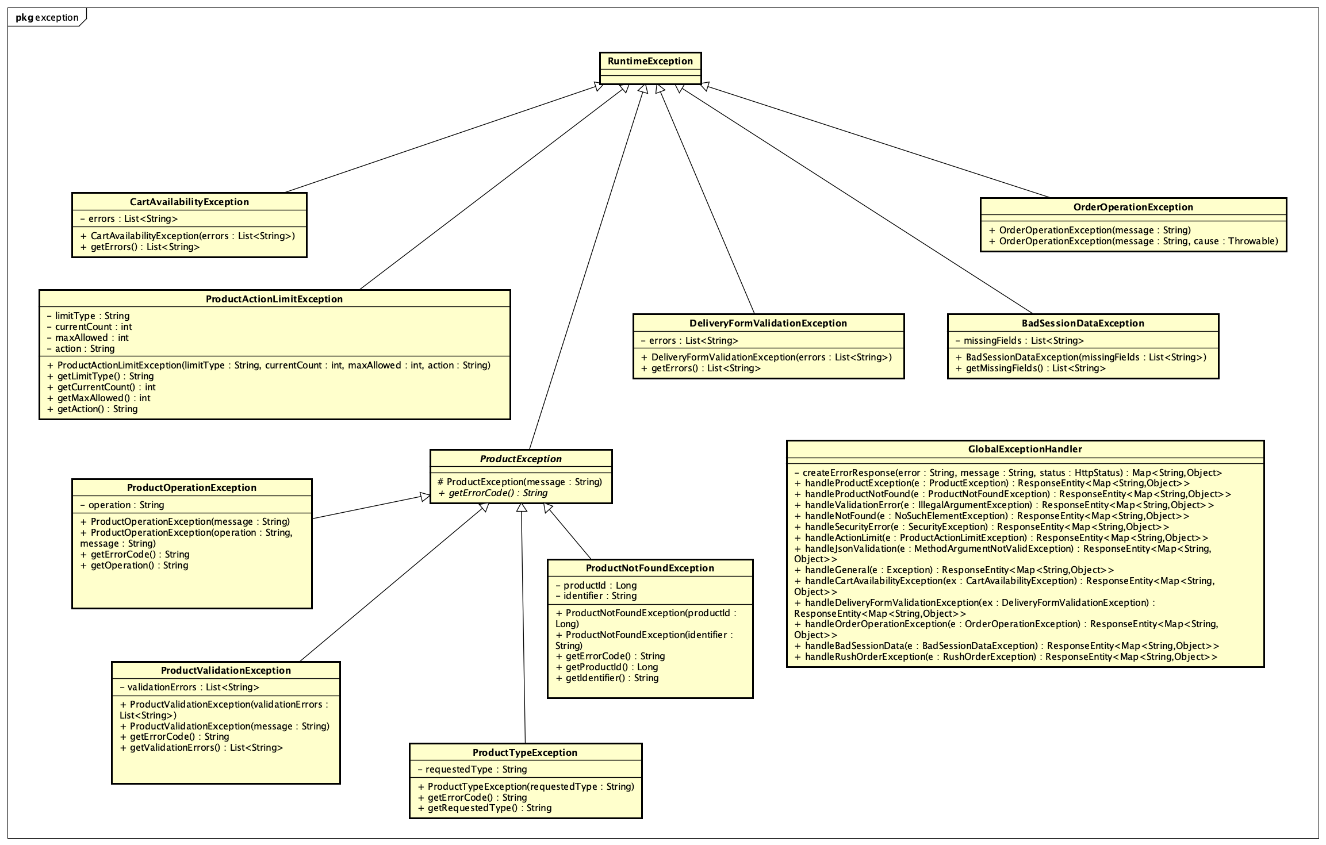

Figure 27: Exception package

#### Class Diagram for Package utils

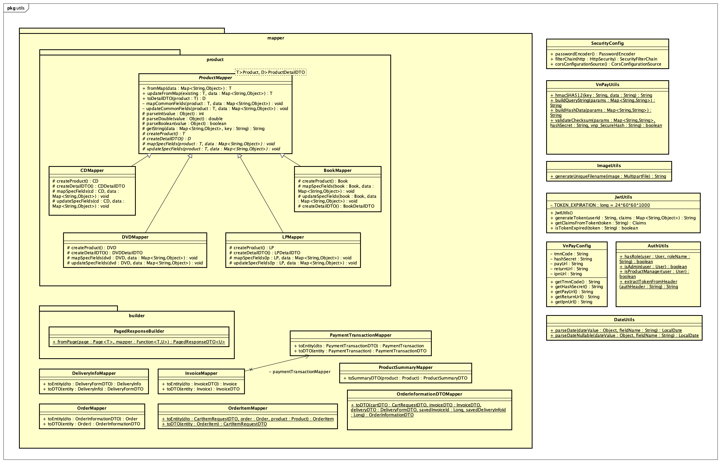

Figure 28: Utils package

### Class Design

#### Class “Product”

Table 20. Attribute Design

|  |  |  |  |  |
| --- | --- | --- | --- | --- |
| *#* | *Name* | *Data type* | *Default value* | *Description* |
| 1 | id | Long | Auto-generated | Unique identifier |
| 2 | title | String |  | Product title/name |
| 3 | value | int |  | Original product value (VND) |
| 4 | currentPrice | int |  | Current sale price (VND) |
| 5 | barcode | String |  | Product barcode (unique string) |
| 6 | description | String |  | Product description |
| 7 | quantity | int |  | Number of products in stock |
| 8 | entryDate | LocalDate |  | Date the product is entered into inventory |
| 9 | dimension | String |  | Physical size or dimension |
| 10 | weight | double |  | Weight in kilograms |
| 11 | rushOrderSupported | Boolean | null | Whether rush order is supported (optional) |
| 12 | imageUrl | String | null | URL of the product image (optional) |
| 13 | category | String | Auto-set | Auto-assigned class name (e.g., Book, DVD...) |
| 14 | isDeleted | boolean | false | Flag to mark product as deleted |

Table 21. Operation Design

|  |  |  |  |
| --- | --- | --- | --- |
| **#** | **Name** | **Return type** | **Description (purpose)** |
| 1 | Product() | constructor | Default constructor. Initializes an empty Product object |
| 2 | Product(...) | constructor | Overloaded constructor initializing all attributes and calling assignCategory() |
| 3 | Product(Product) | constructor | Copy constructor. Clones a product from an existing instance |
| 4 | assignCategory() | void | Lifecycle method (@PrePersist, @PreUpdate) that sets categoryto class name |
| 5 | getId() | Long | Returns the product ID |
| 6 | getTitle() | String | Returns the product title |
| 7 | setTitle(String) | void | Sets the product title |
| 8 | getValue() | int | Returns the product's original value |
| 9 | setValue(int) | void | Sets the product's original value |
| 10 | getCurrentPrice() | int | Returns the current selling price |
| 11 | setCurrentPrice(int) | void | Sets the current selling price |
| 12 | getBarcode() | String | Returns the barcode |
| 13 | setBarcode(String) | void | Sets the barcode |
| 14 | getDescription() | String | Returns the product description |
| 15 | setDescription(String) | void | Sets the product description |
| 16 | getQuantity() | int | Returns the quantity in stock |
| 17 | setQuantity(int) | void | Sets the quantity in stock |
| 18 | getEntryDate() | LocalDate | Returns the inventory entry date |
| 19 | setEntryDate(LocalDate) | void | Sets the inventory entry date |
| 20 | getDimension() | String | Returns the product’s dimension |
| 21 | setDimension(String) | void | Sets the product’s dimension |
| 22 | getWeight() | double | Returns the product’s weight |
| 23 | setWeight(double) | void | Sets the product’s weight |
| 24 | getRushOrderSupported() | Boolean | Returns whether rush order is supported |
| 25 | setRushOrderSupported(Boolean) | void | Sets whether rush order is supported |
| 26 | getImageUrl() | String | Returns the image URL |
| 27 | setImageUrl(String) | void | Sets the image URL |
| 28 | getCategory() | String | Returns the product category (auto-set from class name) |
| 29 | setCategory(String) | void | Protected setter used internally (usually by assignCategory()) |
| 30 | isDeleted() | boolean | Returns the deletion flag (soft delete) |
| 31 | setIsDeleted(boolean) | void | Sets the deletion flag |

*Parameter*:

* title: product name – required
* value: original price – required
* currentPrice: current sale price – required
* barcode: product identification code – required
* description: textual product info – required
* quantity: available stock – required
* entryDate: inventory entry date – required
* dimension: size or shape – required
* weight: physical mass – required
* rushOrderSupported: true/false flag for express delivery – optional
* imageUrl: product image – optional

***Exception***:

**Method:**

* Lifecycle method assignCategory() is used to automatically classify product type when saving to the database.
* Standard getter and setter methods follow JavaBean conventions.
* If this class is extended by child entities (e.g., Book, CD), category will be automatically mapped for inheritance filtering.
* For business logic (pricing validation), external validator classes should be used.

**State**

#### Class “CD”

Table 22. Attribute Design

|  |  |  |  |  |
| --- | --- | --- | --- | --- |
| **#** | **Name** | **Data type** | **Default value** | **Description** |
| 1 | artists | String | null | Name(s) of the artist(s) |
| 2 | recordLabel | String | null | The music record label or publisher |
| 3 | trackList | String | null | List of tracks/songs in the CD |
| 4 | genre | String | null | Music genre (e.g., Pop, Rock, Jazz, etc.) |
| 5 | releaseDate | LocalDate | null | Official release date of the CD |

Table 23. Operation Design

|  |  |  |  |
| --- | --- | --- | --- |
| **#** | **Name** | **Return type** | **Description (purpose)** |
| 1 | CD() | constructor | Default constructor. Initializes an empty CD object |
| 2 | CD(Product, String, String, ...) | constructor | Constructor that initializes from a Product and CD-specific fields |
| 3 | getArtists() | String | Returns the artist(s) |
| 4 | setArtists(String) | void | Sets the artist(s) |
| 5 | getRecordLabel() | String | Returns the record label |
| 6 | setRecordLabel(String) | void | Sets the record label |
| 7 | getTrackList() | String | Returns the CD's track list |
| 8 | setTrackList(String) | void | Sets the CD's track list |
| 9 | getGenre() | String | Returns the genre of the music |
| 10 | setGenre(String) | void | Sets the genre of the music |
| 11 | getReleaseDate() | LocalDate | Returns the CD's release date |
| 12 | setReleaseDate(LocalDate) | void | Sets the CD's release date |

*Parameter*:

* product: A Product object to inherit common fields (title, price, etc.)
* artists: Name(s) of the performer(s)
* recordLabel: Company or publisher responsible for the CD
* trackList: String representation of tracks (could be CSV format)
* genre: Music genre
* releaseDate: Launch or publication date

***Exception***

**Method**

* Uses a constructor that copies common fields from a Product and extends it with CD-specific information.
* Basic getter/setter methods are provided for each new field.
* The category field is automatically set as "CD" via assignCategory() in the parent class Product.

**State**

#### Class “DVD”

Table 24. Attribute Design

|  |  |  |  |  |
| --- | --- | --- | --- | --- |
| **#** | **Name** | **Data type** | **Default value** | **Description** |
| 1 | discType | String | null | Type of disc (e.g., DVD-5, DVD-9) |
| 2 | director | String | null | Name of the film’s director |
| 3 | runtime | int | 0 | Total duration of the movie (in minutes) |
| 4 | studio | String | null | Studio or production company |
| 5 | language | String | null | Original language of the movie |
| 6 | subtitles | String | null | Subtitle languages available (e.g., English, French, Vietnamese) |
| 7 | genre | String | null | Genre of the film (e.g., Action, Comedy, Drama) |
| 8 | releaseDate | LocalDate | null | Date when the DVD was released |

Table 25. Operation Design

|  |  |  |  |
| --- | --- | --- | --- |
| **#** | **Name** | **Return type** | **Description (purpose)** |
| 1 | DVD() | constructor | Default constructor. Initializes an empty DVD object |
| 2 | DVD(Product, String, String, ...) | constructor | Initializes a DVD with inherited and DVD-specific fields |
| 3 | getDiscType() | String | Returns the disc type |
| 4 | setDiscType(String) | void | Sets the disc type |
| 5 | getDirector() | String | Returns the director's name |
| 6 | setDirector(String) | void | Sets the director's name |
| 7 | getRuntime() | int | Returns the movie runtime in minutes |
| 8 | setRuntime(int) | void | Sets the runtime in minutes |
| 9 | getStudio() | String | Returns the production studio |
| 10 | setStudio(String) | void | Sets the production studio |
| 11 | getLanguage() | String | Returns the original language |
| 12 | setLanguage(String) | void | Sets the original language |
| 13 | getSubtitles() | String | Returns the available subtitle languages |
| 14 | setSubtitles(String) | void | Sets the available subtitle languages |
| 15 | getGenre() | String | Returns the film genre |
| 16 | setGenre(String) | void | Sets the film genre |
| 17 | getReleaseDate() | LocalDate | Returns the DVD's release date |
| 18 | setReleaseDate(LocalDate) | void | Sets the DVD's release date |

*Parameter*:

* product: The base product object from which DVD extends common fields.
* discType: Physical format of the DVD disc.
* director: Director of the film.
* runtime: Duration of the film in minutes.
* studio: Producing company.
* language: Primary spoken language.
* subtitles: Available subtitle languages (comma-separated or formatted string).
* genre: Thematic category of the film.
* releaseDate: Date the DVD was officially launched.

***Exception***

**Method**

* The DVD constructor builds from an existing Product and extends it with DVD metadata.
* Basic getter/setter methods are provided for each new field.
* The category field is automatically set as "DVD" via assignCategory() in the parent class Product.

**State**

#### Class “LP”

Table 26. Attribute Design

|  |  |  |  |  |
| --- | --- | --- | --- | --- |
| **#** | **Name** | **Data type** | **Default value** | **Description** |
| 1 | artists | String | null | Name(s) of the artist(s) performing on the LP |
| 2 | recordLabel | String | null | Name of the record label that published the LP |
| 3 | trackList | String | null | List of songs or tracks on the LP (can be comma-separated) |
| 4 | genre | String | null | Musical genre of the LP (e.g., Jazz, Rock, Classical, etc.) |
| 5 | releaseDate | LocalDate | null | Official release date of the LP |

Table 27. Operation Design

|  |  |  |  |
| --- | --- | --- | --- |
| **#** | **Name** | **Return type** | **Description (purpose)** |
| 1 | LP() | constructor | Default constructor. Initializes an empty LP object |
| 2 | LP (Product, String, String, ...) | constructor | Constructor that initializes from a Product and LP -specific fields |
| 3 | getArtists() | String | Returns the artist(s) |
| 4 | setArtists(String) | void | Sets the artist(s) |
| 5 | getRecordLabel() | String | Returns the record label |
| 6 | setRecordLabel(String) | void | Sets the record label |
| 7 | getTrackList() | String | Returns the LP track list |
| 8 | setTrackList(String) | void | Sets the LP track list |
| 9 | getGenre() | String | Returns the genre of the music |
| 10 | setGenre(String) | void | Sets the genre of the music |
| 11 | getReleaseDate() | LocalDate | Returns the LP release date |
| 12 | setReleaseDate(LocalDate) | void | Sets the LP release date |

*Parameter*:

* product: The inherited base product (common fields like title, price, barcode, etc.).
* artists: Artists featured on the LP.
* recordLabel: Name of the publisher or music label.
* trackList: Track listing of the LP (as a string).
* genre: Musical category or style.
* releaseDate: When the LP was first released.

***Exception***

**Method**

* The LP constructor builds from an existing Product and extends it with DVD metadata.
* Basic getter/setter methods are provided for each new field.
* The category field is automatically set as "LP" via assignCategory() in the parent class Product.

**State**

#### Class “Book”

Table 28. Attribute Design

|  |  |  |  |  |
| --- | --- | --- | --- | --- |
| **#** | **Name** | **Data type** | **Default value** | **Description** |
| 1 | authors | String | null | Name(s) of the author(s) |
| 2 | coverType | String | null | Cover type (e.g., Hardcover, Paperback) |
| 3 | publisher | String | null | Publishing company |
| 4 | publicationDate | LocalDate | null | Date the book was published |
| 5 | pages | Integer | null | Total number of pages in the book |
| 6 | language | String | null | Language in which the book is written |
| 7 | genre | String | null | Genre or category of the book (e.g., Fiction, Non-fiction, Science) |

Table 29. Operation Design

|  |  |  |  |
| --- | --- | --- | --- |
| **#** | **Name** | **Return type** | **Description (purpose)** |
| 1 | Book() | constructor | Default constructor. Initializes an empty book object |
| 2 | Book(Product, String, String, ...) | constructor | Initializes a Book object from a base Product and book-specific fields |
| 3 | getAuthors() | String | Returns the name(s) of the book's author(s) |
| 4 | setAuthors(String) | void | Sets the author(s) |
| 5 | getCoverType() | String | Returns the cover type |
| 6 | setCoverType(String) | void | Sets the cover type |
| 7 | getPublisher() | String | Returns the publisher |
| 8 | setPublisher(String) | void | Sets the publisher |
| 9 | getPublicationDate() | LocalDate | Returns the book’s publication date |
| 10 | setPublicationDate(LocalDate) | void | Sets the publication date |
| 11 | getPages() | Integer | Returns the total number of pages |
| 12 | setPages(Integer) | void | Sets the number of pages |
| 13 | getLanguage() | String | Returns the book's language |
| 14 | setLanguage(String) | void | Sets the book's language |
| 15 | getGenre() | String | Returns the genre of the book |
| 16 | setGenre(String) | void | Sets the book's genre |

*Parameter*:

* product: Inherited Product instance (title, price, barcode, etc.)
* authors: Author(s) of the book
* coverType: Hardcover or Paperback
* publisher: Publishing house
* pages: Total page count
* language: Language of the book
* genre: Category or theme of the content
* publicationDate: Date the book was published

***Exception***

**Method**

* Constructs using a Product object and adds book-specific metadata.
* Typical JavaBean-style accessors for all attributes.
* Automatically categorized as "Book" by inherited assignCategory() logic from Product.

**State**

#### Class “Cart”

Table 30. Attribute Design

|  |  |  |  |  |
| --- | --- | --- | --- | --- |
| **#** | **Name** | **Data type** | **Default value** | **Description** |
| 1 | cartItems | List<CartItem> | Empty list ([]) | List of items currently in the cart |
| 2 | instance | static Cart | null | Singleton instance of the cart |

Table 31. Operation Design

|  |  |  |  |
| --- | --- | --- | --- |
| **#** | **Name** | **Return type** | **Description (purpose)** |
| 1 | Cart() | constructor | Default constructor. Initializes an empty cart |
| 2 | getCart() | Cart | Returns the singleton cart instance. Creates one if not already created |
| 3 | emptyCart() | void | Clears all items in the cart |
| 4 | getCartItems() | List<CartItem> | Returns the current list of cart items |
| 5 | addCartItem(CartItem) | void | Adds a new item to the cart |
| 6 | removeCartItem(CartItem) | void | Removes the specified item from the cart |
| 7 | getTotalProduct() | int | Returns the total quantity of products in the cart |
| 8 | checkProductInCart(CartItem) | CartItem or null | Checks whether a given product already exists in the cart |

*Parameter*:

CartItem item: Represents a product along with its quantity in the cart.  
Used for both adding/removing and checking duplicates.

***Exception***

**Method**

* Implements the Singleton pattern to ensure a single shared cart per application session.
* getCart() is the entry point to retrieve or initialize the cart.
* checkProductInCart() uses .equals() to compare products, assuming Product.equals() is properly overridden.
* getTotalProduct() sums up quantities across all CartItems, not just count of distinct products

**State**

#### Class “CartItem”

Table 32. Attribute Design

|  |  |  |  |  |
| --- | --- | --- | --- | --- |
| **#** | **Name** | **Data type** | **Default value** | **Description** |
| 1 | product | Product | null | The product associated with this cart item |
| 2 | quantity | int | 0 | The number of units of the product added to the cart |
| 3 | price | int | 0 | The unit price of the product at the time it was added to cart |

Table 33. Operation Design

|  |  |  |  |
| --- | --- | --- | --- |
| **#** | **Name** | **Return type** | **Description (purpose)** |
| 1 | CartItem() | constructor | Default constructor. Initializes an empty cart item |
| 2 | CartItem(Product, int, int) | constructor | Initializes a cart item with given product, quantity, and price |
| 3 | getProduct() | Product | Returns the product in this cart item |
| 4 | setProduct(Product) | void | Sets the product |
| 5 | getQuantity() | int | Returns the quantity |
| 6 | setQuantity(int) | void | Sets the quantity |
| 7 | getPrice() | int | Returns the unit price |
| 8 | setPrice(int) | void | Sets the unit price |

*Parameter*:

* product: Instance of Product, the item being purchased.
* quantity: Number of product units.
* price: Price per unit (could be based on currentPrice from Product, or discounted).

***Exception***

**Method**

* Represents a line item in the shopping cart.
* Intended to be managed via the Cart class.
* Does not calculate total price; that logic belongs in Cart or a service layer.

**State**

#### Class “Invoice”

Table 34. Attribute Design

|  |  |  |  |  |
| --- | --- | --- | --- | --- |
| **#** | **Name** | **Data type** | **Default value** | **Description** |
| 1 | id | Long | Auto-generated | Unique invoice ID |
| 2 | productPriceExVAT | int | 0 | Total product price excluding VAT |
| 3 | productPriceIncVAT | int | 0 | Total product price including VAT |
| 4 | shippingFee | int | 0 | Total shipping cost |
| 5 | totalAmount | int | 0 | Final amount to be paid (including all charges) |
| 6 | paymentTransaction | PaymentTransaction | null | Linked transaction used to pay for this invoice |
| 7 | refundTransaction | RefundTransaction | null | Linked refund transaction if the invoice is refunded |

Table 35. Operation Design

|  |  |  |  |
| --- | --- | --- | --- |
| **#** | **Name** | **Return type** | **Description (purpose)** |
| 1 | Invoice() | constructor | Default constructor |
| 2 | Invoice(int, int, int, int, Payment, Refund) | constructor | Initializes an invoice with all values and associated transactions |
| 3 | getId() | Long | Returns the invoice ID |
| 4 | getProductPriceExVAT() | int | Returns total product price excluding VAT |
| 5 | setProductPriceExVAT(int) | void | Sets product price excluding VAT |
| 6 | getProductPriceIncVAT() | int | Returns total product price including VAT |
| 7 | setProductPriceIncVAT(int) | void | Sets product price including VAT |
| 8 | getShippingFee() | int | Returns shipping fee |
| 9 | setShippingFee(int) | void | Sets shipping fee |
| 10 | getTotalAmount() | int | Returns final amount (incl. VAT & shipping) |
| 11 | setTotalAmount(int) | void | Sets final amount |
| 12 | getPaymentTransaction() | PaymentTransaction | Returns the associated payment transaction |
| 13 | setPaymentTransaction(PaymentTransaction) | void | Sets the payment transaction |
| 14 | getRefundTransaction() | RefundTransaction | Returns the associated refund transaction |
| 15 | setRefundTransaction(RefundTransaction) | void | Sets the refund transaction |

*Parameter*:

* productPriceExVAT: Raw product total before taxes.
* productPriceIncVAT: Price after adding VAT (Value Added Tax).
* shippingFee: Cost of delivery.
* totalAmount: Final invoice amount = productPriceIncVAT + shippingFee.
* paymentTransaction: Transaction that handled payment.
* refundTransaction: Transaction created if a refund was issued.

***Exception***

**Method**

* Contains only persistence and data accessor logic (POJO/Entity).
* Uses @OneToOne mappings to directly link with one payment and one refund transaction, if applicable.
* Supports cascading for full persistence of payment/refund objects.
* totalAmount must be calculated before instantiation or via external service logic.

**State**

#### Class “Order”

Table 36. Attribute Design

|  |  |  |  |  |
| --- | --- | --- | --- | --- |
| **#** | **Name** | **Data type** | **Default value** | **Description** |
| 1 | id | Long | Auto-generated | Unique identifier for the order |
| 2 | orderDate | LocalDateTime | null | Timestamp when the order was placed |
| 3 | orderStatus | OrderStatus(enum) | PENDING | Current order status (e.g., PENDING, SHIPPED, DELIVERED, CANCELLED) |
| 4 | isRushOrder | Boolean | null | Indicates whether this order is expedited (rush) |
| 5 | rushDeliveryTime | LocalDateTime | null | Expected delivery time if rush order |
| 6 | rushInstruction | String | null | Special instructions for handling the rush delivery |
| 7 | currency | String | "VND" | Currency used for payment and invoice |
| 8 | deliveryInfo | DeliveryInfo | null | Delivery address and customer details |
| 9 | invoice | Invoice | null | Invoice issued for the order |
| 10 | orderItems | List<OrderItem> | [] | Collection of ordered items (products with quantity and price) |

Table 37. Operation Design

|  |  |  |  |
| --- | --- | --- | --- |
| **#** | **Name** | **Return type** | **Description (purpose)** |
| 1 | Order() | constructor | Default constructor. Initializes an empty order |
| 2 | Order(...) | constructor | Constructor with parameters to initialize all order details |
| 3 | getId() | Long | Returns the unique order ID |
| 4 | getOrderDate() | LocalDateTime | Returns the date/time the order was created |
| 5 | setOrderDate(LocalDateTime) | void | Sets the order creation timestamp |
| 6 | getOrderStatus() | OrderStatus | Returns current status of the order |
| 7 | setOrderStatus(OrderStatus) | void | Updates the status of the order |
| 8 | getIsRushOrder() | Boolean | Indicates if the order is marked as rush |
| 9 | setIsRushOrder(Boolean) | void | Marks the order as rush (true/false) |
| 10 | getRushDeliveryTime() | LocalDateTime | Returns the scheduled rush delivery date/time |
| 11 | setRushDeliveryTime(LocalDateTime) | void | Sets the scheduled rush delivery time |
| 12 | getRushInstruction() | String | Returns additional rush delivery instructions |
| 13 | setRushInstruction(String) | void | Sets delivery handling instructions |
| 14 | getCurrency() | String | Returns the payment currency |
| 15 | setCurrency(String) | void | Sets the payment currency |
| 16 | getDeliveryInfo() | DeliveryInfo | Returns delivery address and contact info |
| 17 | setDeliveryInfo(DeliveryInfo) | void | Sets delivery information |
| 18 | getInvoice() | Invoice | Returns associated invoice for the order |
| 19 | setInvoice(Invoice) | void | Sets the invoice for this order |
| 20 | getOrderItems() | List<OrderItem> | Returns the list of all items in the order |
| 21 | setOrderItems(List<OrderItem>) | void | Sets or replaces the list of order items |
| 22 | addOrderItem(OrderItem) | void | Adds an item to the order and links it back to this order |
| 23 | removeOrderItem(OrderItem) | void | Removes an item and unlinks it from this order |

*Parameter*:

* orderDate: Date/time when the order is placed.
* orderStatus: Lifecycle status (PENDING, CANCELLED, etc.)
* isRushOrder: Marks the order as requiring rush shipping.
* rushDeliveryTime: Deadline for rush delivery.
* rushInstruction: Custom handling instructions.
* currency: Payment and pricing currency.
* deliveryInfo: Associated shipping information.
* invoice: The billing object linked to this order.
* orderItems: List of products and quantities in the order.

***Exception***

**Method**

**State**

#### Class “OrderItem”

Table 38. Attribute Design

|  |  |  |  |  |
| --- | --- | --- | --- | --- |
| **#** | **Name** | **Data type** | **Default value** | **Description** |
| 1 | id | OrderItemKey | Auto-generated | Composite key combining orderId and productId |
| 2 | order | Order | null | The order this item belongs to |
| 3 | product | Product | null | The product being ordered |
| 4 | quantity | int | 0 | Number of units of the product ordered |
| 5 | type | enum | null | Type of order item (e.g., NORMAL, RUSH) |
| 6 | price | int |  | Price per unit at the time of order (in VND) |

Table 39. Operation Design

|  |  |  |  |
| --- | --- | --- | --- |
| **#** | **Name** | **Return type** | **Description (purpose)** |
| 1 | OrderItem() | constructor | Default constructor |
| 2 | OrderItem(Order, Product, ...) | constructor | Constructs a new OrderItem with linked order and product |
| 3 | getId() | OrderItemKey | Returns the composite key |
| 4 | setId(OrderItemKey) | void | Sets the composite key |
| 5 | getOrder() | Order | Returns the linked order |
| 6 | setOrder(Order) | void | Sets the order and updates the composite key |
| 7 | getProduct() | Product | Returns the linked product |
| 8 | setProduct(Product) | void | Sets the product and updates the composite key |
| 9 | getQuantity() | int | Returns the quantity of product ordered |
| 10 | setQuantity(int) | void | Sets the quantity |
| 11 | getType() | OrderType | Returns the type of the order item |
| 12 | setType(OrderType) | void | Sets the type of the order item |
| 13 | getPrice() | int | Returns the price per unit |
| 14 | setPrice(int) | void | Sets the unit price |

*Parameter*:

* order: Parent order to which this item belongs.
* product: The product that is ordered.
* quantity: Number of product units in this order line.
* type: Enum describing the item type (e.g., NORMAL, RUSH, etc.).
* price: Price per unit at the time of ordering (not tied to live Product.currentPrice).

***Exception***

**Method**

* This class models a many-to-many with attributes (order ↔ product with quantity, price, type).
* Uses a composite primary key (OrderItemKey) to uniquely identify each item.
* setOrder() and setProduct() automatically update the corresponding fields in id.
* This entity is designed to be managed within Order via addOrderItem()/removeOrderItem()

**State**

#### Class “PaymentTransaction”

Table 40. Attribute Design

|  |  |  |  |  |
| --- | --- | --- | --- | --- |
| **#** | **Name** | **Data type** | **Default value** | **Description** |
| 1 | id | Long | Auto-generated | Unique identifier for the internal transaction |
| 2 | bankTransactionId | String | null | External transaction reference ID from the bank/payment gateway |
| 3 | content | String | null | Description or message provided by the payment |
| 4 | paymentTime | LocalDateTime | null | Timestamp when payment was completed |
| 5 | paymentAmount | int | 0 | Amount paid (in smallest currency unit — e.g., VND) |
| 6 | cardType | String | null | Type of card used (e.g., VISA, MasterCard, ATM...) |
| 7 | currency | String | "VND" | Currency used in the payment |

Table 41. Operation Design

|  |  |  |  |
| --- | --- | --- | --- |
| **#** | **Name** | **Return type** | **Description (purpose)** |
| 1 | PaymentTransaction() | constructor | Default constructor |
| 2 | PaymentTransaction(String, String, ...) | constructor | Constructor to initialize all fields |
| 3 | getId() | Long | Returns internal payment transaction ID |
| 4 | getBankTransactionId() | String | Returns bank-side transaction ID |
| 5 | setBankTransactionId(String) | void | Sets the bank transaction ID |
| 6 | getContent() | String | Returns payment message/content |
| 7 | setContent(String) | void | Sets content of the transaction |
| 8 | getPaymentTime() | LocalDateTime | Returns the date and time of payment |
| 9 | setPaymentTime(LocalDateTime) | void | Sets the date and time of payment |
| 10 | getPaymentAmount() | int | Returns the amount paid |
| 11 | setPaymentAmount(int) | void | Sets the amount paid |
| 12 | getCardType() | String | Returns the card type used |
| 13 | setCardType(String) | void | Sets the card type |
| 14 | getCurrency() | String | Returns the currency of the transaction |
| 15 | setCurrency(String) | void | Sets the transaction currency |

*Parameter*:

* bankTransactionId: ID returned by the external payment service provider.
* content: Textual reference/description of the transaction.
* paymentTime: Time at which payment succeeded.
* paymentAmount: Total amount that was paid.
* cardType: Type of card used (credit/debit).
* currency: Transaction currency (default: VND).

***Exception***

**Method**

**State**

#### Class “RefundTransaction”

Table 42. Attribute Design

|  |  |  |  |  |
| --- | --- | --- | --- | --- |
| **#** | **Name** | **Data type** | **Default value** | **Description** |
| 1 | id | Long | Auto-generated | Unique identifier for the refund transaction |
| 2 | bankTransactionId | String | null | External refund reference ID provided by the payment gateway |
| 3 | refundTime | LocalDateTime | null | Timestamp when the refund was issued |
| 4 | orderAmount | int | 0 | Amount refunded (equal to or less than the original order value) |
| 5 | currency | String | "VND" | Currency used for the refund |

Table 43. Operation Design

|  |  |  |  |
| --- | --- | --- | --- |
| **#** | **Name** | **Return type** | **Description (purpose)** |
| 1 | RefundTransaction() | constructor | Default constructor |
| 2 | RefundTransaction(String, LocalDateTime, ...) | constructor | Initializes refund with full transaction details |
| 3 | getId() | Long | Returns the unique refund transaction ID |
| 4 | getBankTransactionId() | String | Returns the external refund transaction ID |
| 5 | setBankTransactionId(String) | void | Sets the bank refund transaction ID |
| 6 | getRefundTime() | LocalDateTime | Returns the refund timestamp |
| 7 | setRefundTime(LocalDateTime) | void | Sets the refund timestamp |
| 8 | getOrderAmount() | int | Returns the amount refunded |
| 9 | setOrderAmount(int) | void | Sets the amount refunded |
| 10 | getCurrency() | String | Returns the currency of the refund |
| 11 | setCurrency(String) | void | Sets the currency of the refund |

*Parameter*:

* bankTransactionId: External transaction ID confirming the refund was processed.
* refundTime: Time the refund was initiated/processed by the system or payment gateway.
* orderAmount: Amount to be returned to the customer.
* currency: Usually matches the original payment's currency (default: "VND").

***Exception***

**Method**

**State**

#### Class “DeliveryInfo”

Table 44. Attribute Design

|  |  |  |  |  |
| --- | --- | --- | --- | --- |
| **#** | **Name** | **Data type** | **Default value** | **Description** |
| 1 | id | Long | Auto-generated | Unique delivery information identifier |
| 2 | name | String | null | Full name of the recipient |
| 3 | address | String | null | Full delivery address |
| 4 | phoneNumber | String | null | Contact number for delivery purposes |
| 5 | email | String | null | Recipient’s email address |
| 6 | province | String | null | Recipient’s city or province |
| 7 | shippingInstruction | String | null | Additional instructions for delivery (e.g., "Leave at front desk") |
| 8 | expectedTime | LocalDateTime | null | Expected delivery time (set later based on delivery scheduling logic) |

Table 45. Operation Design

|  |  |  |  |
| --- | --- | --- | --- |
| **#** | **Name** | **Return type** | **Description (purpose)** |
| 1 | DeliveryInfo() | constructor | Default constructor |
| 2 | DeliveryInfo(String, String, ...) | constructor | Initializes delivery info with recipient and location details |
| 3 | getId() | Long | Returns the delivery info ID |
| 4 | getName() | String | Returns the recipient's name |
| 5 | setName(String) | void | Sets the recipient's name |
| 6 | getAddress() | String | Returns the shipping address |
| 7 | setAddress(String) | void | Sets the shipping address |
| 8 | getPhoneNumber() | String | Returns the phone number |
| 9 | setPhoneNumber(String) | void | Sets the phone number |
| 10 | getEmail() | String | Returns the recipient’s email address |
| 11 | setEmail(String) | void | Sets the email address |
| 12 | getProvince() | String | Returns the recipient's province |
| 13 | setProvince(String) | void | Sets the province |
| 14 | getShippingInstruction() | String | Returns delivery notes or special instructions |
| 15 | setShippingInstruction(String) | void | Sets delivery instructions |
| 16 | getExpectedTime() | LocalDateTime | Returns expected delivery time |
| 17 | setExpectedTime(LocalDateTime) | void | Sets the expected delivery time |

*Parameter*:

* name: Full recipient name
* address: Street address or detailed location
* phoneNumber: Used by shipper for contact
* email: Optional electronic contact
* province: Helps with routing and shipping cost calculation
* shippingInstruction: Useful for special delivery requests
* expectedTime: Estimated delivery window, often set by backend logic

***Exception***

**Method**

**State**

#### Class “ProductChecklog”

Table 46. Attribute Design

|  |  |  |  |  |
| --- | --- | --- | --- | --- |
| **#** | **Name** | **Data type** | **Default value** | **Description** |
| 1 | id | Long | Auto-generated | Unique identifier for the log entry |
| 2 | userId | Long |  | ID of the user who performed the action |
| 3 | productId | Long |  | ID of the product that was checked/viewed/updated |
| 4 | actionType | ActionType (enum) |  | Enum representing the type of action (e.g., VIEW, EDIT, DELETE) |
| 5 | date | LocalDateTime |  | Timestamp when the action was performed |

Table 47. Operation Design

|  |  |  |  |
| --- | --- | --- | --- |
| **#** | **Name** | **Return type** | **Description (purpose)** |
| 1 | ProductChecklog() | constructor | Default constructor |
| 2 | ProductChecklog(Long, Long, ActionType, ...) | constructor | Creates a new log entry with full metadata |
| 3 | getId() | Long | Returns the log ID |
| 4 | getUserId() | Long | Returns the ID of the user who performed the action |
| 5 | setUserId(Long) | void | Sets the user ID |
| 6 | getProductId() | Long | Returns the ID of the product involved |
| 7 | setProductId(Long) | void | Sets the product ID |
| 8 | getActionType() | ActionType | Returns the type of user action (VIEW, EDIT, etc.) |
| 9 | setActionType(ActionType) | void | Sets the type of user action |
| 10 | getDate() | LocalDateTime | Returns the timestamp of the activity |
| 11 | setDate(LocalDateTime) | void | Sets the activity timestamp |

*Parameter*:

* userId: ID of the user who interacted with a product.
* productId: ID of the target product.
* actionType: Type of action performed (typically an enum: VIEW, EDIT, etc.).
* date: The time the action occurred (for logging and auditing).

***Exception***

**Method**

**State**

#### Class “User”

Table 48. Attribute Design

|  |  |  |  |  |
| --- | --- | --- | --- | --- |
| **#** | **Name** | **Data type** | **Default value** | **Description** |
| 1 | id | Long | Auto-generated | Unique identifier for the user |
| 2 | name | String | null | Full name of the user |
| 3 | password | String | null | Encrypted password used for authentication |
| 4 | email | String | null | Email address (used for login or contact) |
| 5 | phoneNumber | String | null | User’s phone number |
| 6 | roles | Set<Role> | Empty set ({}) | List of roles assigned to this user (many-to-many relationship) |

Table 49. Operation Design

|  |  |  |  |
| --- | --- | --- | --- |
| **#** | **Name** | **Return type** | **Description (purpose)** |
| 1 | User() | constructor | Default constructor |
| 2 | User(String, String, ...) | constructor | Constructor with full attributes |
| 3 | getId() | Long | Returns the user ID |
| 4 | getName() | String | Returns the user's name |
| 5 | setName(String) | void | Sets the user's name |
| 6 | getEmail() | String | Returns the user's email address |
| 7 | setEmail(String) | void | Sets the email address |
| 8 | getPassword() | String | Returns the encrypted password |
| 9 | setPassword(String) | void | Sets the encrypted password |
| 10 | getPhoneNumber() | String | Returns the user's phone number |
| 11 | setPhoneNumber(String) | void | Sets the user's phone number |
| 12 | getRoles() | Set<Role> | Returns the set of roles associated with this user |
| 13 | setRoles(Set<Role>) | void | Sets or replaces the user’s roles |

*Parameter*:

* email: Acts as a unique credential identifier.
* name: Full display name.
* password: Must be encrypted before being stored.
* phoneNumber: Optional for contact or verification purposes.
* roles: Represents permissions or group access; managed via user_role_map

***Exception***

**Method**

**State**

#### Class “AuthController”

Table 50. Attribute Design

|  |  |  |  |  |
| --- | --- | --- | --- | --- |
| **Name** | **Type** | **Description** | **Name** | **Type** |
| authService | AuthService | Authentication logic handler | authService | AuthService |
| blacklistedTokens | Set<String> | In-memory blacklist of JWT tokens invalidated via logout | blacklistedTokens | Set<String> |

Table 51. Operation Design

|  |  |  |  |
| --- | --- | --- | --- |
| **#** | **Name** | **Return type** | **Description (purpose)** |
| 1 | AuthController(AuthService) | constructor | Injects the AuthService dependency and initializes the token blacklist |
| 2 | login(LoginRequestDTO) | ResponseEntity<LoginResponseDTO> | Handles login requests. Authenticates user and returns JWT + user info |
| 3 | logout(String) | ResponseEntity<LoginResponseDTO> | Invalidates token by adding it to an in-memory blacklist |
| 4 | validateSession(String) | ResponseEntity<LoginResponseDTO> | Verifies the JWT token is present, not blacklisted, and not expired |
| 5 | adminOnly(String) | ResponseEntity<LoginResponseDTO> | Validates token and role. Returns success only if user has "ADMIN" role |

*Parameter*:

* LoginRequestDTO: Includes email and password for login
* Authorization header: Contains JWT token to be validated, blacklisted, or used for access control

***Exception***

**Method**

**State**

#### Class “CartController”

Table 52. Attribute Design

|  |  |  |  |  |
| --- | --- | --- | --- | --- |
| **#** | **Name** | **Data type** | **Default value** | **Description** |
| 1 | cartService | CartService | injected | Service layer that handles business logic for cart operations |

Table 53. Operation Design

|  |  |  |  |
| --- | --- | --- | --- |
| **#** | **Name** | **Return type** | **Description (purpose)** |
| 1 | CartController(CartService) | constructor | Initializes the controller with a cart service instance |
| 2 | getCart(HttpSession) | ResponseEntity<CartRequestDTO> | Retrieves the current cart based on the session |
| 3 | addToCart(CartItemRequestDTO, HttpSession) | ResponseEntity<CartRequestDTO> | Adds a new item to the cart and returns updated cart |
| 4 | updateCartItem(CartItemRequestDTO, HttpSession) | ResponseEntity<CartRequestDTO> | Updates an existing item in the cart and returns updated cart |
| 5 | removeFromCart(Long, HttpSession) | ResponseEntity<CartRequestDTO> | Removes the specified item from the cart and returns updated cart |
| 6 | clearCart(HttpSession) | ResponseEntity<Void> | Clears all items in the current session's cart |

*Parameter*:

* CartService: Injected dependency that provides cart-related services.
* HttpSession: Stores user session information, used to manage cart state per user.
* CartItemRequestDTO: Data transfer object representing a product to be added/updated/removed.
* CartRequestDTO: Represents the overall cart (list of items and possibly total values).
* productId (Long): Identifier of the product to be removed

***Exception***

**Method**

**State**

#### Class “HomeController”

Table 54. Attribute Design

|  |  |  |  |  |
| --- | --- | --- | --- | --- |
| **#** | **Name** | **Data type** | **Default value** | **Description** |
| 1 | homeService | HomeService | injected | Service layer that handles homepage and product search logic |

Table 55. Operation Design

|  |  |  |  |
| --- | --- | --- | --- |
| **#** | **Name** | **Return type** | **Description (purpose)** |
| 1 | HomeController(HomeService) | constructor | Initializes the controller with homeServicedependency |
| 2 | getHomePage(int, int) | ResponseEntity<PagedResponseDTO<ProductSummaryDTO>> | Returns a page of random products for homepage display |
| 3 | searchProducts(String, String, String, String, int, int) | ResponseEntity<PagedResponseDTO<ProductSummaryDTO>> | Searches products based on query, category, sorting and pagination |
| 4 | getProductsByCategory(String, String, String, int, int) | ResponseEntity<PagedResponseDTO<ProductSummaryDTO>> | Returns a paginated list of products in a specific category |
| 5 | healthCheck() | ResponseEntity<String> | Simple endpoint to verify service health (returns "OK") |

*Parameter*:

* query: Search keyword entered by user.
* category: Product category to filter results.
* sortBy: Field to sort results by (default: title).
* sortDirection: Sorting direction, either "asc" or "desc".
* page: Current page index (pagination).
* size: Number of items per page.
* category (path variable): The product category used in URL path

***Exception***

**Method**

**State**

#### Class “OrderPMController”

Table 56. Attribute Design

|  |  |  |  |  |
| --- | --- | --- | --- | --- |
| **#** | **Name** | **Data type** | **Default value** | **Description** |
| 1 | orderService | OrderService | injected | Service class used to process and update order status |
| 2 | emailSenderFactory | EmailSenderFactory | injected | Factory for selecting and triggering email sending logic |

Table 57. Operation Design

|  |  |  |  |
| --- | --- | --- | --- |
| **#** | **Name** | **Return type** | **Description (purpose)** |
| 1 | OrderPMController(OrderService, EmailSenderFactory) | constructor | Initializes controller with order and email services |
| 2 | getPendingOrders() | ResponseEntity<List<OrderInformationDTO>> | Retrieves all orders currently in PENDING status |
| 3 | approveOrder(Long, HttpSession) | ResponseEntity<Void> | Approves an order, prepares email session, and triggers approval email |
| 4 | rejectOrder(Long, HttpSession) | ResponseEntity<Void> | Rejects an order, prepares email session, and triggers rejection email |

*Parameter*:

• **id (Long)**: ID of the order to be approved or rejected.

• **session (HttpSession)**: Used to temporarily store order/email info to be sent.

• **OrderInformationDTO**: Data Transfer Object representing summary info of an order.

***Exception***

**Method**

**State**

#### Class “PaymentController”

Table 58. Attribute Design

|  |  |  |  |  |
| --- | --- | --- | --- | --- |
| **#** | **Name** | **Data type** | **Default value** | **Description** |
| 1 | vnPayService | VnPayService | injected | Handles logic for creating and verifying VNPay transactions |
| 2 | vnPayConfig | VnPayConfig | injected | Contains configuration like return URL for VNPay |
| 3 | paymentResultService | PaymentResultService | injected | Processes payment results and creates PaymentResultDTO |

Table 59. Operation Design

|  |  |  |  |
| --- | --- | --- | --- |
| **#** | **Name** | **Return type** | **Description (purpose)** |
| 1 | createVnPayUrl(VnPayCreateRequestDTO, HttpServletRequest) | ResponseEntity<Map<String, String>> | Generates a VNPay payment URL and returns transaction reference |
| 2 | vnPayReturn(HttpServletRequest) | ResponseEntity<PaymentResultDTO> | Handles redirect from VNPay after payment is completed |
| 3 | getPaymentResult(String, String) | ResponseEntity<PaymentResultDTO> | Returns processed payment result by transaction ref and response code |
| 4 | getPaymentStatus(String) | ResponseEntity<Map<String, Object>> | Returns current status of a transaction (e.g. PENDING, SUCCESS) |
| 5 | vnPayIpn(HttpServletRequest) | ResponseEntity<VnPayIpnResponseDTO> | Handles Instant Payment Notification (IPN) callback from VNPay |

*Parameter*:

* txnRef: Transaction reference ID, typically auto-generated.
* responseCode: Code returned from VNPay indicating payment result.
* VnPayCreateRequestDTO: Request body including amount, order info, etc.
* HttpServletRequest: To retrieve client IP or VNPay callback parameters.
* VnPayIpnResponseDTO: Custom response object for VNPay IPN.

***Exception***

**Method**

**State**

#### Class “PlaceOrderController”

Table 60. Attribute Design

|  |  |  |  |  |
| --- | --- | --- | --- | --- |
| **#** | **Name** | **Data type** | **Default value** | **Description** |
| 1 | handleRequestService | HandleRequestService | injected | Handles request phase of placing an order |
| 2 | deliveryFormValidator | DeliveryFormValidator | injected | Validates submitted delivery form |
| 3 | normalOrderService | NormalOrderService | injected | Handles normal order processing and invoice creation |
| 4 | paymentHandlerService | PaymentHandlerService | injected | Handles final payment success and order creation logic |
| 5 | sessionValidatorService | SessionValidatorService | injected | Validates required data in session at each phase |
| 6 | reservationService | ReservationService | @Lazy @Autowired | Releases or creates product reservations (used during cancel and test flow) |

Table 61. Operation Design

|  |  |  |  |
| --- | --- | --- | --- |
| **#** | **Name** | **Return type** | **Description (purpose)** |
| 1 | PlaceOrderController(...) | constructor | Initializes controller with all required service dependencies |
| 2 | requestToPlaceOrder(CartRequestDTO, HttpSession) | ResponseEntity<String> | Saves cart request to session; represents start of order placement |
| 3 | submitDeliveryForm(DeliveryFormDTO, HttpSession) | ResponseEntity<String> | Validates and saves delivery form to session |
| 4 | cancelOrder(HttpSession) | ResponseEntity<String> | Cancels an ongoing order by clearing session data and releasing reservations |
| 5 | handleNormalOrder(HttpSession) | ResponseEntity<Map<String,Object>> | Processes a normal order using session cart and delivery info; returns invoice and confirmation |
| 6 | handlePaymentSuccess(HttpSession) | ResponseEntity<String> | Mocks a payment transaction and triggers post-payment order finalization |

*Parameter*:

• **CartRequestDTO**: Cart submitted by user (list of products, quantities, currency).

• **DeliveryFormDTO**: User-provided delivery info (name, address, contact...).

• **HttpSession**: Session object used to store and track order state across multiple steps.

• **InvoiceDTO**: Contains final computed invoice (prices, shipping, VAT).

• **PaymentTransactionDTO**: Simulated payment result saved to session for testing.

***Exception***

**Method**

**State**

#### Class “PlaceRushOrderController”

Table 62. Attribute Design

|  |  |  |  |  |
| --- | --- | --- | --- | --- |
| **#** | **Name** | **Data type** | **Default value** | **Description** |
| 1 | rushOrderEligibilityService | RushOrderEligibilityService | injected | Determines which items qualify for rush delivery |
| 2 | rushOrderValidationService | RushOrderValidationService | injected | Validates rush-specific delivery form fields |
| 3 | rushOrderProcessingService | RushOrderProcessingService | injected | Processes rush order logic and returns invoices |
| 4 | rushOrderSaveService | RushOrderSaveService | injected | Saves rush order to database |
| 5 | sessionValidatorService | SessionValidatorService | injected | Validates session state (cart + delivery info present, etc.) |
| 6 | paymentHandlerService | PaymentHandlerService | injected | Common logic to finalize order after payment |
| 7 | cartCleanupService | CartCleanupService | injected | Cleans cart-related data (not directly used in current methods) |
| 8 | emailSenderFactory | EmailSenderFactory | injected | Handles email sending after order placement |
| 9 | reservationService | ReservationService | injected | Releases reserved inventory when order is canceled |

Table 63. Operation Design

|  |  |  |  |
| --- | --- | --- | --- |
| **#** | **Name** | **Return type** | **Description (purpose)** |
| 1 | PlaceRushOrderController(...) | constructor | Injects all service dependencies for rush order flow |
| 2 | checkRushOrderEligibility(session) | ResponseEntity<RushOrderEligibilityResponseDTO> | Checks if current cart items are eligible for rush order |
| 3 | submitRushOrderInfo(rushInfo, session) | ResponseEntity<String> | Submits extra rush delivery info (instructions, expected time) and updates session |
| 4 | processRushOrder(session) | ResponseEntity<RushOrderResponseDTO> | Processes rush + normal items and returns invoice info |
| 5 | saveRushOrder(session) | ResponseEntity<String> | Saves rush order to database using PaymentHandlerService |
| 6 | handlePaymentSuccess(session) | ResponseEntity<String> | Finalizes order after successful payment (shared with Place Order flow) |
| 7 | cancelRushOrder(session) | ResponseEntity<String> | Cancels ongoing rush order, clears session attributes, and releases reservations |
| 8 | payInvoice(invoiceId, session) | ResponseEntity<String> | Finalizes payment for specific invoice in multi-invoice scenario (splitted rush order) |

*Parameter*:

• **HttpSession**: Stores and manages state across multiple rush order steps (e.g., cart, delivery form, invoices).

• **RushDeliveryInfoDTO**: Contains rush-specific delivery details (expected date/time, instructions).

• **RushOrderEligibilityResponseDTO**: Holds categorized rushable and non-rushable items.

• **RushOrderResponseDTO**: Contains generated invoices and corresponding cart segments.

• **invoiceId**: Identifier of a specific invoice to pay, used in multi-invoice flow

***Exception***

**Method**

**State**

#### Class “ProductPMController”

Table 64. Attribute Design

|  |  |  |  |  |
| --- | --- | --- | --- | --- |
| **#** | **Name** | **Data type** | **Default value** | **Description** |
| 1 | productService | ProductService | injected | Service layer responsible for managing product creation, update, deletion, and retrieval |

Table 65. Operation Design

|  |  |  |  |
| --- | --- | --- | --- |
| **#** | **Name** | **Return type** | **Description (Purpose)** |
| 1 | ProductPMController(ProductService) | constructor | Initializes controller with ProductService dependency |
| 2 | create(Map<String,Object>, MultipartFile) | ResponseEntity<ProductDetailDTO> | Creates a new product using provided metadata and optional image |
| 3 | update(Long, Map<String,Object>, MultipartFile, Long) | ResponseEntity<ProductDetailDTO> | Updates an existing product using metadata, image, and user ID for auditing |
| 4 | view(Long) | ResponseEntity<ProductDetailDTO> | Returns detailed view of a specific product |
| 5 | deleteProducts(Map<String,List<Long>>, Long) | ResponseEntity<Map<String,String>> | Deletes a list of products by their IDs with user ID authorization |

*Parameter*:

***Exception***

**Method**

**State**

#### Class “ProductUserController”

Table 66. Attribute Design

|  |  |  |  |  |
| --- | --- | --- | --- | --- |
| **#** | **Name** | **Data type** | **Default value** | **Description** |
| 1 | productService | ProductService | injected | Service layer responsible for managing product creation, update, deletion, and retrieval |

Table 67. Operation Design

|  |  |  |  |
| --- | --- | --- | --- |
| **#** | **Name** | **Return type** | **Description (Purpose)** |
| 1 | ProductUserController(...) | constructor | Injects ProductService (and optionally ProductSummaryMapper, unused here) |
| 2 | getProductDetail(Long) | ResponseEntity<ProductDetailDTO> | Returns full product detail for given product ID; returns 404 if not found |

*Parameter*

***Exception***

**Method**

**State**

#### Class “AuthService”

Table 68. Attribute Design

|  |  |  |  |  |
| --- | --- | --- | --- | --- |
| **#** | **Name** | **Data type** | **Default value** | **Description** |
| 1 | userRepository | UserRepository | injected | Interface to fetch user info from the database |
| 2 | jwtUtils | JwtUtils | injected | Utility class for generating and validating JWT tokens |
| 3 | messageService | MessageService | injected | Provides localized or reusable authentication error messages |
| 4 | passwordEncoder | PasswordEncoder | injected | Encrypts and verifies passwords using a hashing algorithm (e.g., BCrypt) |

Table 69. Operation Design

|  |  |  |  |
| --- | --- | --- | --- |
| **#** | **Name** | **Return type** | **Description (Purpose)** |
| 1 | AuthService(...) | constructor | Injects dependencies |
| 2 | authenticate(LoginRequestDTO) | LoginResponseDTO | Authenticates user by verifying email and password, returns JWT + user info |
| 3 | validateTokenAndGetUserInfo(String) | LoginResponseDTO | Validates a JWT token and returns the associated user info |
| 4 | validateTokenAndGetUserInfo(String, String) | LoginResponseDTO | Validates a JWT token and checks whether user has required role |

*Parameter*:

• **LoginRequestDTO**: Contains user's email and password.

• **LoginResponseDTO**: Contains success flag, message, JWT token, and user info.

• **UserInfoDTO**: DTO representing the authenticated user's profile (id, name, email, roles).

• **token (String)**: Encoded JWT string passed from client.

• **requiredRole (String)**: Name of the role required to access a secured endpoint

***Exception***

**Method**

**State**

#### Class “HomeService”

Table 70. Attribute Design

|  |  |  |  |  |
| --- | --- | --- | --- | --- |
| **#** | **Name** | **Data type** | **Default value** | **Description** |
| 1 | homeRepo | HomeRepository | injected | Repository interface for retrieving product data from the database |
| 2 | productSummaryMapper | ProductSummaryMapper | injected | Maps Product entities to ProductSummaryDTO objects |
| 3 | SORT_FIELD_MAP | Map<String, String> | static | Defines client-visible sorting fields and their corresponding DB fields |

Table 71. Operation Design

|  |  |  |  |
| --- | --- | --- | --- |
| **#** | **Name** | **Return type** | **Description (Purpose)** |
| 1 | HomeService(...) | constructor | Injects repository and mapper |
| 2 | getRandomProducts(int page, int size) | PagedResponseDTO<ProductSummaryDTO> | Returns a paginated list of random products for home page |
| 3 | searchProducts(ProductSearchRequestDTO searchRequest) | PagedResponseDTO<ProductSummaryDTO> | Searches products by title and optionally filters by category |
| 4 | getProductsByCategory(String category, String sortBy, String sortDirection, int page, int size) | PagedResponseDTO<ProductSummaryDTO> | Returns products filtered by category with sorting and pagination |
| 5 | createSort(String sortBy, String sortDirection) | Sort | Maps sort keys (e.g., "price") to database fields and constructs a Sort object |

*Parameter*:

***Exception***

**Method**

**State**

#### Class “OrderService”

Table 72. Attribute Design

|  |  |  |  |  |
| --- | --- | --- | --- | --- |
| **#** | **Name** | **Data type** | **Default value** | **Description** |
| 1 | orderRepository | OrderRepository | injected | Data access layer for reading and updating order data from the database |
| 2 | orderMapper | OrderMapper | injected | Maps Order entities to DTOs used in the service and controller layers |

Table 73. Operation Design

|  |  |  |  |
| --- | --- | --- | --- |
| **#** | **Name** | **Return type** | **Description (Purpose)** |
| 1 | approveOrder(Long orderId) | void | Approves a pending order; throws if order is not found or not in PENDING status |
| 2 | rejectOrder(Long orderId) | void | Rejects a pending order; throws if order is not found or not in PENDING status |
| 3 | getPendingOrders() | List<OrderInformationDTO> | Retrieves all orders currently in PENDINGstatus |
| 4 | prepareOrderSessionForEmail(Long orderId, HttpSession) | void | Loads order-related DTOs into the HTTP session (used for email sending) |

*Parameter*:

***Exception***

**Method**

**State**

#### Class “ProductService”

Table 74. Attribute Design

|  |  |  |  |  |
| --- | --- | --- | --- | --- |
| **#** | **Name** | **Data type** | **Default value** | **Description** |
| 1 | imageService | ImageService | – | Handles image upload logic |
| 2 | factoryProvider | ProductFactoryProvider | – | Provides factories for product creation/update logic |
| 3 | actionService | ProductActionService | – | Validates and logs product-related user actions |
| 4 | productRepo | ProductRepository | – | Interface to the database for Product |

Table 75. Operation Design

|  |  |  |  |
| --- | --- | --- | --- |
| **#** | **Name** | **Return type** | **Description (purpose)** |
| 1 | createProduct | ProductDetailDTO | Create and persist new product based on category; uploads image and delegates to factory |
| 2 | updateProduct | ProductDetailDTO | Update product with validation, logging, and image upload |
| 3 | viewProduct | ProductDetailDTO | Retrieve detailed view of a product by ID and category |
| 4 | deleteProducts | void | Soft delete up to 10 products after validation and action logging |
| 5 | uploadImage | void (private) | Uploads image and inserts the image URL into data map |

*Parameter*:

* createProduct(data: Map<String, Object>, image: MultipartFile)
* data: Map of product attributes (including "category")
* image: optional image file to upload
* updateProduct(id: Long, data: Map<String, Object>, image: MultipartFile, userId: Long)
* id: ID of product to update
* data: updated fields
* image: optional image file
* userId: user requesting update
* viewProduct(id: Long)
* deleteProducts(userId: Long, productIds: List<Long>)
* userId: ID of requesting user
* productIds: list of product IDs to delete

***Exception***

* ProductOperationException if missing category on create, product IDs empty or >10 on delete, product already deleted
* ProductTypeException if invalid or unsupported product category
* ProductNotFoundException if product not found for given ID(s)

**Method**

* Uses attributes such as factoryProvider, imageService, etc., as injected dependencies.
* Delegates key logic to product-specific ProductFactory (validation, conversion, saving).
* Upload image (if any) before passing data to factory.
* Uses actionService for enforcing user permissions and logging actions.
* Provides centralized control logic per use case (create, update, view, delete).

**State**

#### Class “ReservationService”

Table 76. Attribute Design

|  |  |  |  |  |
| --- | --- | --- | --- | --- |
| **#** | **Name** | **Data type** | **Default value** | **Description** |
| 1 | reservationRepository | ReservationRepository | – | Handles CRUD operations on reservation entities |
| 2 | inventoryService | InventoryService | – | Manages inventory adjustments when confirming reservations |

Table 77. Operation Design

|  |  |  |  |
| --- | --- | --- | --- |
| **#** | **Name** | **Return type** | **Description (purpose)** |
| 1 | ReservationService(...) | constructor | Initializes the service with required repository and product service |
| 2 | createReservation(CartRequestDTO, String) | void | Creates a new reservation from the cart and removes any existing ACTIVE reservation for session |
| 3 | releaseReservation(HttpSession) | void | Releases an ACTIVE reservation unless it is already CONFIRMED or RELEASED |
| 4 | confirmReservation(HttpSession) | void | Confirms the reservation if invoice and payment transaction exist in the session |

*Parameter*:

* cart: Cart data containing a list of products and quantities to reserve.
* sessionId: The user’s session ID, used to fetch or remove existing reservations.
* session: The HttpSession object containing runtime session data like invoice.
* reservationRepository: Repository interface for database operations on reservations.
* inventoryService: Service for updating product information such as quantity.

***Exception***

* IllegalArgumentException: Thrown in createReservation() if the cart is empty.
* IllegalStateException: Thrown in releaseReservation() or confirmReservation() if:
  + More than one ACTIVE reservation exists for a session.
  + No ACTIVE reservation is found for a session.
  + The reservation is already CONFIRMED or RELEASED.
  + The invoice or payment transaction is missing in the session.

**Method**

**State**

#### Class “TotalUpdateRule”

Table 78. Attribute Design

|  |  |  |  |  |
| --- | --- | --- | --- | --- |
| **#** | **Name** | **Data type** | **Default value** | **Description** |
| 1 | repo | ProductChecklogRepository |  | Repository used to retrieve and count user actions from the audit logs. |

Table 79. Operation Design

|  |  |  |  |
| --- | --- | --- | --- |
| **#** | **Name** | **Return type** | **Description (purpose)** |
| 1 | TotalUpdateRule(ProductChecklogRepository) | constructor | Instantiates the rule class with a repository for querying user activity logs. |
| 2 | validate(Long userId, Long productId, Map<String, Object> data) | void | Validates whether a user can update a product based on the number of updates today. |

*Parameter*:

* userId: The ID of the user initiating the update operation. This ID is used to query the repository for the number of updates already made by the user today.
* productId: The ID of the product being updated. Although not used in this implementation for logic, it is passed to the method as part of the interface contract and could be used in other implementations.
* data: A map containing the update payload (e.g., fields and values to be changed). In this rule, the map is not directly used, but it represents the context of the update action.
* repo: An instance of ProductChecklogRepository, injected via constructor. It is used to count how many update-related actions (UPDATE, UPDATE_PRICE) the user has performed on the current day.

***Exception***

* IllegalArgumentException: Thrown when the total number of update actions (UPDATE, UPDATE_PRICE) performed by the user in the current day exceeds 30. This helps enforce a daily limit on product modifications to prevent abuse or overuse of the system's update capabilities.

**Method**

**State**

#### Class “TotalDeleteRule”

Table 80. Attribute Design

|  |  |  |  |  |
| --- | --- | --- | --- | --- |
| **#** | **Name** | **Data type** | **Default value** | **Description** |
| 1 | repo | ProductChecklogRepository |  | Repository that provides methods to count user actions from the audit logs. |

Table 81. Operation Design

|  |  |  |  |
| --- | --- | --- | --- |
| **#** | **Name** | **Return type** | **Description (purpose)** |
| 1 | TotalDeleteRule(ProductChecklogRepository) | constructor | Creates an instance of the rule using the provided checklog repository. |
| 2 | validate(Long userId, List productIds) | void | Validates that the user does not exceed the allowed number of product deletions per day. |

*Parameter*:

* userId: The unique identifier of the user attempting to delete products. This value is used to query how many delete actions the user has already performed today.
* productIds: A list of product IDs that the user wants to delete in the current operation. The system uses the size of this list to calculate the new total number of delete actions for the current day.
* repo: A ProductChecklogRepository instance injected through the constructor. This repository provides access to audit log data and allows the system to count how many DELETE actions the user has executed today.

***Exception***

* IllegalArgumentException: Thrown when the combined total of delete actions the user has already performed today and the number of products being deleted in the current operation exceeds 30. This enforces a strict daily deletion limit per user, preventing abuse or accidental mass deletion.

**Method**

**State**

#### Class “UpdatePriceRule”

Table 82. Attribute Design

|  |  |  |  |  |
| --- | --- | --- | --- | --- |
| **#** | **Name** | **Data type** | **Default value** | **Description** |
| 1 | repo | ProductChecklogRepository |  | Repository used to retrieve user action logs from the database |

Table 83. Operation Design

|  |  |  |  |
| --- | --- | --- | --- |
| **#** | **Name** | **Return type** | **Description (purpose)** |
| 1 | UpdatePriceRule(ProductChecklogRepository repo) | constructor | Initializes the UpdatePriceRule with a ProductChecklogRepository instance for data access. |
| 2 | validate(Long userId, Long productId, Map<String, Object> data) | void | Validates if a price update operation is allowed. Specifically, it checks if the user has updated the price for a given product more than twice a day. |

*Parameter*:

* userId: The unique identifier of the user attempting to delete products. This value is used to query how many delete actions the user has already performed today.
* productIds: A list of product IDs that the user wants to delete in the current operation. The system uses the size of this list to calculate the new total number of delete actions for the current day.
* repo: A ProductChecklogRepository instance injected through the constructor. This repository provides access to audit log data and allows the system to count how many DELETE actions the user has executed today.

***Exception***

* IllegalArgumentException: Thrown if the user attempts to update the price of a product more than twice within the same day. The message will be: "You can't update prices more than twice a day!".

**Method**

**State**

#### Class “SessionValidatorService”

Table 84. Attribute Design

|  |  |  |  |  |
| --- | --- | --- | --- | --- |
| **#** | **Name** | **Data type** | **Default value** | **Description** |

Table 85. Operation Design

|  |  |  |  |
| --- | --- | --- | --- |
| **#** | **Name** | **Return type** | **Description (purpose)** |
| 1 | validateDeliveryAndCartForCheckout(HttpSession) | void | Validates if deliveryForm and cartRequested exist in session before checkout. Throws exception if any are missing. |
| 2 | validateCartRequestedPresent(HttpSession) | void | Validates if cartRequested and its product list exist and are not empty. Throws exception if invalid. |
| 3 | validateAfterPayment(HttpSession) | void | Validates the presence of deliveryForm, cartRequested, invoice, and paymentTransaction in session. Throws exception if any are missing. |

*Parameter*:

* session: The current HTTP session from which required attributes are fetched and validated.

***Exception***

* BadSessionDataException: Thrown when expected session attributes are missing or incomplete. The exception contains a list of missing attribute names.

**Method**

**State**

#### Class “RushShippingFee”

Table 86. Attribute Design

|  |  |  |  |  |
| --- | --- | --- | --- | --- |
| **#** | **Name** | **Data type** | **Default value** | **Description** |
| 1 | (No attributes defined) | – | – | Stateless service; does not maintain internal state |

Table 87. Operation Design

|  |  |  |  |
| --- | --- | --- | --- |
| **#** | **Name** | **Return type** | **Description (purpose)** |
| 1 | calculateShippingFee(DeliveryFormDTO, CartRequestDTO) | int | Calculates rush delivery shipping fee based on province, total item weight, and number of items. Includes both base fee and rush surcharge. |

*Parameter*:

* deliveryInfo: Delivery information including destination province.
* rushCart: Cart containing product list used to compute weight and item count.

***Exception***

**Method**

**State**

#### Class “StandardShippingFee”

Table 88. Attribute Design

|  |  |  |  |  |
| --- | --- | --- | --- | --- |
| **#** | **Name** | **Data type** | **Default value** | **Description** |
| 1 | (No attributes defined) | – | – | Stateless service, does not maintain internal state |

Table 89. Operation Design

|  |  |  |  |
| --- | --- | --- | --- |
| **#** | **Name** | **Return type** | **Description (purpose)** |
| 1 | calculateShippingFee(DeliveryFormDTO, CartRequestDTO) | int | Calculates the shipping fee based on delivery province and total weight of items. Applies discount if order price exceeds threshold. |

*Parameter*:

* deliveryForm: Contains delivery details including delivery province.
* cart: Contains product list and total price used for fee calculation.

***Exception***

**Method**

**State**

#### Class “SupabaseStorage”

Table 90. Attribute Design

|  |  |  |  |  |
| --- | --- | --- | --- | --- |
| **#** | **Name** | **Data type** | **Default value** | **Description** |
| 1 | supabaseUrl | String | Injected (@Value) | Base URL of the Supabase storage service |
| 2 | bucket | String | Injected (@Value) | Target bucket name used for storing images |
| 3 | serviceRole | String | Injected (@Value) | Authorization key for Supabase service-role |
| 4 | restTemplate | RestTemplate | Injected via constructor | Used to perform HTTP operations to Supabase API |

Table 91. Operation Design

|  |  |  |  |
| --- | --- | --- | --- |
| **#** | **Name** | **Return type** | **Description (purpose)** |
| 1 | SupabaseStorage(RestTemplate) | constructor | Initializes the storage service with the injected RestTemplate instance |
| 2 | upload(byte[], String, String) | String | Uploads a file to Supabase storage using HTTP PUT and returns the public file URL if successful |

*Parameter*:

* content: The binary content of the file to upload.
* fileName: The name (path) of the file in the Supabase bucket.
* contentType: MIME type of the uploaded file (e.g. image/png, image/jpeg).

***Exception***

* RuntimeException: Thrown if the upload response from Supabase is not successful.

**Method**

**State**

#### Class “ProductFactoryProvider”

Table 90. Attribute Design

|  |  |  |  |  |
| --- | --- | --- | --- | --- |
| **#** | **Name** | **Data type** | **Default value** | **Description** |
| 1 | factories | Map<String, ProductFactory<?, ?>> | – | Holds registered product factories keyed by product type (lowercase) |

Table 91. Operation Design

|  |  |  |  |
| --- | --- | --- | --- |
| **#** | **Name** | **Return type** | **Description (purpose)** |
| 1 | getFactory | Optional<ProductFactory<T, D>> | Returns the product factory for a given product type if supported |
| 2 | supports | boolean | Checks whether a product type is supported (i.e., has a registered factory) |

*Parameter*:

* getFactory(productType: String)
  + productType: Product type string (e.g., "book", "cd", ...)
  + Return: Optional of ProductFactory<T, D> if matched, otherwise empty
* supports(productType: String)
  + productType: Product type to check
  + Return: true if supported; otherwise false

***Exception***

**Method**

* ProductFactoryProvider is constructed with a list of concrete factories (e.g., BookFactory, CDFactory)
* These factories are stored in a map (factories) with lowercase product type keys
* getFactory() returns the factory wrapped in Optional, safely cast to correct generics
* Used by service layer (e.g., ProductService) to dynamically delegate logic per product type
* Supports open-closed principle: new product types can be registered via Spring injection

**State**

#### Class “ProductFactoryProvider”

Table 90. Attribute Design

|  |  |  |  |  |
| --- | --- | --- | --- | --- |
| **#** | **Name** | **Data type** | **Default value** | **Description** |
| 1 | factories | Map<String, ProductFactory<?, ?>> | – | Holds registered product factories keyed by product type (lowercase) |

Table 91. Operation Design

|  |  |  |  |
| --- | --- | --- | --- |
| **#** | **Name** | **Return type** | **Description (purpose)** |
| 1 | getProductType | String | Returns the product type identifier this factory supports |
| 2 | supports | boolean | Checks whether this factory handles the given product type |
| 3 | createProduct | D | Create a product instance and return its DTO from raw input data |
| 4 | updateProduct | D | Update an existing product instance with new data and return its DTO |
| 5 | viewProduct | D | Return a detailed DTO of a product instance |

*Parameter*:

* getProductType()
  + No parameters
  + Returns a string (e.g., "book", "cd", …)
* supports(productType: String)
  + productType: The category of the product (case-insensitive)
  + Returns: true if this factory can handle the given type
* createProduct(data: Map<String, Object>)
  + data: Map of fields extracted from request (raw input)
* Returns: ProductDetailDTO instance
  + updateProduct(existing: T, data: Map<String, Object>)
  + existing: Product entity to update
  + data: Updated values
  + Returns: Updated DTO
* viewProduct(product: T)
  + product: Product entity
  + Returns: DTO for viewing details

***Exception***

**Method**

* Generic interface for handling all operations related to a specific product type
* Enforces uniform structure for create, update, and view product logic
* Implementations (e.g., BookFactory, CDFactory) will encapsulate their type-specific behavior

**State**

#### Class “BookFactory”

Table 90. Attribute Design

|  |  |  |  |  |
| --- | --- | --- | --- | --- |
| **#** | **Name** | **Data type** | **Default value** | **Description** |
| 1 | handler | BookHandler | – | Handles entity creation, update, mapping |
| 2 | validator | BookValidator | – | Validates Book entity |

Table 91. Operation Design

|  |  |  |  |
| --- | --- | --- | --- |
| **#** | **Name** | **Return type** | **Description** |
| 1 | getProductType | String | Returns "Book" as supported type |
| 2 | supports | boolean | Checks if type equals "Book" |
| 3 | createProduct | BookDetailDTO | Converts map to Book, validates and persists, returns DTO |
| 4 | updateProduct | BookDetailDTO | Updates existing Book with map data and returns DTO |
| 5 | viewProduct | BookDetailDTO | Converts Book entity to DTO |

*Parameter*:

***Exception***

**Method**

**State**

#### Class “CDFactory”

Table 90. Attribute Design

|  |  |  |  |  |
| --- | --- | --- | --- | --- |
| **#** | **Name** | **Data type** | **Default value** | **Description** |
| 1 | handler | CDHandler | – | Handles entity creation, update, mapping |
| 2 | validator | CDValidator | – | Validates CD entity |

Table 91. Operation Design

|  |  |  |  |
| --- | --- | --- | --- |
| **#** | **Name** | **Return type** | **Description** |
| 1 | getProductType | String | Returns "CD" as supported type |
| 2 | supports | boolean | Checks if type equals "CD" |
| 3 | createProduct | CDDetailDTO | Converts map to CD, validates and persists, returns DTO |
| 4 | updateProduct | CDDetailDTO | Updates existing CD with map data and returns DTO |
| 5 | viewProduct | CDDetailDTO | Converts CD entity to DTO |

*Parameter*:

***Exception***

**Method**

**State**

#### Class “DVDFactory”

Table 90. Attribute Design

|  |  |  |  |  |
| --- | --- | --- | --- | --- |
| **#** | **Name** | **Data type** | **Default value** | **Description** |
| 1 | handler | DVDHandler | – | Handles entity creation, update, mapping |
| 2 | validator | DVDValidator | – | Validates DVD entity |

Table 91. Operation Design

|  |  |  |  |
| --- | --- | --- | --- |
| **#** | **Name** | **Return type** | **Description** |
| 1 | getProductType | String | Returns "DVD" as supported type |
| 2 | supports | boolean | Checks if type equals "DVD" |
| 3 | createProduct | DVDDetailDTO | Converts map to DVD, validates and persists, returns DTO |
| 4 | updateProduct | DVDDetailDTO | Updates existing DVD with map data and returns DTO |
| 5 | viewProduct | DVDDetailDTO | Converts DVD entity to DTO |

*Parameter*:

***Exception***

**Method**

**State**

#### Class “LPFactory”

Table 90. Attribute Design

|  |  |  |  |  |
| --- | --- | --- | --- | --- |
| **#** | **Name** | **Data type** | **Default value** | **Description** |
| 1 | handler | LPHandler | – | Handles entity creation, update, mapping |
| 2 | validator | LPValidator | – | Validates LP entity |

Table 91. Operation Design

|  |  |  |  |
| --- | --- | --- | --- |
| **#** | **Name** | **Return type** | **Description** |
| 1 | getProductType | String | Returns "LP" as supported type |
| 2 | supports | boolean | Checks if type equals "LP" |
| 3 | createProduct | DVDDetailDTO | Converts map to LP, validates and persists, returns DTO |
| 4 | updateProduct | DVDDetailDTO | Updates existing LP map data and returns DTO |
| 5 | viewProduct | DVDDetailDTO | Converts LP to DTO |

*Parameter*:

***Exception***

**Method**

**State**

#### Class “ProductValidator”

Table 92. Attribute Design

|  |  |  |  |  |
| --- | --- | --- | --- | --- |
| **#** | **Name** | **Data type** | **Default value** | **Description** |
| 1 | validators | Map<String, ProductValidator<?>> | new HashMap<>() | The registry stores the corresponding validators for the product types, in lowercase. |

Table 93. Operation Design

|  |  |  |  |
| --- | --- | --- | --- |
| **#** | **Name** | **Return type** | **Description (purpose)** |
| 1 | getType() | String | Returns the product type string (used for registry lookup). |
| 2 | getSupportedClass() | Class<T> | Returns the specific class this validator supports. |
| 3 | canValidate(Product) | boolean | Checks whether this validator can handle the given product instance. |
| 4 | validate(Product) | List<String> | Performs validation on the product. If applicable, runs both common and type-specific validation. Returns a list of error messages. |
| 5 | validateCommon(Product, List<String>) | void | Validates general fields of any product (e.g., title, price, quantity, etc.). |
| 6 | validateSpecific(T, List<String>) | void | (abstract) Validates type-specific product fields. Must be implemented in subclasses. |
| 7 | rejectIfBlank(String, String, int, List<String>) | void | Adds an error if the string is null/blank or exceeds the max length. |
| 8 | rejectIfNegative(int, String, List<String>) | void | Adds an error if the number is zero or negative. |
| 9 | rejectIfNull(Object, String, List<String>) | void | Adds an error if the object is null. |

*Parameter*:

* product: The product instance to be validated.
* value: The string or numeric value to be checked in utility methods.
* field: The name of the field being validated (used in error messages).
* max: Maximum allowed length (for string fields).
* errs: A list that collects validation error messages.
* T: The specific product subclass (e.g., Book, CD) being validated.

***Exception***

**Method**

**State**

#### Class “BookValidator”

Table 94. Attribute Design

|  |  |  |  |  |
| --- | --- | --- | --- | --- |
| **#** | **Name** | **Data type** | **Default value** | **Description** |
| 1 |  | – | – |  |

Table 95. Operation Design

|  |  |  |  |
| --- | --- | --- | --- |
| **#** | **Name** | **Return type** | **Description (purpose)** |
| 1 | getType() | String | Returns "Book" as the product type string handled by this validator. |
| 2 | getSupportedClass() | Class<Book> | Returns the Book class. Used for compatibility checks in validation logic. |
| 3 | validateSpecific(Book, List<String>) | void | Validates Book-specific fields such as disc type, director, runtime, studio, language, and subtitles. Adds error messages if validation fails. |

*Parameter*:

* b: The Book product instance being validated.
* errs: List that accumulates error messages if any fields are invalid.

***Exception***

**Method**

**State**

#### Class “CDValidator”

Table 96. Attribute Design

|  |  |  |  |  |
| --- | --- | --- | --- | --- |
| **#** | **Name** | **Data type** | **Default value** | **Description** |
| 1 |  | – | – |  |

Table 97. Operation Design

|  |  |  |  |
| --- | --- | --- | --- |
| **#** | **Name** | **Return type** | **Description (purpose)** |
| 1 | getType() | String | Returns "CD" as the product type string handled by this validator. |
| 2 | getSupportedClass() | Class<CD> | Returns the CD class. Used for compatibility checks in validation logic. |
| 3 | validateSpecific(CD, List<String>) | void | Validates CD-specific fields such as disc type, director, runtime, studio, language, and subtitles. Adds error messages if validation fails. |

*Parameter*:

* cd: The CD product instance being validated.
* errs: List that accumulates error messages if any fields are invalid.

***Exception***

**Method**

**State**

#### Class “DVDValidator”

Table 98. Attribute Design

|  |  |  |  |  |
| --- | --- | --- | --- | --- |
| **#** | **Name** | **Data type** | **Default value** | **Description** |
| 1 |  | – | – |  |

Table 99. Operation Design

|  |  |  |  |
| --- | --- | --- | --- |
| **#** | **Name** | **Return type** | **Description (purpose)** |
| 1 | getType() | String | Returns "DVD" as the product type string handled by this validator. |
| 2 | getSupportedClass() | Class<DVD> | Returns the DVD class. Used for compatibility checks in validation logic. |
| 3 | validateSpecific(DVD, List<String>) | void | Validates DVD-specific fields such as disc type, director, runtime, studio, language, and subtitles. Adds error messages if validation fails. |

*Parameter*:

* d: The DVD product instance being validated.
* errs: List that accumulates error messages if any fields are invalid.

***Exception***

**Method**

**State**

#### Class “LPValidator”

Table 100. Attribute Design

|  |  |  |  |  |
| --- | --- | --- | --- | --- |
| **#** | **Name** | **Data type** | **Default value** | **Description** |
| 1 |  | – | – |  |

Table 101. Operation Design

|  |  |  |  |
| --- | --- | --- | --- |
| **#** | **Name** | **Return type** | **Description (purpose)** |
| 1 | getType() | String | Returns "LP" as the product type string handled by this validator. |
| 2 | getSupportedClass() | Class<LP> | Returns the LP class. Used to check type compatibility. |
| 3 | validateSpecific(LP, List<String>) | void | Validates fields specific to LP products (e.g., artists, genre, etc.). Adds error messages to the list if invalid. |

*Parameter*:

* lp: The LP product instance being validated.
* errs: List used to collect validation error messages.

***Exception***

**Method**

**State**

#### Class “PaymentSubsystem”

Table 100. Attribute Design

|  |  |  |  |  |
| --- | --- | --- | --- | --- |
| **#** | **Name** | **Data type** | **Default value** | **Description** |
| 1 |  | – | – |  |

Table 101. Operation Design

|  |  |  |  |
| --- | --- | --- | --- |
| **#** | **Name** | **Return type** | **Description** |
| 1 | createPaymentUrl(...) | String | Builds the full payment URL with query params |
| 2 | handlePaymentReturn(...) | boolean | Validates return query parameters from payment gateway |
| 3 | handleReturnAndBuildRedirect(...) | String | Handles post-payment logic and returns redirect URL for frontend |

*Parameter*:

* String createPaymentUrl(...)
  + VnPayCreateRequestDTO req: structured payment request data
  + String clientIp: IP address of the requester
  + String returnUrl: frontend URL to return after payment
  + String txnRef: unique transaction reference ID
  + Return: full redirect URL for the VNPAY gateway
* boolean handlePaymentReturn(Map<String, String> params)
  + params: raw query params received from VNPAY on return
  + Return: true if signature and data are valid, else false
* String handleReturnAndBuildRedirect(HttpServletRequest request, HttpServletResponse response)
  + request: HTTP request with return parameters from VNPAY
  + response: HTTP response (optional for redirection or headers)
  + Return: redirect URL to frontend (/success, /failed, etc.)

***Exception***

* IOException if error during redirection logic

**Method**

**State**

#### Class “VNPayPaymentSubsystem”

Table 102. Attribute Design

|  |  |  |  |  |
| --- | --- | --- | --- | --- |
| **#** | **Name** | **Data type** | **Default value** | **Description** |
| 1 | vnPayConfig | VnPayConfig |  | Holds merchant code, return URL, hash secret, and pay URL |
| 2 | orderRepository | OrderRepository |  | Used for order retrieval (future extensions) |
| 3 | paymentTransactionRepository | PaymentTransactionRepository |  | Can persist transaction to DB (currently unused) |
| 4 | restTemplate | RestTemplate |  | Sends HTTP request to /place-order/handle-payment endpoint |

Table 103. Operation Design

|  |  |  |  |
| --- | --- | --- | --- |
| **#** | **Name** | **Return type** | **Description** |
| 1 | createPaymentUrl(...) | String | Builds signed query string for redirecting to VNPAY |
| 2 | handlePaymentReturn(...) | boolean | Validates VNPAY return params and checksum |
| 3 | handleReturnAndBuildRedirect(...) | String | Processes VNPAY return, creates PaymentTransactionDTO, triggers backend, returns frontend redirect URL |

*Parameter*:

* String createPaymentUrl(...)
  + Parameters:
    - VnPayCreateRequestDTO req: request object with order and billing info
    - String clientIp: IP address of user
    - String returnUrl: URL to return after payment
    - String txnRef: Unique transaction reference
  + Returns: URL to redirect user to VNPAY for payment
* boolean handlePaymentReturn(Map<String, String> params)
  + Parameters:
    - params: All query params returned from VNPAY
  + Returns: true if payment is successful and valid, else false
* String handleReturnAndBuildRedirect(HttpServletRequest request, HttpServletResponse response)
  + Parameters:
    - request: Raw servlet request with query params
    - response: HTTP response (not used directly)
  + Returns: Redirect URL to frontend route /vnpay-return

***Exception:***

**Method**

**State**

#### Class “CartService”

Table 102. Attribute Design

|  |  |  |  |  |
| --- | --- | --- | --- | --- |
| **#** | **Name** | **Data type** | **Default value** | **Description** |
| 1 | inventoryService | InventoryService | – | Checks product stock availability |
| 2 | productRepository | ProductRepository | – | Retrieves product info from database |

Table 103. Operation Design

|  |  |  |  |
| --- | --- | --- | --- |
| **#** | **Name** | **Return type** | **Description (Purpose)** |
| 1 | getCart(HttpSession) | CartRequestDTO | Retrieves cart from session or creates a new one if not present |
| 2 | addToCart(CartItemRequestDTO, HttpSession) | CartRequestDTO | Adds an item to the cart or updates quantity if item exists |
| 3 | updateCartItem(CartItemRequestDTO, HttpSession) | CartRequestDTO | Updates quantity of an existing item in the cart |
| 4 | removeFromCart(Long, HttpSession) | CartRequestDTO | Removes a specific item from the cart |
| 5 | clearCart(HttpSession) | void | Clears the entire cart by resetting session cart state |
| 6 | updateCartTotals(CartRequestDTO) | void | Calculates total item count and total price of the cart |

*Parameter*:

* addToCart(item: CartItemRequestDTO, session: HttpSession)
  + item: Product info and quantity to add
  + session: HTTP session storing the user's cart
* updateCartItem(item: CartItemRequestDTO, session: HttpSession)
  + item: Product info and new quantity
  + session: HTTP session storing the user's cart
* removeFromCart(productId: Long, session: HttpSession)
  + productId: ID of product to remove
  + session: HTTP session storing the user's cart
* getCart(session: HttpSession)
  + session: HTTP session from which the cart is retrieved or initialized
* clearCart(session: HttpSession)
  + session: HTTP session that will be assigned a new, empty cart

***Exception:***

* NoSuchElementException if:
  + Product not found in database
  + Item not found in cart when updating
* ProductOperationException if:
  + Product has insufficient inventory quantity for requested amount

**Method**

* CartRequestDTO is stored in session with attribute "cart"
* If cart is absent, a new one is created with empty product list and zero totals
* All modification methods (add, update, remove) trigger a recalculation of totals
* Item validation ensures inventory stock is sufficient before proceeding
* New items include product metadata such as name, price, weight from DB

**State**

# Design Considerations

The design of the system and its software is driven by several overarching goals, guidelines, principles, and priorities aimed at achieving a balance between performance, usability, maintainability, and security.

## Goals and Guidelines

The system is designed with a balanced focus on performance, scalability, security, and usability. It prioritizes performance optimization to ensure fast, responsive interactions by leveraging efficient database queries, caching, and minimizing processing and communication overhead. Scalability is also a key goal, with a modular architecture and technologies like PostgreSQL and cloud infrastructure that allow the system to grow seamlessly with increased demand. Equally important is security and privacy, achieved through strong encryption, reliable authentication and authorization, and comprehensive logging and auditing to safeguard sensitive user data and meet compliance requirements.

To enhance the user experience, the system also emphasizes a user-friendly interface that is intuitive and consistent, reducing the learning curve and increasing overall satisfaction. These goals are supported by several key development guidelines. Coding standards ensure consistency, readability, and maintainability through proper naming conventions, formatting, and documentation. The system adopts a modular design, where features are separated into independent, self-contained components, simplifying testing, updates, and issue isolation. Finally, robust error handling mechanisms allow the system to manage unexpected issues gracefully, with useful feedback for both developers and users, and effective error logging for debugging and monitoring purposes.

## Architectural Strategies

The system architecture is built on solid technical strategies that support performance, maintainability, and ease of collaboration. Java is the primary programming language, and the backend is developed using the Spring Boot framework. This choice provides a powerful foundation for building scalable, secure, and maintainable web applications, thanks to Spring Boot’s modular design, built-in dependency injection, and wide community support.

For database management, the system uses PostgreSQL, a reliable and high-performance relational database that supports ACID transactions, complex queries, and advanced data types. PostgreSQL’s scalability, strong security features, and compatibility with enterprise-level systems align well with the project’s long-term goals.

The user interface is designed to be web-based and responsive, offering a modern experience that emphasizes usability and accessibility. By following RESTful principles and using Spring’s MVC architecture, the system ensures a clean separation of concerns between business logic, presentation, and data access.

To ensure stability and fault tolerance, the system includes robust error handling mechanisms. Exceptions are managed using Spring Boot’s built-in error handling and custom exception classes, providing meaningful error messages for users while logging technical details for developers. This enhances the user experience and simplifies debugging and monitoring.

In terms of testing, the project uses JUnit in combination with Mockito for unit and integration testing. JUnit allows the team to write automated test cases to validate application behavior, while Mockito is used to mock dependencies and isolate logic for more accurate testing. This approach leads to better test coverage, early bug detection, and overall code reliability.

Version control is managed using Git with a repository hosted on GitHub. The team follows a ‘feature/release’ branching strategy, where each new feature or fix is developed in its own branch (e.g., feature/CreateProducts). Developers commit changes locally, push them to GitHub, and open pull requests for peer review. Once approved, the changes are merged into the main branch. This workflow promotes clean collaboration, reduces conflicts, and ensures high-quality, stable releases.

## Design and Program Evaluation

The system is architected to maintain low coupling between its components, which is crucial for improving modularity, simplifying testing, and making the system easier to maintain and evolve. Low coupling is evident in several aspects of the design:

* Layered MVC Architecture: The application follows the Spring Boot MVC pattern, with clear separation between controllers, services, repositories, and entities. This separation ensures that changes in one layer (e.g., the data access layer) have minimal impact on others.
* Use of Interfaces and Abstractions: Service and repository layers interact through interfaces rather than concrete implementations. This allows for greater flexibility and easier mocking during testing, reducing tight interdependencies.
* Frontend-Backend Decoupling: The UI, developed using React, communicates with the backend via RESTful APIs. This separation of concerns enables frontend and backend teams to work independently and makes the system more scalable and adaptable.

The system design emphasizes high cohesion within each module or class, meaning that each component is focused on a well-defined set of responsibilities. High cohesion enhances clarity, reusability, and maintainability. Examples include:

* Single Responsibility Principle (SRP): Each class and method is responsible for a single, specific function. For instance, Spring Boot controllers manage HTTP request handling, service classes contain business logic, and repository interfaces handle database operations.
* Consistent Architectural Patterns: The adoption of a clean separation between Controller – Service – Repository – Model in the backend ensures that related logic is grouped together. This consistency supports better maintainability and helps enforce cohesive responsibilities across the codebase.

Together, low coupling and high cohesion contribute to a robust and adaptable system architecture.

### Cohesion & SRP

Table 104. Cohesion & SRP of AIMS

|  |  |  |  |  |  |
| --- | --- | --- | --- | --- | --- |
| *#* | *Class Name* | *PIC* | *Cohesion* | *SRP* | *Solution* |
| 1 | RejectOrderController | Hồ Bảo Thư | Functional – All methods execute the reject order process. | Yes, this controller is responsible for coordinating the reject order workflow. | No change needed. |
| 2 | OrderRejectionService | Hồ Bảo Thư | Functional – Single method updates the status and reason of an order. | Yes, this service is responsible for updating the status and reason for order rejection. | No change needed. |
| 3 | PlaceOrderController | Hồ Bảo Thư | Functional – All methods contribute to executing the place order process. | Yes, this controller is responsible for coordinating the place order workflow across multiple steps. | No change needed. |
| 4 | ProductAvailabilityService | Hồ Bảo Thư | Funtional  All methods and fields in the class contribute to a single task: checking the availability of products in the cart using ProductService | Yes, this service is responsible for validating the availability of all products in a cart before placing an order. | No change needed. |
| 5 | ProductService | Hồ Bảo Thư | Logical cohesion Its methods perform different actions (restocking, availability checking) that are logically related to product inventory. | No, Its methods perform different actions (restocking, availability checking) that are logically related to product inventory. | To make ProductService comply with Functional Cohesion and Single Responsibility Principle (SRP), we can split it into two separate services: |
| 6 | CreateUserController | Hà Việt Khánh | Functional. All the functions in the class work together to support a single responsibility - coordinating the user creation process. | Yes. It coordinates the user creation process by delegating to separate services for validation, persistence, email, and logging. It should only change if the flow changes. | No change needed. |
| 7 | UserValidator | Hà Việt Khánh | Functional. All methods are focused on validating different aspects of a user. | Yes. Its responsibility is to validate the user’s information (email, phone number, password, role, etc.) before user creation. | No change needed. |
| 8 | UserRepository | Hà Việt Khánh | Functional. Handles all logic related to storing and retrieving user data. | Yes. It is responsible for storing and retrieving user data and generating user IDs. | No change needed. |
| 9 | User | Hà Việt Khánh | Functional. All methods and attributes are directly related to managing a user’s data (e.g., name, email, password, role) and behavior (e.g., update role, reset password). | Yes. It encapsulates all user-related data and operations. | No change needed. |
| 10 | Product | Đặng Văn Nhân | Informational Cohesion As it groups related data and behavior for a product | Yes as it only represents a product entity | No need to change |
| 11 | CD | Đặng Văn Nhân | Informational Cohesion As it groups related data and behavior for a CD | Yes, as it only represents a CD entity | No need to change |
| 12 | DVD | Đặng Văn Nhân | Informational Cohesion As it groups related data and behavior for a DVD | Yes, as it only represents a DVD entity | No need to change |
| 13 | LP | Đặng Văn Nhân | Informational Cohesion As it groups related data and behavior for a LP | Yes, as it only represents a LP entity | No need to change |
| 14 | ProductInfo | Đặng Văn Nhân | Coincidental Cohesion Low cohesion since it's just a wrapper around Product | No, since it doesn't add significant value beyond wrapping Product | Consider removing this class entirely and using Product directly |
| 15 | BookValidator | Đặng Văn Nhân | Functional Cohesion As it has a single responsibility of validating Book-specific fields | Yes, as it only handles Book validation | No need to change |
| 16 | CDValidator | Đặng Văn Nhân | Functional Cohesion As it has a single responsibility of validating CD-specific fields | Yes, as it only handles CD validation | No need to change |
| 17 | DVDValidator | Đặng Văn Nhân | Functional Cohesion As it has a single responsibility of validating DVD-specific fields | Yes, as it only handles DVD validation | No need to change |
| 18 | LPValidator | Đặng Văn Nhân | Functional Cohesion As it has a single responsibility of validating LP-specific fields | Yes, as it only handles LP validation | No need to change |
| 19 | ProductValidator | Đặng Văn Nhân | Functional Cohesion As it defines a single responsibility for product validation | Yes as it has a single responsibility of defining validation contract | No need to change |
| 20 | CreateProductController | Đặng Văn Nhân | Functional Cohesion As all methods are related to product creation and validation | No: 1. It handles both validation and creation logic 2. It contains error display functionality which could be separated | Split into separate classes: - ProductValidator: Handle all validation logic - ProductCreator: Handle product creation and database operations - ErrorHandler: Handle error display and logging |
| 21 | PlaceRushOrderController | Nguyễn Lan Nhi | Functional Cohesion - All methods (checkValidAddressAndAvailableItem, submitForm, validateForm, calculateShippingFee) work together toward the goal of handling rush orders. | Yes – This class only handles rush order requests and coordinates actions such as address check, product availability, shipping fee calculation, and form validation. | No change needed. |
| 22 | RushOrderForm | Nguyễn Lan Nhi | Functional Cohesion  – All attributes (deliveryTime, deliveryInstruction) and methods (submitForm()) support a single purpose: capturing and submitting rush order delivery information. | Yes – This class is responsible only for the rush order form and its related data handling. | No change needed. |
| 23 | DeliveryInfo | Nguyễn Lan Nhi | Communicational Cohesion  – All components focus on storing and retrieving delivery-related data (name, address, province, email, phone number, etc.). | Yes – This class only handles storage and access of delivery information. | No change needed. |
| 24 | OrderManagementController | Nguyễn Lan Nhi | Functional Cohesion – Methods (approveOrder, sendApprovedEmail, sendRejectedEmail) serve the single purpose of processing and communicating order approval decisions. | Yes  – This class only coordinates the logic for managing orders and sending relevant notifications. | No change needed. |
| 25 | Order | Nguyễn Lan Nhi | Functional Cohesion – Contains related data (orderID, status, mediaList) and methods (updateOrderStatusToApproved, updateOrderStatusToRejected) tied to order state. | Yes  – This class manages the state of an business order only (status, items, date, etc) | No change needed. |
| 26 | RushOrderService | Nguyễn Lan Nhi | Functional Cohesion – All methods focus on determining rush order eligibility logically. | Yes  – This class only handles eligibility checking logic, no unrelated concerns like payment or UI. | Consider extracting address check logic to a LocationValidator if reused. |
| 27 | OrderDetailScreen | Nguyễn Lan Nhi | Logical Cohesion – UI class containing approval and reject logic may mix responsibilities (display + trigger logic). | No  – If the UI directly calls approval logic, it breaks SRP and tightly couples UI with business logic. | Separate UI from logic: keep OrderDetailScreen for presentation only, and delegate logic to OrderManagementController. |
| 28 | ViewProductDetailsService | Trần Cao Phong | Procedural Cohesion (original) → Functional Cohesion (after refactor | Originally No, but now split across dedicated classes | Moved validation to ProductValidator and data persistence to ProductRepository. Service now only orchestrates, aligning with SRP and higher cohesion. |
| 29 | ProductRepository | Trần Cao Phong | Functional Cohesion – manages only database operations for products | Yes – encapsulates product persistence logic | Abstracts data access, enabling cleaner separation of concerns from business logic. |
| 30 | ProductValidatorFactory | Trần Cao Phong | Functional Cohesion – manages only database operations for products | Yes (with minor caveat) – single responsibility to return correct validator | Could be improved using polymorphism (e.g., factory method pattern within product subclasses), but acceptable in this context. |
| 31 | RejectOrderController | Hồ Bảo Thư | Functional – All methods execute the reject order process. | Yes, this controller is responsible for coordinating the reject order workflow. | No change needed. |

### Coupling & Other SOLID

Table 105. Coupling & other SOLID of AIMS

|  |  |  |  |  |
| --- | --- | --- | --- | --- |
| *#* | *Problem* | *PIC* | *Location* | *Solution* |
| 1 | Common Coupling | Đặng Văn Nhân | ProductInfo wrapping Product | Remove ProductInfo if it only wraps Product; merge into a single cohesive entity or enrich ProductInfo with meaningful data |
| 2 | Content Coupling | Đặng Văn Nhân | CreateProductController, Product | Encapsulate validation logic inside Product subclasses or validators instead of exposing all internals |
| 3 | Stamp Coupling | Đặng Văn Nhân | BookValidator, CDValidator, DVDValidator, LPValidator, Product | Instead of downcasting Product, use polymorphism or visitor pattern to invoke product-type-specific validations |
| 4 | Control Coupling | Đặng Văn Nhân | CreateProductController, ProductValidatorFactory | Create a new interface and inject it via constructor to decouple control logic; Apply strategy pattern for validation dispatch |
| 5 | Stamp Coupling Passing the Cart object into calculateShippingFee(), but only using some fields | Nguyễn Lan Nhi | Class "PlaceRushOrderController" → Class "Cart" | Refactor calculateShippingFee() to accept only the needed data as parameters. |
| 6 | Stamp Coupling  Passing the DeliveryInfo object into calculateShippingFee() but only using some fields | Nguyễn Lan Nhi | Class "PlaceRushOrderController" → Class "DeliveryInfo" | Extract required fields before calling method; or create ShippingAddressDTO with only needed fields. |
| 7 | Stamp Coupling sendApprovedEmail(email, Order) passes the full Order object, though it likely only requires partial data. | Nguyễn Lan Nhi | Class "OrderManagementController" → Class "Order" | Pass only essential fields to sendApprovedEmail(). |
| 8 | Control Coupling Logic in approveOrder() branches depending on Order.Status | Nguyễn Lan Nhi | Class "OrderManagementController" | Create subclasses like ApprovedOrder, RejectedOrder, PendingOrder that extend a base Order class or implement an OrderState interface. |
| 9 | Stamp Coupling DeliveryInfo is passed as a whole, but only .getProvince() is used. | Nguyễn Lan Nhi | Class "RushOrderService" | Extract getProvince() before calling isAddressInHanoiInnerCity(), or pass province directly. |
| 10 | Content Coupling ViewProductDetailsService handles validation, retrieval, and transformation in one place. | Trần Cao Phong | ViewProductDetailsService | Refactor by extracting validation to ProductValidator, data access to ProductRepository, and transformation to a mapper or factory. Service now only coordinates logic. |
| 11 | Stamp Coupling  Passes full Product into ProductInfo constructor, but only uses some fields. | Trần Cao Phong | ViewProductDetailsService → ProductInfo | Refactor ProductInfo to accept only required fields or use a static method to map needed data. Avoid unnecessary object dependency. |
| 12 | Control + Content Coupling CreateUserController handles validation, persistence, email, and logging | Hà Việt Khánh | CreateUserController | Refactor by extracting validation, email, persistence, and logging into separate services. Controller now only coordinates the process. |
| 13 | Control Coupling Passing role string to controller/service to decide flow (e.g., "admin", "productManager") instead of separating behaviors | Hà Việt Khánh | CreateUserController → validation & logic branching | Split into specialized services or use polymorphism (e.g., separate creation flows for each role). |
| 14 | Stamp Coupling Cart is passed to ProductAvailabilityService.checkCartAvailability(), but only product name and quantity are used. | Hồ Bảo Thư | PlaceOrderController → Cart | Replace Cart with a DTO containing only necessary info (productId, quantity). |
| 15 | Stamp Coupling Order is passed to DeliveryFormScreen.promptUserInput(), but only orderId is used. | Hồ Bảo Thư | PlaceOrderController → DeliveryFormScreen | Pass only orderId or use lightweight DTO like OrderSummary. |
| 16 | Stamp Coupling Order passed to OrderService.attachDeliveryAndInvoice() but only orderId is accessed internally. | Hồ Bảo Thư | PlaceOrderController → OrderService | Refactor to pass orderId only if no other order data is used. |
| 17 | Stamp Coupling DeliveryInformation passed to ShippingFeeCalculator.calculate() but only partial data may be used. | Hồ Bảo Thư | PlaceOrderController → ShippingFeeCalculator | Consider redesigning method to accept only required fields. |
| 18 | Stamp Coupling Order passed to OrderService.saveTransaction(), but only orderId is needed. | Hồ Bảo Thư | PlaceOrderController → OrderService | Replace with just orderId if possible. |

## Design Patterns

We applied some design patterns to ensure that our system is flexible, extensible, and maintainable. Below are the design patterns used along with their implementation rationale and details.

### Factory Pattern

#### Usage

The Factory Pattern is implemented through the ProductFactory interface with concrete implementations (BookFactory, CDFactory, DVDFactory, LPFactory). The ProductFactoryProvider acts as a factory registry that manages all factory instances and provides dynamic factory selection based on product type.

#### Why to use

This pattern enables dynamic product creation without tight coupling to concrete classes. It supports easy extension by adding new factory implementations while maintaining type safety. Each product type has its dedicated factory, improving maintainability and following the Open/Closed Principle.

#### Implementation Details

Each factory implements the ProductFactory<T, D> interface with generic type parameters for the product entity and DTO types. The createProduct() method returns a ProductDetailDTO containing the handler, validator, and mapper for the specific product type. ProductFactoryProvider maintains a map of factories indexed by product type and provides getFactory() and createProduct() methods for component retrieval.

### Strategy Pattern

#### Usage

The Strategy Pattern is implemented through the ProductHandler interface with concrete implementations (BookHandler, CDHandler, DVDHandler, LPHandler). Each handler represents a different strategy for processing specific product types. The pattern is also applied in CRUD operations within ProductService, where the service obtains the appropriate handler from ProductFactoryProvider and delegates operations based on the product category.

#### Why to use

This pattern encapsulates type-specific logic behind a common interface, avoiding complex conditionals and improving code maintainability. It enables easy addition of new product types by implementing new handler strategies without modifying existing code, supporting the Open/Closed Principle

#### Implementation Details

ProductHandler interface defines six key methods: getType(), supports() for type checking, toEntity() for creating entities from input data, updateEntity() for modifying existing entities, save() for persistence, and toDTO() for DTO conversion.

Concrete implementations like BookHandler override these methods with type-specific logic and maintain their own repository and mapper dependencies.

Each handler encapsulates complete CRUD operations for its product type, ensuring full separation of concerns.

The supports() method uses case-insensitive string comparison to determine if the handler can process a given product type.

### Template Method Pattern

#### Usage

Template Method Pattern is implemented in the abstract class ProductValidator<T>, which defines the overall validation algorithm structure. All concrete validators like BookValidator, CDValidator, DVDValidator, and LPValidator extend this abstract class. The pattern is used during product creation and updates in ProductService.

#### Why to use

This design pattern ensures a consistent validation flow for all product types by centralizing common checks in the abstract class and allowing subclasses to define specific rules. It avoids code duplication, follows the DRY (Don’t Repeat Yourself) principle, and helps maintain data integrity and consistency.

#### Implementation Details

The abstract class ProductValidator<T> provides the template method validate() which follows a fixed algorithm: type checking, common validation, and specific validation.

It includes helper methods like rejectIfBlank(), rejectIfNegative(), and rejectIfNull() for common validation scenarios.

The validateCommon() method handles universal product properties like title, price, barcode, and dimensions, while the abstract validateSpecific() method must be implemented by subclasses.

Each validator specifies its supported type through getType() and getSupportedClass() methods. The validation results are accumulated in a list, allowing multiple errors to be reported simultaneously rather than failing on the first error.